

Plant Fact Sheet

# splitbeard bluestem

## Andropogon ternarius Michx.

Plant Symbol = ANTE2

Contributed by: USDA NRCS East Texas Plant Materials Center

*Splitbeard bluestem plant.*

Melinda Brakie, East Texas Plant Materials Center

### Alternative Names

### Some alternate names include: silvery beardgrass, split bluestem, and feather bluestem.

**Uses**

*Livestock:* Splitbeard bluestem is readily grazed by cattle in spring shortly after growth starts. If used as winter forage, cattle should be fed a protein supplement.

*Ornamental Landscaping*: Because of its silvery, fluffy seedhead, splitbeard bluestem is used as an ornamental in native landscapes.

*Erosion Control*: Splitbeard bluestem grows in poor or sandy soils.

*Wildlife:* Birds and mammals utilize this grass for cover.

### Status

Please consult the PLANTS Web site and your State Department of Natural Resources for this plant’s current status (e.g. threatened or endangered species, state noxious status, and wetland indicator values).

### Description and Adaptation

Splitbeard bluestem is a warm season, native, perennial bunchgrass. This grass is a member of the *Andropogoneae* tribe of grasses. Splitbeard bluestem grows to mature height of 0.7 to 1.2 meters tall (2 to 4 feet). The upper half to 2/3 of the plant is branching in appearance. The stems are usually long, slender, and erect. They are often purplish to reddish green with green upper sheaths. The flat leaves are 20-45 cm long (8-18 inches) and 2-4 mm wide (1/16-5/32 inches). Both the leaves and sheaths are often densely hairy and have a waxy silver appearance. The inflorescence has three to six pairs of racemes about 2 inches long with a white tuft at the base. The seedhead is a showy silvery – white that contrasts with the green foliage and stems of the plant. Splitbeard bluestem begins growing in April and continues through the summer. The plant produces seed from September to November.

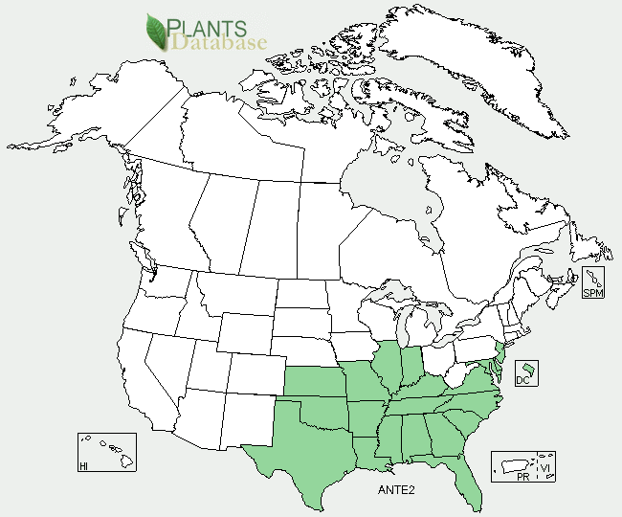

Distribution of *Andropogon ternarius* Michx. from PLANTS database

Splitbeard bluestem is distributed from Delaware to Kentucky and Kansas and south to Florida and Texas. It is especially wide spread in the eastern half of Texas. This plant grows on medium and coarse textured soils with a pH ranging from 4 to 7.5. Splitbeard bluestem prefers open woods or woodland pastures on sandy soils. This grass is moderately shade tolerant, but seldom dominates a plant community.

Establishment

The seed should be planted in late winter as a dormant seeding. Plant the seeds at a depth of ¼ to ¾ inch using a seeding rate of 10 to 12 pounds pure live seed/acre.

### Management

It is not recommended to include splitbeard bluestem in a seed mix with cool season species. This grass is not common enough to be a key management species. Splitbeard bluestem is grazed by cattle in the spring after growth starts. However, they ignore splitbeard bluestem as it matures during the growing season. A stubble height of at least 6” is recommended when mowing or grazing. It will withstand periodic controlled burning. However, annual burning followed by grazing tends to eventually eliminate this species from the site’s plant community.

### Pests and Potential Problems

Splitbeard bluestem has no known pests or problems.

### Cultivars, Improved, and Selected Materials (and area of origin)

There are no known cultivars available; however common seed and container plants are readily available from a number of growers, wholesalers, and retailers of native seed.

Prepared By:

*Melinda Brakie*, USDA NRCS East Texas Plant Materials Center, Nacogdoches, Texas

Species Coordinator:

*Melinda Brakie*, USDA NRCS East Texas Plant Materials Center, Nacogdoches, Texas

### Citation

Brakie, M. 2007. Plant fact sheet for splitbeard bluestem Andropogon ternarius Michx.USDA-Natural Resources Conservation Service, East Texas Plant Materials Center, Nacodoches, TX 75964.

Edited 091207 jsp; 12092011mb

Published September 2007

For more information about this and other plants, please contact your local NRCS field office or Conservation District <<http://www.nrcs.usda.gov/>>, and visit the PLANTS Web site <[http://plants.usda.gov](http://plants.usda.gov/)> or the Plant Materials Program Web site <<http://plant-materials.nrcs.usda.gov>>

.

**USDA IS AN EQUAL OPPORTUNITY PROVIDER AND EMPLOYER**