

Plant Fact Sheet

# Prairie sagewort

## Artemisia frigida Willd.

Plant Symbol = ARFR4

Contributed by: USDA NRCS Colorado Plant Materials Program and the Upper Colorado Environmental Plant Center

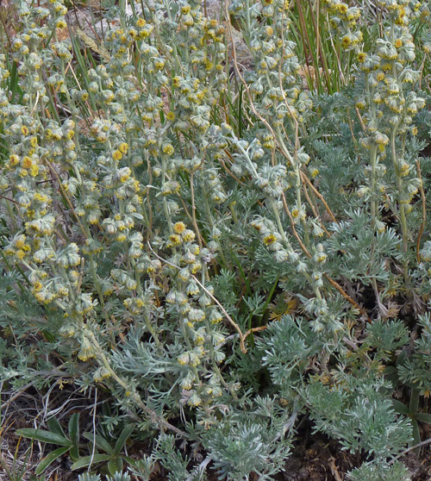Figure 1: Prairie sagewort, (Artemisia frigida) photo ©Al Schneider, www.swcoloradowildflowers.com, used with permission.

Figure 2: Eucosma ragonoti, moth on prairie sagewort. Photo by Christine Taliga, Colorado Plant Materials Program.

### Alternative Names

Common Alternate Names: Fringed sage, fringed sagebrush, sagebrush, prairie sagebrush, sagewort, pasture sage, sweet sage, northern wormwood.

Scientific Alternate Names: N/A

### Uses

Prairie sagewort is a pioneer shrub resistant to browsing and animal impact by certain livestock and wildlife species and has an application for stabilizing disturbed sites.

Forage: Prairie sagewort varies considerably in its value as forage for livestock. It has been considered to be both an adequate [forage](http://en.wikipedia.org/wiki/Forage) species and a nuisance species, and may play an important role on winter pastures. For cattle, palatability varies from “unpalatable” to “fairly good.” It is rated “good” to “fair” for domestic sheep and “fair” to “poor” for horses.

Landscape: Prairie sagewort is drought tolerant and ideal for the xeriscape landscape. The thin, silver-gray leaves have a pleasant herbal scent and remain semi-evergreen in mild climates.

Ethnobotanical: Prairie sagewort has a rich history of utilization by Native American tribes. Uses range from preservatives for meat, horsefeed, insect repellent (through burning of the plant), medicinal decoctions to alleviate toothache, headache, coughing, lung ailments, heartburn, and as a cold remedy. Early settlers used prairie sage to make a bitter tea which they believed was a tonic and remedy for typhoid fever. *A. frigida* is listed as a source of camphor although it has not been recognized by the U.S. Pharmacopoeia for this purpose.

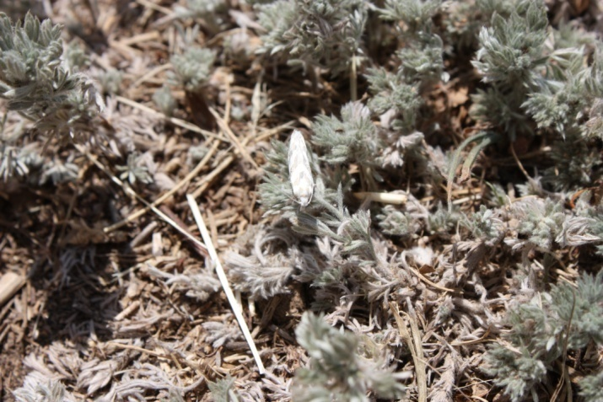Pollinators: Even though the small flowers are [wind-pollinated](http://en.wikipedia.org/wiki/Wind-pollinated), *Artemisia* species are used as [food plants](http://en.wikipedia.org/wiki/List_of_Lepidoptera_that_feed_on_Artemisia) by the [larvae](http://en.wikipedia.org/wiki/Larva) of a number of [*Lepidoptera*](http://en.wikipedia.org/wiki/Lepidoptera)species and other insects.

Wildlife: Big game such as elk, mule deer, bighorn sheep, and pronghorn tend to utilize prairie sagewort in spring, autumn, and winter months. Sage-grouse and greater prairie-chickens utilize prairie sagewort (although other sage species may be preferred) as both adults and juveniles, and chicks consume insects associated with the plants. Prairie sagewort is also important to small game and nongame mammals including, in part, white-tailed jack rabbits, desert cottontails, and black-tailed prairie dogs.

### Status

Please consult the PLANTS Web site and your State Department of Natural Resources for this plant’s current status (e.g., threatened or endangered species, state noxious status, and wetland indicator values).

### Weediness

This plant displaces desirable vegetation in poorly managed rangeland. Please consult with your local NRCS Field Office, Cooperative Extension Service office, state natural resource, or state agriculture department regarding its status and use. Weed information is also available from the PLANTS Web site. Please consult the Related Web Sites on the Plant Profile for this species for further information.

### Description and Adaptation

*General:* Sunflower Family (Asteraceae).

Prairie sage is a mound-forming, spreading sub-shrub with flowering stalks reaching 4-16 inches tall. Covering the plant is an abundance of silvery hairs giving it a silky grey-green appearance. The leaves are round in outline and 3 to 5 times divided, abundant, clustered toward the base, and scattered along the stem. The lower leaves are stalked (petiolate) 0.5 in long, with the upper leaves becoming sessile (no stalk). Flower clusters are a quarter inch in diameter and made up of numerous tiny [disk flowers](http://www.swcoloradowildflowers.com/glossary.htm#Disk). The plant is strongly aromatic. Prairie sagewort blooms from July to August. 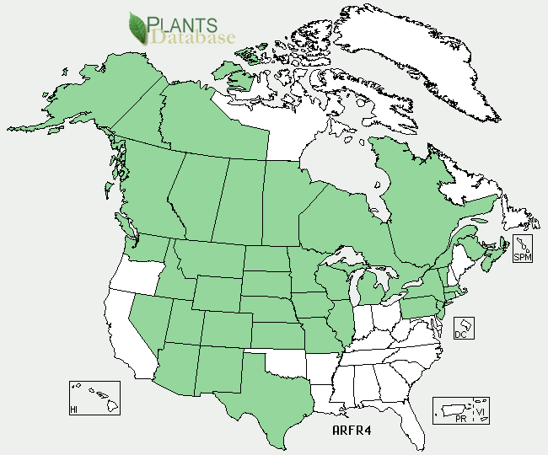

Figure 3: Prairie Sage, distribution from USDA-NRCS PLANTS Database.

For updated distribution, please consult the Plant Profile page for this species on the PLANTS Web site.

### Establishment

### *Artemisia* species can be propagated by seeds, by division of the rootstock, or by cuttings taken in the early summer. Germination is improved with a cold treatment and seed should be broadcast or planted shallowly ( 1/8 inch deep).

### Pests and Potential Problems

None known at this time.

### Environmental Concerns

Due to prairie sagewort’s drought and grazing resistant nature, it may increase rapidly and become dominant. 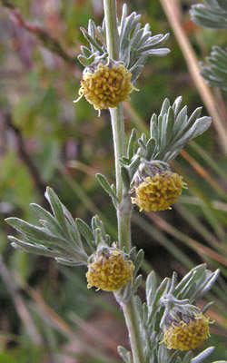

Figure 4: Prairie Sage, (Artemisia frigida) photo ©Al Schneider, www.swcoloradowildflowers.com, used with permission.

**Control**

Please contact your local agricultural extension specialist or county weed specialist to learn what works best in your area and how to use it safely. Always read label and safety instructions for each control method.

### Cultivars, Improved, and Selected Materials (and area of origin)

Prairie sage is available through your local native plant nursery within its range.

### Prepared By

*Christine Taliga*; Plant Materials Specialist, Denver, Colorado.

*Steve Parr*; Manager, Upper Colorado Environmental Plant Center, Meeker, Colorado.

**Citation**

Taliga, Christine E. and S. Parr, 2012. Plant fact sheet for Prairie sage (*Artemisia frigida)*. USDA-Natural Resources Conservation Service, Denver State Office. Denver, Colorado.

Published *September, 2012*

Edited: 19Sep2012jab, 19Sep2012cga

For more information about this and other plants, please contact your local NRCS field office or Conservation District <<http://www.nrcs.usda.gov/>>, and visit the PLANTS Web site <[http://plants.usda.gov](http://plants.usda.gov/)> or the Plant Materials Program Web site <http://plant-materials.nrcs.usda.gov**.**

**USDA IS AN EQUAL OPPORTUNITY PROVIDER AND EMPLOYER**