

Plant Fact Sheet

# Mancos milkvetch

## Astragalus humillimus A. Gray

Plant Symbol = ASHU

#### Contributed by: USDA NRCS Colorado Plant Materials Program

One inch high Astragalus humilimus specimen showing beautiful purple flowers and gray green foliage

Figure 1: Mancos milkvetch (Astragalus humillimus). Photo ©Al Schneider, Plants Database and www.swcoloradowildflowers.com,

used with permission.

### Alternate Names

### *Tragacantha humillima* (A. Gray) O. Kuntze

### *Phaca humillima* (A. Gray) Rydberg

### Uses

### As a pollinator, the attractive and sweet-smelling flowers of Mancos milkvetch are frequented by a variety of pollinators including members of the bee family, *Osmia titusi* and *O. sculleni*, as well as by honey bees. Butterflies are also often seen resting on the fragrant plant when it is in bloom. It has no known agricultural, economic, or other human uses at this time.

### Status

Mancos milkvetch is listed as endangered without critical habitat throughout its range by the U.S. Fish and Wildlife Service (USFWS). Please consult the PLANTS Web site and your State Department of Natural Resources for this plant’s current status (e.g., threatened or endangered species, state noxious status, and wetland indicator values).

### Description and Adaptation

#### General:

Pea family (Fabaceae). Mancos milkvetchis a diminutive, low-growing, tufted perennial sub-shrub growing in clumps up to 12 inches (in) (30 centimeters [cm] across, with a dense crown of persistent spiny leaf stalks (Figure 1). No other mat-forming *Astragalus* species has persistent, sub-spinescent petioles. Stems are up to 0.4 in (1 cm) long and are crowded with matted leaves up to 1.6 in (4 cm) long, which are made up of several oval or nearly rounded leaflets no more than 0.1 in (2 millimeters [mm]) long. Flower branches support 1 to 3 lavender/purplish flowers with a conspicuous lighter-colored spot in the throat of the corolla tube. The pods are egg-shaped and laterally compressed measuring about 0.2 in (4.5 mm) long and 0.1 in (2 mm) wide. Flowering occurs in late April and early May.

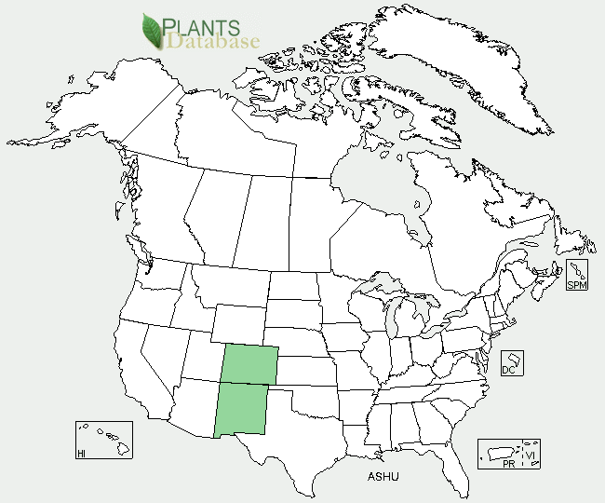

Figure 2. Mancos milvetch distribution from USDA-NRCS PLANTS Database.

**Adaptation**

Mancos milkvetch is adapted to occur within a narrow band of Mesozoic sandstone derived from the Hogback geologic formation. Occupied habitat is confined to large sheets of exfoliating sandstone substrate ledges and mesa tops where plants grow in cracks or shallow bowl-like depressions (tinajas) that accumulate sandy soils and rainfall at 5,650 feet, (1,854 meters) in elevation . This species occurs within an average annual precipitation range of 5-10 inches (12-25 cm). Common plant associates include: scabrous bricklebush (*Brickellia microphyla* var. *scabra*), single leaf ash (*Fraxinus anomala*), small leaf mohagany (*Cercocarpus intricatus*), and rosy ipomosis (*Ipomopisis roseata*).

Mancos milkvetch is a narrow endemic known only from the Four Corners region of the southwestern United States. Its known global distribution includes 13 sites, including 3 sites from Colorado in Montezuma County and 10 sites from New Mexico, in San Juan County.

For updated distribution, please consult the Plant Profile page for this species on the PLANTS Web site.

### Establishment

Seed germination trials conducted by the Arboretum at Flagstaff, Arizona have shown that this species is difficult to establish from seed and difficult to keep in cultivation as it is sensitive to over- or under-watering. Low fecundity is commonly found in plants of the genus *Astragalus* particularly where species persist in small, highly restricted populations which are endemic to particular geologic formation.

Mancos milkvetch plants produce viable fruit by outcrossing and self-pollination. Each fruit of Mancos milkvetch produces 4 to 9 seeds in its egg-shaped pods. It takes two growing seasons for seedlings to mature, with flowering usually the third and fourth year compared to other species of *Astragalus,* which generally take one growing season to bloom.

### Management

Mancos milkvetch is threatened by surface disturbance activities associated with energy exploration and development and transmission line construction and maintenance, as well as recreational off-highway vehicle (OHV) use. The plant's habitat occurs in areas of active oil and gas development. Nearly all known and potential habitat may be affected by natural gas or oil exploration and development. Most damage occurs after vehicles and heavy equipment drive over and crush individual plants as well as break apart sandstone areas that contain tinajas, which are a requirement for Mancos milkvetch establishment.

### Pests and Potential Problems

Spider mite insect infestations have been noted to cause mortality, especially when the plants are already stressed by drought. Larval bruchine beetles of the genus *Acanthoscelides* may also feed upon Mancos milkvetch seeds as evidenced by pin-sized emergence holes on the seed pods.

### Environmental Concerns

The decrease in population numbers of Mancos milkvetch is thought to be due to several notable drought periods of the recent past. Some recovery with new seedlings has occurred but appears to be triggered by both adult mortality and increased moisture events.

**Cultivars, Improved, and Selected Materials (and area of origin)**

None at this time.

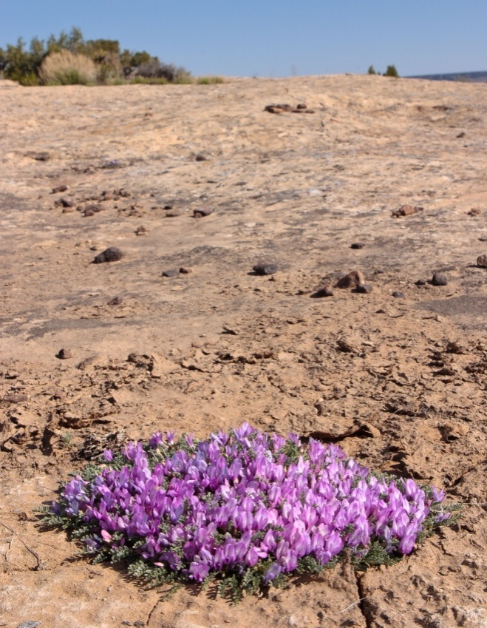

Figure 3: Mancos milkvetch (*Astragalus humillimus*) habitat,

photo © Steve O'Kane, used with permission.

**Prepared By**:

*Christine Taliga*; Plant Materials Specialist, USDA NRCS, Denver, Colorado.

### Citation

Taliga, Christine E., 2012. Plant Fact Sheet for Mancos milkvetch (*Astragalus humillimus)*. USDA-Natural Resources Conservation Service, Colorado State Office. Denver, CO 80225-0426.

Published *September, 2012*

Edited: 18Sep2012jab

For more information about this and other plants, please contact your local NRCS field office or Conservation District at <http://www.nrcs.usda.gov/> and visit the PLANTS Web site at <http://plants.usda.gov/> or the Plant Materials Program Web site <http://plant-materials.nrcs.usda.gov> PLANTS is not responsible for the content or availability of other Web sites.

**USDA IS AN EQUAL OPPORTUNITY PROVIDER AND EMPLOYER**