

Plant Fact Sheet

# Swamp milkweed

## Asclepias incarnata L.

Plant Symbol = ASIN

Contributed by: USDA NRCS, Norman A. Berg National Plant Materials Center, Beltsville, MD

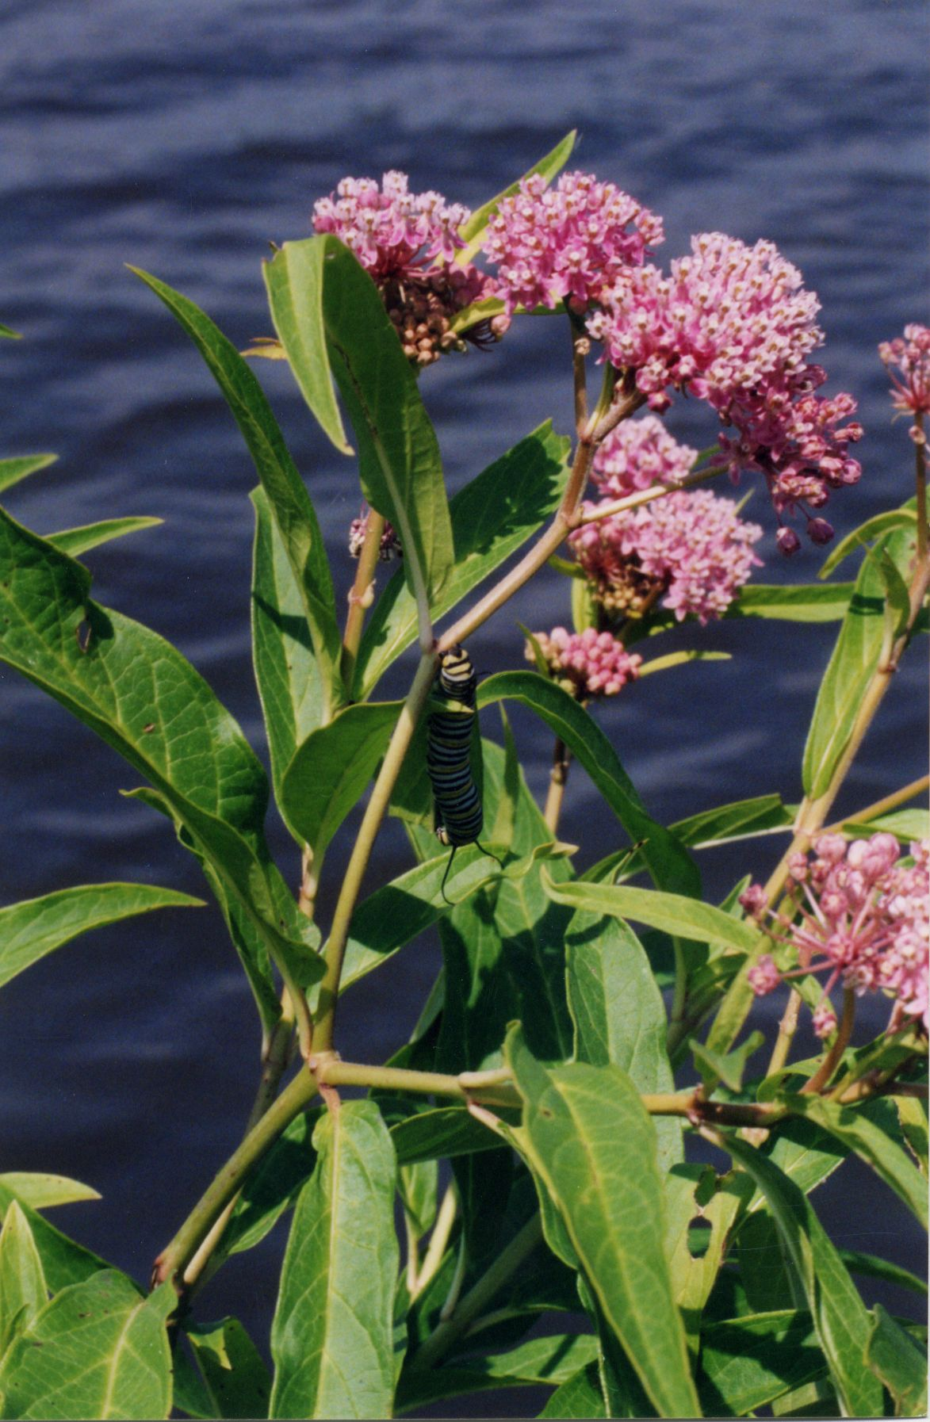

Jennifer Anderson. IA, Scott Co., Davenport, Nahant Marsh. January 2, 2002

### Alternate Names

Rose milkweed

Pleurisy Root

White Indian hemp

**Warning: Swamp milkweed may be toxic when taken internally without sufficient preparation.**

### Uses

*Conservation:* Swamp milkweed is a native, colonizing, perennial wildflower useful for wetland rehabilitation. It is a good component of a wildlife seed mixture when seeded with native grasses and wildflowers. It prefers moisture retentive to damp soils in full sun to partial shade.

*Wildlife:* Swamp milkweed is a favored food of monarch butterfly (*Danaus plexippus*) larva (shown in the picture above). Swamp milkweed is also an important food source for the queen butterfly (*Danaus glippus*) larva. Various other butterflies and hummingbirds consume nectar from the flowers.

*Ethnobotanical:* The Chippewa and Iroquois have used an infusion of the roots externally to strengthen the body and heal babies’ navels. The Iroquois and Meskwaki have also used a decoction of the roots and/or aerial portions of the plant as an emetic, diuretic, and anthelmintic (de-worming agent). The common name, Pleurisy Root, comes from its once common use to treat lung problems. Swamp milkweed is toxic when taken in large doses. The tough stringy stem fibers have been used to make twine, rope and rough textiles.

The downy parachutes (comas) that are attached to each seed are six times more buoyant that cork and five times warmer than wool. Large quantities of milkweed were grown for use as stuffing in pillows and lifejackets during World War II.

*Landscape:* Swamp milkweed is a tall plant with fragrant, showy clusters of pink and light purple flowers. It does well in landscape plantings with moist soil and in plantings near bodies of water. Unlike many ornamentals, swamp milkweed tolerates heavy clay soils and is very deer-resistant. It is a more cultivated alternative to common milkweed that is also attractive to egg-laying Monarchs.

*Livestock:* The bitter leaves of swamp milkweed do not appeal to livestock; sheep are especially susceptible to the poisonous compounds in swamp milkweed, and sheep fatalities have been reported after consuming the plant.

### Status

Please consult the PLANTS Web site and your State Department of Natural Resources for this plant’s current status (e.g., threatened or endangered species, state noxious status, and wetland indicator values).

### Description and Adaptation

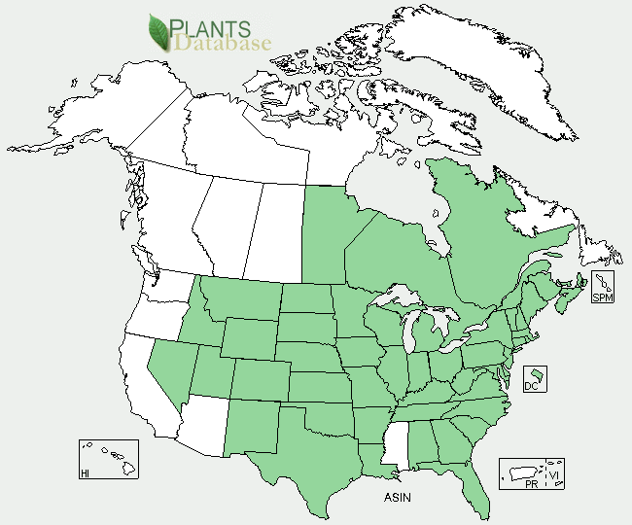

Swamp milkweed distribution from USDA-NRCS PLANTS Database.

*Description:* Swamp milkweed is a native, perennial, wildflower growing three to six feet tall. It gets its common name from its white sap, although it has less sap than many of its relatives. The genus was named in honor of Aesculapius, Greek god of medicine, undoubtedly because some species have long been used to treat a variety of ailments. The Latin species name means flesh-colored. It has long, narrow, lance-shaped leaves that progress in pairs up the stem. Bright pink, white and purple clusters of flowers appear in summer at the tops of the stems. In the fall, blooms give way to distinctive tear-shaped five-inch seed pods that are green when unripe, but harden to brown. The individual seeds are attached to fluffy hairs that allow the seeds to drift on the wind. Swamp milkweed also spreads through rhizomes (roots that grow horizontally from the original plant).

*Adaptation and distribution:* Swamp milkweed is widely distributed across the U.S. and Canada from Quebec and Maine south to Florida and Texas and west to Nevada and Idaho. It prefers neutral to slightly acidic soil, although it will tolerate a pH up to 8.0. Its moisture requirements are high, and it is primarily found in moist habitats such as wet meadows, floodplains, riverbanks, pond shores, stream banks, wet woods, swamps, and marshes, although it will also grow in drier areas such as prairies, fields, and roadsides. Swamp milkweed needs full sun or partial shade to flourish. It is insect-pollinated and self-fertilizing

### Establishment

*Propagation by seeds*: Collect seeds in the fall, when the brown pods are dry and have begun to split. Crack the pods open completely allowing the seeds to dry for one to two weeks in paper bags. Several weevil larvae prey on developing seeds, so look for signs of damage including small entry holes in the pod exuding latex. Once they are dry, place the seeds into plastic bags filled with moist perlite or vermiculite and store them in a cold place, approximately 35 to 38 degrees Fahrenheit, for at least 4 to 12 weeks (stratification). Good germination results have been reported without stratification by soaking the seed. Soak the seed in hot water (190 degrees Fahrenheit) for 12 hours. Repeat this process two additional times for expected seed germination of 50%. Seed can be placed in cold storage for up to three years.

To grow plants, use germination trays with cells two inches wide and four inches deep. Fill the cells with a commercial seedling mixture or a mix of sphagnum peat moss and vermiculite and moisten well. Press the seed gently into the soil, three seed per cell, and cover with a very thin layer of soil. Keep the soil moist during germination by spraying or misting. Ambient temperatures should remain between 65 and 75 degrees Fahrenheit. Swamp milkweed seed requires light for germination. Germination is poor at temperatures higher than 85 degrees Fahrenheit. Seedlings should not be transplanted until they have at least one set of true leaves. Allow 4 to 8 weeks inside growing time for seedlings before moving to a cold frame or transplanting outside. Plants can be moved outside once the danger of frost has passed.

### Management

Swamp milkweed spreads through rhizomes; established plants can be divided in late spring. Swamp milkweed is a relatively long-lived (and slow-growing) herbaceous perennial.

### Pests and Potential Problems

Swamp milkweed attracts the orange milkweed aphid. If plants begin to look unhealthy, spray them with a soap solution or high-pressure blasts of water.

### Environmental Concerns

None at this time.

### Cultivars, Improved, and Selected Materials

The cultivars ‘Ice Ballet’ and ‘Cinderella’ can be found at many native plant nurseries.

### Prepared By

Samantha Kirk and Shawn Belt, USDA-NRCS, Norman A. Berg National Plant Materials Center, Beltsville, MD.

### Citation

Kirk, S. and Belt, S. 2011. Plant fact sheet for swamp milkweed (*Asclepias incarnata)*. USDA-Natural Resources Conservation Service, Norman A. Berg National Plant Materials Center. Beltsville, MD 20705.

Published April, 2011

Edited: 07Feb2011 SMK, 15Feb2011 SVB, 21Apr JW, 25Apr RG

For more information about this and other plants, please contact your local NRCS field office or Conservation District <<http://www.nrcs.usda.gov/>>, and visit the PLANTS Web site <[http://plants.usda.gov](http://plants.usda.gov/)> or the Plant Materials Program Web site <http://plant-materials.nrcs.usda.gov