

Plant Fact Sheet

# Kremmling

# Milkvetch

## Astragalus osterhoutii

## M.E. Jones

Plant Symbol = ASOS

*Contributed by*: USDA NRCS Colorado Plant Materials Program

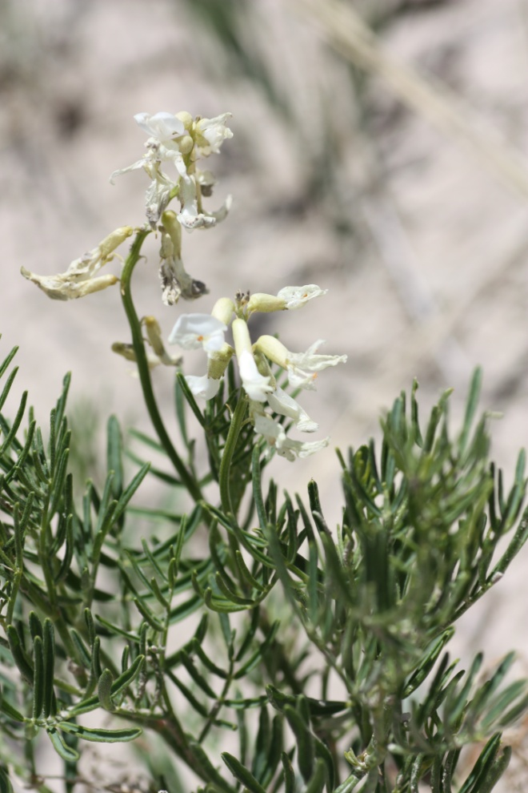

Figure1: Kremmling milkvetch, (Astragalus osterhoutii). Photo USFWS, Alicia Langton July 2010.

### Alternative Names

### *Common Alternate Names: Osterhout’s milkvetch*

### Warning: Kremmling milkvetch is a selenium accumulator and may cause selenium poisoning.

### Uses

### The flowers are white and showy, attracting a variety of pollinators. Primary pollinators include *Apis mellifera*, *Bombus* sp., and *Osmia* sp. Kremmling milkvetch is of economic significance as an indicator of selenium and as a potentially toxic plant in rangelands.

### Status

Kremmling milkvetch was listed as “endangered” under the Endangered Species Act in 1989.

The NatureServe conservation status rank, an international effort which rank species on their “global” status, denotes Kremmling milkvetch as G1/S1- critically imperiled globally and statewide, because of its extreme rarity, it is especially vulnerable to extinction.

Please consult the PLANTS Web site and your State Department of Natural Resources for this plant’s current status (e.g., threatened or endangered species, state noxious status, and wetland indicator values).

### Description and Adaptation

Pea family (Fabaceae). Kremmling milkvetch, is a relatively tall plant with linear leaflets and several bright green stems reaching up to 40 inches (100 centimeters) in height. There are 12—25 white flowers, 1 in. (2.4 cm) long, per inflorescence, each ultimately with stipitate pendulous pods, 1.8 in. (4.5 cm) long. *Astragalus pattersonii* and *A. bisulcatus* are similar species also with a relatively tall growth form. The three species may be separated as follows: Kremmling milkvetch is distinguished from *A. pattersonii* by its long, pendulous fruits that are laterally compressed, from *A. bisulcatus* by its large, white flowers, and from both by its lime-green,linear leaflets.

Kremmling milkvetch is adapted to grow on highly seleniferous, grayish-brown clay soils derived from shales of Niobrara, Pierre, and Troublesome formations. Kremmling milkvetch occurs on shaley slopes at middle elevations ranging from 7,400 – 7,900 feet (2,256 – 2,408 meters) within the sagebrush parks eco-region with an average annual precipitation of 10-16 inches.

*Habitat*:

Kremmling milkvetch occurs on moderate slopes, on white shale outcrops of the Niobrara, Pierre, and Troublesome Formations in northern Grand County, Colorado. The chaparral/shrubland habitat includes the following common plant associates: big sagebrush *(Artemesia tridentata),* yellow rabbitbrush (*Chrysothamnus viscidiflorus),* broom snakeweed *(*Gutierrezia sarothrae), winterfat (Krascheninnikovia lanata)*,* spiny phlox (*Phlox hoodii),* shortstem buckwheat (*Eriogonum brevicaule),* andwestern wheatgrass (Pascopyrum smithii).

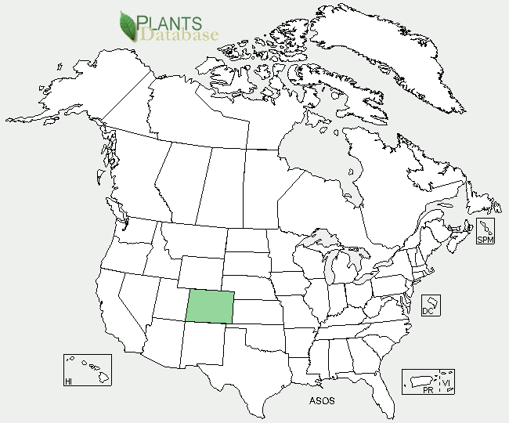

Figure 2: Kremmling milkvetch distribution from USDA-NRCS PLANTS Database.

Kremmling milkvetch is known to be endemic only to a localized area near the town of Kremmling, in Middle Park, Colorado. The current known global distribution includes five small and scattered populations within an eight-mile radius, occupying an estimated 800 acres of habitat near the town of Kremmling in Middle Park, Colorado.

For updated distribution, please consult the Plant Profile page for this species on the PLANTS Web site.

### Establishment

Seeds of Kremmling milkvetch exhibit physical dormancy requiring scarification in order to germinate. Kremmling milkvetch may be mycorrhizaland , a symbiotic dinitrogen fixer with Rhizobium bacteria, as nearly all *Astragalus* species. Kremmling milkvetch plants produce viable seeds by both outcrossing and self-pollination, with higher fruit set from self-pollination. Low fecundity is commonly found in the *Astragalus* genus, many species persist in small, highly restricted populations which are endemic to particular geologic formations.

### Management

Kremmling milkvetch is threatened by commercial, residential, and agricultural property development, and the associated new utility installations and access roads, reservoir operations and expansion, off-highway vehicle recreation, oil and gas exploration, and livestock grazing. A loss of pollinators and their habitat due to development is also a threat to this species.

### Pests and Potential Problems

Blister beetles (*Epicauta pennsylvanica*) have been noted feeding en masse on the flowers of Kremmling milkvetch, particularly affecting populations occuring along Muddy Creek. Also, larval bruchine beetles of the genus *Acanthoscelides* may feed uponKremmling milkvetch seeds, as evidenced by pin-sized emergence holes on the seed pods.

### Environmental Concerns

Kremmling milkvetch is known to accumulate selenium at toxic levels in its foliage and is known to be a selenium indicator plant. Selenium causes the plant to emit an unpleasant pungent odor of garlic or sulfur (a “rotten egg” smell), and at high levels is known to be toxic to grazing animals.

### Cultivars, Improved, and Selected Materials (and area of origin)

None at this time.

**Prepared By**:

*Christine Taliga*, Plant Materials Specialist, USDA NRCS Colorado State Office, Denver, Colorado.

### Citation

Taliga, Christine E., 2012. Plant Fact Sheet for Kremmling milkvetch (*Astragalus osterhoutii)*. USDA-Natural Resources Conservation Service, Colorado State Office. Denver, CO 80225-0426.

Published September 2012

Edited: 19Sep2012jab, 20Sep2012cga

For more information about this and other plants, please contact your local NRCS field office or Conservation District at <http://www.nrcs.usda.gov/> and visit the PLANTS Web site at <http://plants.usda.gov/> or the Plant Materials Program Web site <http://plant-materials.nrcs.usda.gov>.

**USDA IS AN EQUAL OPPORTUNITY PROVIDER AND EMPLOYER**