

Plant Fact Sheet

# AMERICAN SLOUGHGRASS

## Beckmannia syzigachne (Steud.) Fernald

Plant Symbol = BESY

Contributed by: USDA NRCS Corvallis Plant Materials Center, Oregon and Manhattan Plant Materials Center, Kansas

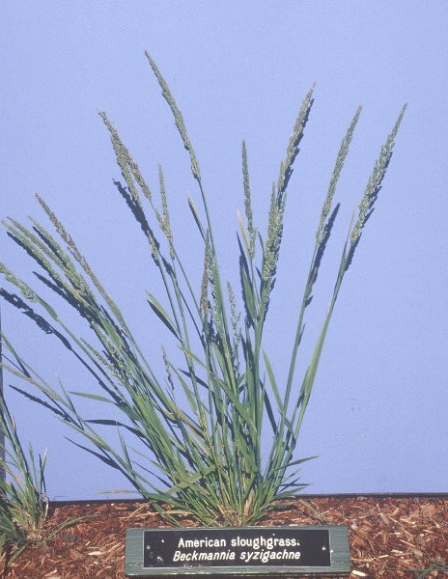

### Alternative Names

*Alternate Common Names*: western sloughgrass, caterpillar grass, slough grass

*Alternate Scientific Names*: *Beckmannia eruciformis, Beckmannia eruciformis* ssp. *baicalensis*, *Beckmannia eruciformis* var. *uniflora*, *Beckmannia syzigachne* ssp. *baicalensis*, *Beckmannia syzigachne* var. *uniflora*

### Uses

American sloughgrass is a native cool season grass important for wetland restoration as well as erosion control along ditches, streams, waterways, and the shorelines of lakes or ponds. It is valuable as a wetland forage species and is hayed or grazed in some regions. The seeds provide important food for waterfowl, seed-eating birds, and small mammals. The species has been commonly sown for wetland wildlife habitat. Palatability is rated high for all classes of livestock and it is frequently hayed or grazed. Forage nutritional data indicates that it is high in protein and nonstructural carbohydrates. This plant provides relatively quick and reliable cover under appropriate growing conditions.

### Status

This species is listed as Endangered in Illinois and Threatened in Michigan. Please consult the PLANTS Web site and your State Department of Natural Resources for this plant’s current status (e.g., threatened or endangered species, state noxious status, and wetland indicator values).

### Description and Adaptation

*General*: American sloughgrass is an annual or short-lived perennial bunchgrass with stout, leafy stems (culms) that are 24 to 40 inches (60 to 100 cm) tall. The flowerhead (inflorescence) is a very narrow, upright spike, 8 to 12 inches (20 to 30 cm) long. It has a double row of densely compacted, single-flowered spikelets on one side of the panicle branches. The seed with hull attached is nearly flat and disk-like in shape. American sloughgrass has a very distinctive appearance that is hard to confuse with other species in the Pacific Northwest. The seed head looks a little like introduced barnyard grass (*Echinochloa crusgalli*), but its growth form is more upright and less spreading. Seedling vigor and establishment are moderately rapid. The plant flowers in June and goes to seed in July or August in western Oregon. Individual plants usually contain many seed heads, which produce abundant seed. The seed does not shatter readily, which creates a large window of time for easy collection.

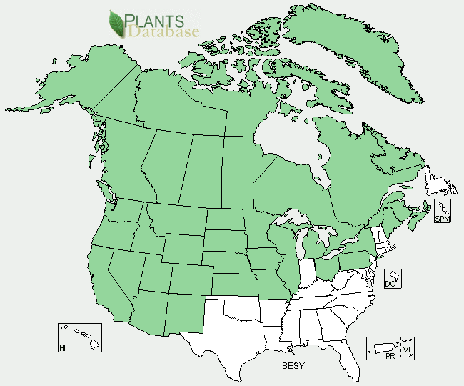

American sloughgrass distribution from USDA-NRCS PLANTS Database.

*Distribution*: This species occurs in the cooler parts of North America, particularly the north central and northwestern United States, as well as southern Canada, Alaska, and a portion of Eastern Europe and Asia. However, it is not found at mid or high elevations and has not been collected in western Washington. It is a common species in western Oregon, but may be scarce or rare in other parts of its natural range. For updated distribution, please consult the Plant Profile page for this species on the PLANTS Web site.

*Adaptation*: American sloughgrass is best adapted to poorly drained, irrigated, and somewhat acidic to alkaline soils with shallow water tables. It performs best on clay soils covered with a thin layer of organic matter, but grows on coarser substrates as well. Habitats include marshes, vernal pools and depressions within wetland prairies, pond shores, shallow water, and other flooded or seasonally wet sites. American sloughgrass thrives where the soils are saturated at or near the surface year round. It will also maintain itself under continuous, year round flooding up to 4 inches (10 cm) deep. Studies have shown that survival rapidlydeclines beginning at depths of 6 inches (15 cm) and beyond. It is intolerant of summer dry soils and shade.

### Establishment

American sloughgrass lacks complex seed dormancy characteristics and rapidly colonizes mudflats or other recently exposed moist soil. Reports of percent seed germination vary, but it may be improved by rubbing or dehulling the seed (and possibly light abrasion of the seed coat), and by providing alternating temperature regimes. The best time to plant is in the fall, or as a dormant seeding, which will promote early spring establishment. Surface sown seed readily floats and migrates with flowing water, so insure adequate but shallow soil or mulch coverage. There are 240,000 seeds per pound (± 20%) with hulls intact. The free flowing spikelets present no difficulty for conventional planting equipment. Recommended single species seeding rates can vary widely, depending on the site and purpose of the planting, ranging from 5 to 18 lbs/acre. One pound of live seed per acre is equivalent to 5 to 6 live seeds per square foot.

### Management

In the Northern Plains, forage production is considered moderate to high. As a short-lived species, a pattern of deferred, rotational grazing may be needed every two or three years to allow for seed production and natural regeneration of the stand. The plant requires a high water table or regular irrigation during the dry season. Sloughgrass has the ability to readily volunteer on exposed mudflats or other moist, disturbed ground and produce abundant seed crops. This makes it a good candidate for moist soil management (slow de-watering, disking, etc.) of certain wetlands and shallow water impoundments for waterfowl, shorebird, and other wildlife habitat.

### Pests and Potential Problems

Plants may become prone to disease when grown on upland or droughty sites without irrigation.

### Environmental Concerns

This species has a relatively narrow ecological adaptation. While sloughgrass is usually replaced by more competitive grasses over time (typically four to five years), it is sometimes considered weedy in low lying seed production field of introduced grasses in western Oregon. It can volunteer readily after tillage.

### Cultivars, Improved, and Selected Materials (and area of origin)

Seed sources are relatively common for western Oregon, Alaska, and the north central US, but less so elsewhere.

‘Egan’ American sloughgrass (AK, 1986) is a cultivar recommended for waterfowl habitat and reclamation and erosion control plantings in seasonally wet areas such as ditches, stream banks, or fresh water shorelines in Alaska.

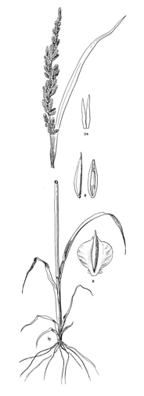

Reprinted with permission of University of Washington Press.

### Prepared By

*Dale Darris and Amy Bartow*

USDA-NRCS Corvallis Plant Materials Center, Oregon

*Richard Wynia*

USDA-NRCS Manhattan Plant Materials Center, Kansas

### Citation

Darris, D., A. Bartow, and R. Wynia. 2004. Plant fact sheet for American sloughgrass (*Beckmannia syzigachne)*. USDA-Natural Resources Conservation Service, Plant Materials Center, Corvallis, OR.

Published December 2004

Edited: 23Mar2006 jsp; 17Feb2012 aym

For more information about this and other plants, please contact your local NRCS field office or Conservation District <<http://www.nrcs.usda.gov/>>, and visit the PLANTS Web site <[http://plants.usda.gov](http://plants.usda.gov/)> or the Plant Materials Program Web site <<http://plant-materials.nrcs.usda.gov>>

**USDA IS AN EQUAL OPPORTUNITY PROVIDER AND EMPLOYER**