|  |
| --- |
| CALIFORNIA BROME |
| ***Bromus carinatus*** Hook. & Arn. |
| plant symbol = BRCA5 |

*Contributed by: USDA NRCS Plant Materials Center, Corvallis, Oregon*

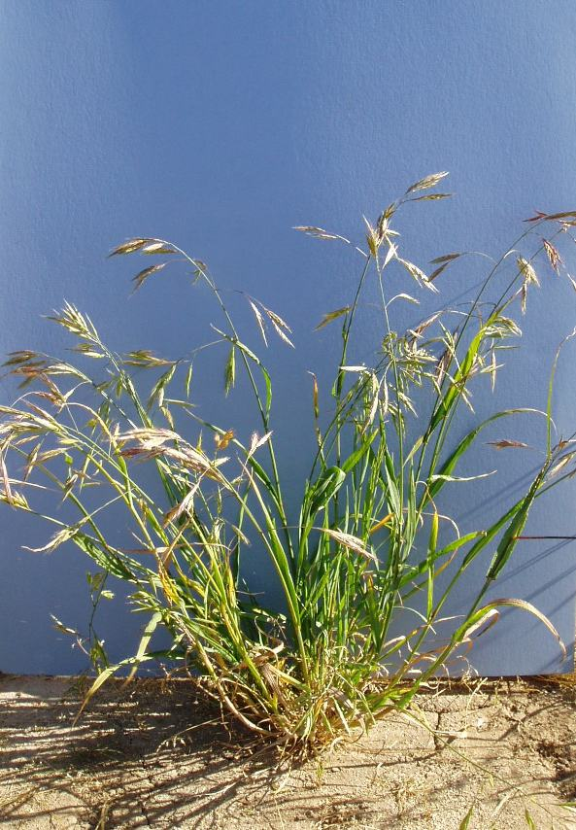

Dale Darris

USDA NRCS Corvallis PMC

**Alternate names:** Some taxonomic treatments include mountain brome (*Bromus marginatus*), (*Bromus carinatus* var. *marginatus*) and others. Consult the Flora of North America, Volume 24 (2007) and Intermountain Flora, Volume 6 (1977).

**Uses:** California brome is a medium-tall, competitive, native bunchgrass valued for its rapid and easy establishment in revegetation and erosion control. It is also widely used for rehabilitation after wildfires and mining, rangeland improvement, and restoration of upland plant communities. This species is considered to be a moderately to highly productive, nutritious, and palatable forage relished by all classes of livestock prior to maturity. In some ranges it is important summer forage for elk, but considered less palatable to deer. Bear, geese, and various rodents also consume the foliage. The deep fibrous root system makes the plant fairly resistant to grazing and drought. While a good range grass, used alone it may not be suitable for permanent pasture because of its short longevity. One of the better uses of California brome may be as a native competitor to aid in the reduction of exotic weeds a year or two in advance of planting other native grasses. California brome provides good cover for wildlife and the seed is consumed by small mammals and game birds. It is sometimes recommended as a cover crop for vineyards and orchards in California.

**Description**: California brome is a native, cool-season, annual, biennial, or short-lived perennial bunchgrass. It is a highly variable species. The base of this robust plant is very open with coarse, erect to spreading stems (culms) that grow 45-120 cm tall. Leaf blades are 1-12 mm wide, lax and spread out along stems. The inflorescence (seed head , panicle) is 10-30 cm long, large, open, and erect to somewhat drooping. The root system is deep and widespread.

*Key to identification*: California brome intergrades with mountain bromeand some authors classify both as the same species. Other species are also very difficult to distinguish from California brome so a current taxonomic key should be consulted. Sitka brome (*Bromus sitchensis*) is a good example and their natural habitats overlap considerably. Both occur in full sun, but Sitka brome can also be found in somewhat shadier environments. According to some taxonomists, Sitka brome is taller with broader, more drooping panicles and spikelets (subunits of the seedhead) that occur more toward the tip of the branchlets compared to California brome. Pacific brome (*Bromus pacificus*) can also be confused with both bromes, but its leaves are soft hairy (on at least one side) and it has other distinguishing features. Pacific brome occurs mainly along the Pacific Coast in moist habitats but extends inland to the Puget trough of Washington at low elevations.

**Adaptation:** California brome is widely distributed in western North America from British Columbia and Alberta south to California and Mexico and eastward to Montana, Wyoming, Colorado, and New Mexico. It occurs in open areas including meadows, coastal prairies, montane slopes, and waste places as well as open woodlands, oak savanna, sagebrush, and chaparral from sea level to 11,000 ft in elevation. The species is adapted to moderately moist to dry soils with a pH of 5.5 to 8.0. While tolerant of somewhat poor drainage and fine textured clays, best growth is attained on medium-textured or loamy soils with good drainage. It is found in environments with full sun to slight shade. The species withstands fall fires and controlled burns and will sprout from surviving crowns. In other cases, stands may top kill but full stand recovery occurs after a few years.

**Commercial availability:** Seed is readily found on the market. Sources derived from local, natural origins should be favored. Cultivated varieties are also available for use in certain regions of the West.

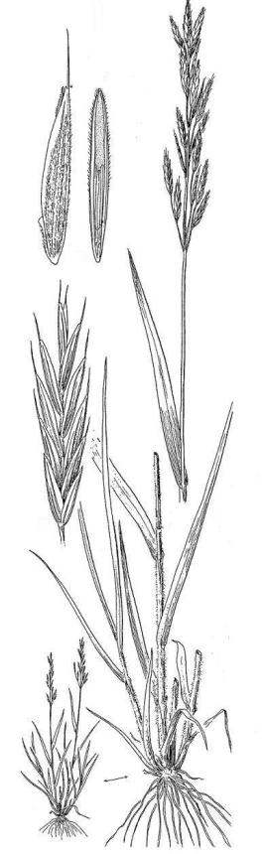

##### Line drawing reprinted with permission,

University of Washington Press

**Relative abundance in the wild:** The species is very common in open areas, meadows, and waste places. Seed is easy to collect.

**Limitations or environmental concerns:** California brome spreads easily by seed and can quickly become a moderate to serious weed pest in certain agricultural crops. Its use should generally be avoided in certain areas of intensive agriculture such as fields of introduced grasses grown for seed. Seed may remain viable in the soil for several years. High seeding rates in mixes with other less competitive native grasses should be avoided. California brome is susceptible to a disease called head smut. Wild stands or fields to be harvested for seed should be inspected carefully for the disease and infected plants avoided or removed. Smut can be controlled by treating the seed with an approved fungicide prior to sowing. Leaf and stem rusts are other potential pests.

**Establishment:** Seed dormancy is usually absent in natural populations from low elevation so California brome can be fall or spring sown. Germination occurs in 10-14 days and seedling growth and plant development are rapid. However, seed obtained from higher elevation populations may have dormancy requiring 30-90 days of cold moist stratification (moist pre-chilling) or fall sowing for best germination. Physical conditioning of the seed to remove the awns (narrow appendage at the tip of the seed) is an option to improve flow through seeding equipment. There are 60, 000-82,000 seeds/lb with the upper range associated with de-awned seed. Therefore, each pound of seed planted per acre will result in about 1.5-2.0 seeds/sq. ft. When sown alone, the suggested rate is 8-10 lbs of pure live seed (PLS) per acre. Lower rates (1-3 lbs/ac) should be used in seed mixes with less competitive grasses.

Stand management depends on your project objectives (prairie restoration, cover crop, rotational livestock grazing, etc.). As a cover crop, the species has intermediate tolerance to mowing. Fire is an effective tool for post harvest residue management in seed production. The species decreases under heavy grazing but increases with light to moderate use.

Prepared By:

Dale Darris, USDA NRCS Plant Materials Center, Corvallis, Oregon. July 2007.

Species Coordinator:

Dale Darris, USDA NRCS Plant Materials Center, Corvallis, Oregon.

Edited: 070723 jsp

For more information about this and other plants, please contact your local NRCS field office or Conservation District, and visit the PLANTS Web site<<http://plants.usda.gov>> or the Plant Materials Program Web site <<http://Plant-Materials.nrcs.usda.gov>>

*The U.S. Department of Agriculture (USDA) prohibits discrimination in all its programs and activities on the basis of race, color, national origin, sex, religion, age, disability, political beliefs, sexual orientation, and marital or family status. (Not all prohibited bases apply to all programs.) Persons with disabilities who require alternative means for communication of program information (Braille, large print, audiotape, etc.) should contact USDA's* [*TARGET Center*](http://www.usda.gov/oo/target.htm) *at 202-720-2600 (voice and TDD).*

*To file a complaint of discrimination write USDA, Director, Office of Civil Rights, Room 326-W, Whitten Building, 14th and Independence Avenue, SW, Washington, DC 20250-9410 or call 202-720-5964 (voice or TDD). USDA is an equal opportunity provider and employer.*

*Read about* [*Civil Rights at the Natural Resources Conservation Service*](http://www.nrcs.usda.gov/about/civilrights/)