

Plant Fact Sheet

# American Beautyberry

## Callicarpa americana L.

### Plant Symbol = CAAM2

#### Contributed by: USDA NRCS NRCS East Texas Plant Materials Center

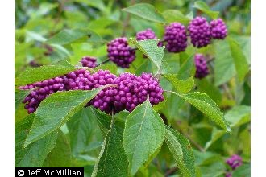

**Jeff McMillian@USDA-NRCS PLANTS**

#### **Alternate Names**

American beautyberry is also known as French mulberry, sourbush, bunchberry, or purple beauty-berry. In Greek, the genus name Callicarpa means callos, “beauty” and carpos “fruit”.

#### **Uses**

Ethnobotanic: The roots, leaves, and branches were used by various Native American tribes for medicinal purposes to treat malarial fevers and rheumatism. The roots were used to treat dizziness, stomachaches and dysentery. Roots and berries were boiled and drunk to treat colic.

In the early 20th century, farmers would crush the leaves and place them under the harnesses of horses and mules to repel mosquitoes. The farmers rubbed the crushed leaves on themselves to repel mosquitoes and biting bugs. Studies conducted by the Agricultural Research Service has shown two compounds – callicarpenal and intermedeol - are responsible for the repellant.

Wildlife: The fruit is high in moisture content and is an important food source for more than forty species of songbirds including the American Robin, Brown Thrasher, Purple Finch, and Eastern Towhee. The drupes or clusters are eaten by armadillo, foxes, opossum, raccoon and squirrels. White tailed deer consume the fruit in the fall after leaf drop. They also browse the leaves in summer when highly preferred foods are not available. Protein content of the leaves ranges from 18 percent in spring to 8 percent in fall.

Other: American beautyberry is used as an ornamental shrub in mass plantings, borders and container planting.

Livestock: Cattle browse the twigs in winter and the leaves and twigs in the spring.

#### **Status**

Please consult the PLANTS Web site; <http://plants.usda.gov> and your State Department of Natural Resources for this plant’s current status (e.g., threatened or endangered species, state noxious status, and wetland indicator values).

#### **Description and Adaptation**

American beautyberry is a fast growing native perennial shrub; growing five to eight feet tall and almost as wide with drooping branches. The elliptical to ovate shaped leaves have an opposite arrangement with saw toothed margins. The underside of the leaves may be covered with wooly like hairs. The stems are slender, gray to reddish brown, and terete or four sided. In late spring to early summer, inconspicuous flowers of blue, violet, pink, or white are arranged in clusters on the stems between the leaves. In August or September, clusters of small purple to blue berries or drupes encircle the woody stems. Each small berry in the cluster contains two to four seeds about 1/16 in. long.

This plant is distributed throughout the southeastern United States from Texas and Oklahoma east to Maryland. It also grows in the Caribbean and northern Mexico. American beautyberry is found in woods, particularly on moist areas under open pine canopies, thickets, right of ways, and fence rows. It is adapted to moist, loam, sandy or shallow upland sites and a wide pH range. The shrub is considered a pioneer species and is characteristic of the mid stages of plant succession. This plant is very tolerant of fire. However, it is intolerant of deep shade and declines in number when mid-story vegetation is dense.

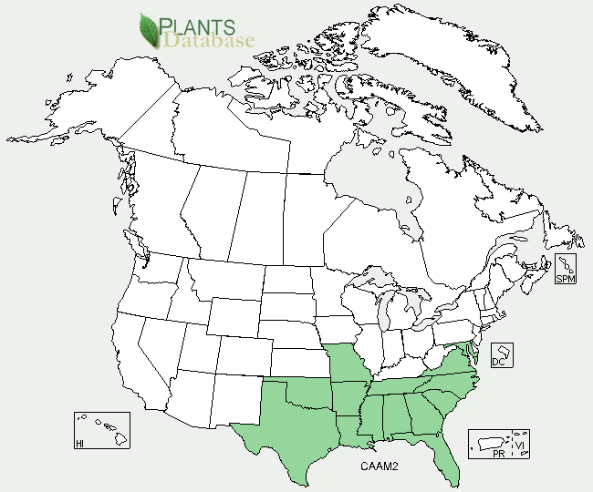

American beautyberry distribution from USDA-NRCS PLANTS Database.

For updated distribution, please consult the Plant Profile page for this species on the PLANTS Web site.

#### **Establishment**

American beautyberry can be propagated by transplanting volunteer plants, softwood cuttings, or seeds. Volunteer plants are very hearty and can be dug up and transplanted to a different location. Softwood stem cuttings (4” to 6” long) can be taken in the summer and fall. Dip the cut end into indol -3 – butyric acid (IBA; 1000 ppm) and insert into a rooting media. Keep the temperature of the media between 70-750. Water the cuttings and cover with plastic to keep the material moist. Roots should develop within a few weeks. After rooting begins, remove the plastic at longer intervals each day for seven to ten days. Afterwards, remove the plastic permanently. The seed is easily gathered by hand picking the mature fruit in the fall. The harvested berries, which contain 2 to 4 seeds each, can be treated in several ways; one is planting the berries in the fall for spring germination. American beautyberry seeds can survive several years in the soil bank. Another way is cleaning the seeds using a kitchen blender for small seedlots. Mix the berries with at least five times their volume of water and pour into the blender. Run the blender at its lowest speed using short bursts of a few seconds at a time to separate the skin and tissue from the seeds. Eventually, mature seeds sink to the bottom, while immature seeds, skins and tissue remain near the top. Check the seeds for possible damage. Pour off the unwanted material and repeat the process two or three times. Eventually, a clean seed sample will be left at the bottom of the blender. Drain the seeds and spread them out to dry. After drying, the seeds are ready for planting or storage in a cool, dry place.

#### **Management**

Prune the plants in the fall or winter to maintain its form. Cut away the old stems since the berries are present only on new growth.

#### **Pests and Potential Problems**

Some of the diseases which affect this genus include leaf spots (*Atractilina callicarpae*) and black mold (*Meliola cookeana*).

#### **Environmental Concerns**

American beautyberry seed is dispersed by birds and animals.

#### **Cultivars, Improved, and Selected Materials (and area of origin)**

This plant is available from commercial sources. Some nurseries produce a white fruited plant; *C. Americana var. lactea. .*

#### **Prepared By:** Melinda Brakie, USDA NRCS Plant Materials Center, Nacogdoches, Texas.

#### **Citation**

Brakie, M. 2010. Plant fact sheet for American beautyberry (*Callicarpa americana)*. USDA-Natural Resources Conservation Service, East Texas Plant Materials Center. Nacogdoches, TX, 75964.

Published: September 2010

For more information about this and other plants, please contact your local NRCS field office or Conservation District <<http://www.nrcs.usda.gov/>>, and visit the PLANTS Web site <[http://plants.usda.gov](http://plants.usda.gov/)> or the Plant Materials Program Web site <<http://plant-materials.nrcs.usda.gov>>

**USDA IS AN EQUAL OPPORTUNITY PROVIDER AND EMPLOYER**