

Plant Fact Sheet

# bluejoint

## Calamagrostis canadensis

## (Michx.) P. Beauv.

Plant Symbol = CACA4

Contributed by: USDA NRCS Plant Materials Center, Corvallis, Oregon

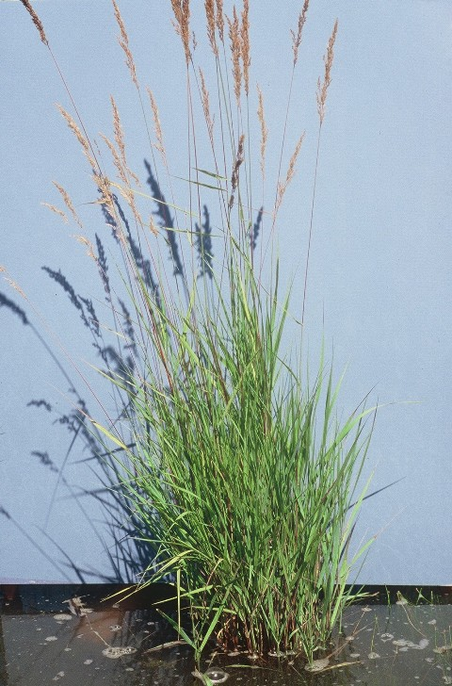

*Photo by Dale Darris, USDA-NRCS Corvallis PMC.*

### Alternative Names

*Alternate Common Names:* Other common names include bluejoint reedgrass, Canada bluejoint, Canadian reedgrass, meadow pinegrass, marsh reedgrass, and marsh pinegrass.

*Alternate Scientific Names:* none

Uses

Bluejoint is a mid-sized to tall native grass useful for wetland restoration and enhancement as well as shoreline and streambank stabilization. Creeping underground shoots (rhizomes) improve the plants ability to bind soil, especially along higher gradient streams and waterways. It is included in hydroseeding mixtures for drainage ditches designed to filter stormwater. This species provides forage for bison, elk, and deer, as well as food and habitat for small mammals, waterfowl, birds, and bears. It furnishes substantial amounts of herbage and stands have been hayed in the Midwestern states. Forage value varies widely by region with ratings from poor to good for all classes of livestock. Palatability is considered fair at best regardless of livestock type. It is highest in the spring prior to maturity.

Status

Please consult the PLANTS Web site and your State Department of Natural Resources for this plant’s current status (e.g. threatened or endangered species, state noxious status, and wetland indicator values).

Description and Adaptation

Bluejoint is a long lived, perennial cool season grass with stout stems that grows 60 to 180 cm tall. There are 3 to 8 prominent joints (nodes) along the stems. This species spreads slowly (5 to 15 cm/year) by rhizomes forming a sod. Leaves are ribbed, lax, rough to the touch, and 3 to 8 mm wide. The flower head (panicle) is rather narrow to open and loosely branched, upright to drooping when mature, and 10 to 20 (30) cm long. Flowering occurs in late June or July and the seed matures in August. The tiny seeds have fine hairs attached at one end of their hull and are easily windborne. They remain viable in the soil for up to 5 (7) years. Bluejoint occurs from low to mid-elevation across most of Canada and the United States, except for the Southeast.

*Adaptation:*Bluejoint can be found in a wide variety of environments including meadows, open woods, wet thickets or swamps, marshes, bogs, ditches, and the margins of streams and lakes. It can readily colonize disturbed areas especially in colder northern forests following logging or fire. This species thrives in more nutrient rich, saturated soils, peat, or deep, fine textured substrates that are moist all summer. Reportedly, bluejoint only withstands seasonal inundation and temporary spring flooding up to 15 cm deep. However, stands have maintained themselves for several years in permanent standing water at similar depths. This species is adapted to very acid to slightly alkaline soils (pH 3.5 to 8).

*Key to identification:* This species resembles reed canarygrass (*Phalaris arundinacea*) but the latter is coarser textured, has much larger, smooth seed, and produces reddish rhizomes near the soil surface. Consult a botanical key to distinguish bluejoint from other *Calamagrostis* species.

### *Relative abundance in the wild:* Common in many areas of the northern boreal and temperate forests, it is scarce to nonexistent in the Willamette Valley of Oregon, but more common along the Pacific Coast near lakes, in the Puget lowlands of Washington, and at mid-elevations in the Mountains. Seed ripens in late summer. Collection can be difficult due to poor or erratic seed production.

### Line drawing of bluejoint courtesy of the University of Washington Press.

### *Line drawing of* Calamagrostis canadensis *reprinted with permission, University of Washington Press*

Establishment

Bluejoint seed has no dormancy and germinates when fall or spring sown. The basal hairs on the seed should be removed with a debearder to improve seed flow. Hulls may be removed in the process, resulting in approximately 4 million seeds per pound (± 20%). A seeding rate of one pound per acre will result in about 92 seeds per square foot. Because seed is expensive, it typically comprises 1 to 20% of a wetland mix. Rates as low as 0.03 to 0.06 lbs/acre are suggested. Rhizomes and plugs are more successful. One source recommends a spacing of 6, 12 or 18 inches for uniform aerial coverage in one, two or three years. The recommended planting density is 3,500 to 7,000 plants per acre.

Management

This species is sensitive to overgrazing in some regions and multiple cuttings can reduce forage yields. Foliage is most palatable when young, prior to seed head maturation. Coincidently, moist soil conditions may restrict spring grazing. Therefore, livestock utilization should be timed according to how dry the soils are and the stage of plant maturity.

**Weediness and control**

This plant may become weedy or invasive in some regions or habitats and may exclude desirable vegetation if not properly managed. Methods of control for reforestation include using herbicide applications, biological control with diseases, minimal or specialized mechanical site preparation methods, and deep burning, hot fires. If bluejoint is a problem in your area, please consult your local NRCS, Extension Service, state forestry or agriculture department offices regarding the plants use and control measures.

Environmental Concerns

Poor seed fill can occur in many populations. In contrast, regeneration and spread from seed and rhizomes can be highly prolific on moist sites in the northern boreal forests of Canada. As a result, bluejoint is a serious competitor to white spruce seedlings and other conifer reforestation efforts in that region. After logging, light fires, or other disturbances, it can increase quickly, forming a complete stand with a thick layer of thatch that restricts establishment of other species. Bluejoint is a minor weed in cranberry bogs. When used for forage or hay, its value is limited by high silica content and a rapid loss of nutritional quality following seed head formation. Some strains are apparently susceptible to a fungal or bacterial disease of the stems called white top.

Cultivars, Improved, and Selected Materials (and area of origin)

Seed is expensive and sources specific to Oregon, Washington, and California are lacking. Nursery stock and seed are more readily available in other parts of the West, Midwest, and Northeast United States.

Prepared By

*Dale Darris*, USDA NRCS Plant Materials Center, Corvallis, Oregon

Citation

Darris, D. 2005. Plant fact sheet for bluejoint (Calamagrostis canadensis). USDA-Natural Resources Conservation Service, Plant Materials Center, Corvallis, OR.

Edited: 23Mar2006 jsp, 16Sep2008 dcd.; 17Sep2008 jsp; 17Feb2012 aym

For more information about this and other plants, please contact your local NRCS field office or Conservation District <<http://www.nrcs.usda.gov/>>, and visit the PLANTS Web site <[http://plants.usda.gov](http://plants.usda.gov/)> or the Plant Materials Program Web site <<http://plant-materials.nrcs.usda.gov>>

**USDA IS AN EQUAL OPPORTUNITY PROVIDER AND EMPLOYER**