

Plant Fact Sheet

|  |
| --- |
| Pecan |
| *Carya illinoinensis* (Wangenh.) K. Koch |
| Plant Symbol = CAIL2 |

Contributed by: USDA NRCS East Texas Plant Materials Center

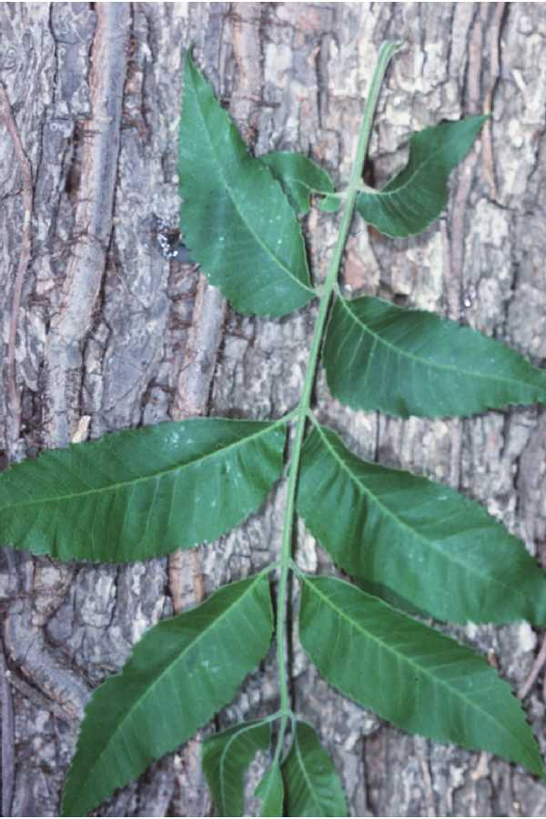

Robert Mohlenbrock

USDA, NRCS, Wetland Science Institute

@PLANTS

Alternate Names

Sweet pecan, Illinois nut, faux hickory, pecan hickory, pecan nut, pecan tree

Uses

Nut production, wildlife habitat enhancement, esthetics, shade tree, wood and veneer production

Status

Please consult the PLANTS Web site and your State Department of Natural Resources for this plant’s current status (e.g. threatened or endangered species, state noxious status, and wetland indicator values).

Description and Adaptation

Pecan is a large tree to 150 feet with a broad rounded crown. It is the largest of all the hickories. It produces flowers from March to May with both male and female flowers on the same tree. Leaves are alternate, odd-pinnately compound with 9-17 leaflets. The fruit is a nut 1 to 2 inches long and ½ to l inch in diameter. The nut is encased in a thin husk which is divided into sections which open in the fall at maturity. The bark is grayish brown to light brown with flattened ridges and narrow fissures. The wood is reddish brown with lighter sapwood, brittle and hard. Pecan grows best in loam soils which are well drained without prolonged flooding. Pecan is adapted to areas with a minimum of 30 inches of average rainfall.

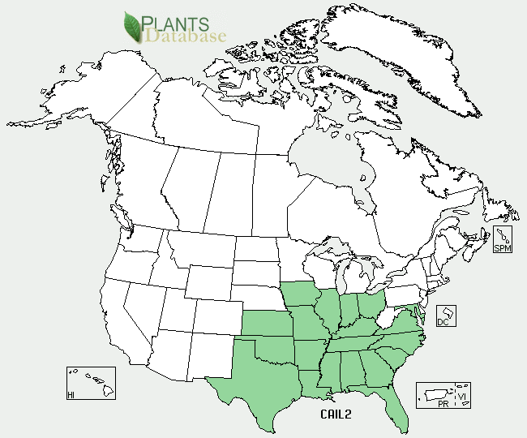

Pecan distribution from USDA-NRCS Plants database

Establishment

Due to stratification requirements for the nut to sprout, establishment is best with nursery grown seedlings which are planted in the fall or early winter. In mass plantings bare root seedlings can be planted by hand or machine. Care should be taken with root placement and planting depth. The root collar should be planted at the same depth as grown in the nursery.

Management

Weed control and fertilization are important considerations for maximizing nut production. Fertility should be added according to a leaf analysis or you can use the rule of thumb of l pound of balanced fertilizer per l inch of trunk diameter. Fertilizer should be applied just prior to bud break. Pecan trees have a high requirement for zinc. Zinc should be applied by foliar application at the beginning of bud break and every 14 days through early summer.

Pests and Potential Problems

Several insects need to be monitored. Insects attacking the nut include; pecan weevil, pecan nut casebearer, and hickory shuck worm. Pecan scab disease is a potential problem.

Environmental Concerns

None

Cultivars, Improved, and Selected Materials (and area of origin)

Numerous cultivars are available for nut production, disease resistance, and adaptability. The USDA Agricultural Research Service names their cultivars after Native American tribes.

Websites

<http://msucares.com/pubs/infosheets/is0439.pdf>

<http://pecankernel.tamu.edu/pecan_insects/pests/index.html>

<http://www.noble.org/Ag/Horticulture/BestPecan/Index.htm>

<http://www.lsuagcenter.com/en/lawn_garden/commercial_horticulture/fruits_nuts/Homeowners+Guide+for+Fertilizing+Pecan+Trees+in+Louisiana.htm>

Prepared By:

*Jim Stevens*

East Texas Plant Materials Center

Nacogdoches, Texas

Species Coordinator:

*M. Kat Anderson*

USDA, NRCS, National Plant Data Center, c/o Plant Science Department, Davis, California

Published: October 2010

Edited: 090107 jsp

For more information about this and other plants, please contact your local NRCS field office or Conservation District <<http://www.nrcs.usda.gov/>>, and visit the PLANTS Web site <[http://plants.usda.gov](http://plants.usda.gov/)> or the Plant Materials Program Web site <<http://plant-materials.nrcs.usda.gov>>

**USDA IS AN EQUAL OPPORTUNITY PROVIDER AND EMPLOYER**