

Plant Fact Sheet

# Prairie sandreed

## Calamovilfa longifolia (Hook.) Scribn.

Plant Symbol = CALO

Contributed by: USDA NRCS Bismarck, North Dakota and Manhattan, Kansas Plant Materials Centers PM Program

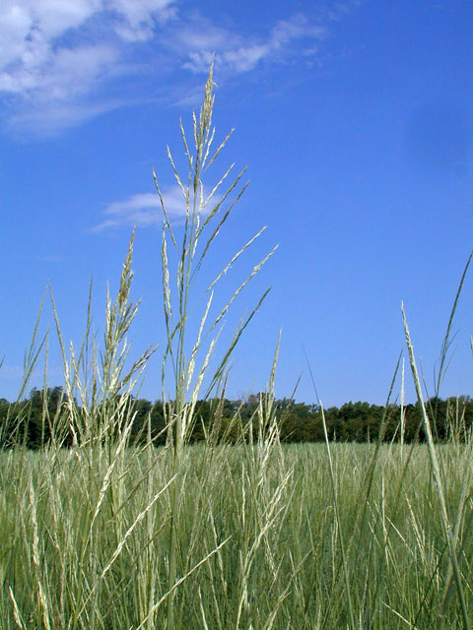

© Mike Haddock Kansas Wildflowers and Grasses

**Alternate Names**

Sand reed, prairie sandgrass, and big sandgrass

### Uses

*Grazing/rangeland/hayland:* Prairie sandreed is a native, sod forming, warm-season grass commonly found on sandy rangeland sites throughout the Central and Northern Plains. This grass species is considered a key species in grazing programs because of its abundance, yield potential and distribution of forage production during the growing season. Prairie sandreed begins growth earlier in the spring than most other warm-season grass species, thus it provides forage for early livestock grazing.

*Wildlife Value:* Prairie sandreed provides fair forage for grazing and browsing wildlife in early spring and summer. The plants forage value increases in importance in late fall and winter as the plant cures well on the stem and provides upright and accessible forage. Seeds are used by songbirds and small rodents.

*Erosion Control:* The rhizomatous growth habit and extensive fibrous root system of this species makes it an excellent stabilizer of sandy sites.

Status

Please consult the PLANTS Web site and your State Department of Natural Resources for this plant’s current status (e.g., threatened or endangered species, state noxious status, and wetland indicator values).

### Description and Adaptation

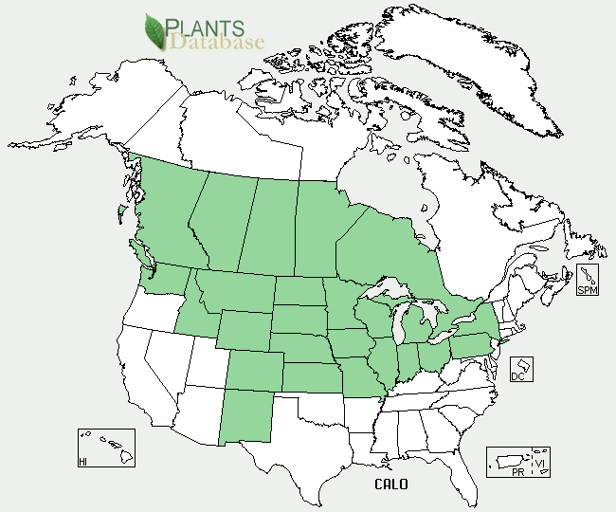

Prairie Sandreed distribution from USDA-NRCS PLANTS Database.

Prairie sandreed is a tall, coarse, stemmy, open, sod forming grass found on sandy soil sites in typically low precipitation zones. Its coarsely fibrous root system augmented by scaly, spreading rhizomes produces an effective sand binding species. Its culms are 3 to 5 feet tall, arising singularly and are attached to its stout spreading rhizomes. Leaves are pale green to straw colored. Leaf blades are rigid, flat to rolled, hairless, 12 inches long or longer and tapered to a drawn out tip. The ligule is short and hairy and the collar is hairy inside. Inflorescence is a panicle 6 to 13 inches long, semi-open and wider in the middle. Spikelets are pale, shiny and one flowered. The lemmas are awnless and densely hairy at the base. It flowers from August to September and like most grasses is wind pollinated.

Prairie sandreed is drought tolerant and adapted to an average annual precipitation of from 10 to 20 inches. It is predominantly found growing in clumps or colonies on coarse, sandy soil types. It will grow on soils that are somewhat alkaline, but it does not tolerate salt. It also is intolerant of high water tables and early spring flooding. Prairie sandreed occurs naturally in mixed native stands with sand bluestem *Andropogon hallii*, little bluestem *Schizachyrium* *scoparium,* and sand lovegrass *Eragrostis trichoides* on sandy range sites. Several shrubs, including yucca, *Yucca glauca,* and sand sage, *Artimesia filifolia,* and a variety of forbs occur intermixed on these sites. It has been found growing on blow out sites in the Nebraska Sandhills.

For updated distribution, please consult the Plant Profile page3 for this species on the PLANTS Web site.

Establishment

Propagation of *Calamovilfa longifolia* can be accomplished by seed and vegetative means. Planting of prairie sandreed should be accomplished with a drill equipped with depth bands to control depth of seeding. Seed should be planted at a depth of 1 inch on coarse textured soils and ½ inch or less on medium to fine textured soils. Seedbed preparation should provide a weed free, firm surface on which to plant. Seedling vigor of this species is only fair and stands develop rather slowly. Seeding rate will vary by region and may be influenced by degree of processing provided by the seed vendor.

### Management

Forage production of ND-95 at Pierre, SD was reported at 5,279 pounds per acre. June and August defoliations of prairie sandreed produced the greatest forage yields over a three year period. Generally concentrations of crude protein decreased with increased maturity of the forage. Dry matter digestibility also declined with advanced maturity of the plant. Prairie sandreed responds positively to early spring burns.

Pests and Potential Problems

Grasshopper infestations can damage seedlings. Gophers have been known to undercut and utilize the forage. Leaf rust, *Puccinia amphigena,* was identified as a potential anti-quality factor in the forage production of prairie sandreed. Prairie sandreed plants with origins in the dryer sections of the Great Plains become increasingly susceptible to rust as they are moved eastward into higher precipitation zones.

### Environmental Concerns

Prairie sandreed does not pose any known negative concerns to the environment. It can form dense colonies on coarse textured soils where it is well adapted. This attribute is often looked at as a positive trait for increasing ground cover which reduces both wind and water erosion on these sites.

### Control

Please contact your local agricultural extension specialist or county weed specialist to learn what works best in your area and how to use it safely. Always read label and safety instructions for each control method.

### Cultivars, Improved, and Selected Materials (and area of origin)

‘Goshen’ prairie sandreed was cooperatively named and released in 1976 by the Soil Conservation Service Plant Materials Center, Bridger, Montana and the Montana and Wyoming Agriculture Experiment Stations. The original germplasm was collected in 1959 near Torrington, Wyoming. It was released without selection and tested under the experimental designation WY-17 and P-15588.

‘Pronghorn’ prairie sandreed was cooperatively released in 1988 by the USDA-ARS, University of Nebraska and the USDA-SCS Manhattan Plant Materials Center, Manhattan, KS. An assembly of 48 accessions was collected in 1968 from Kansas, Nebraska, and South Dakota and established in a field space plant nursery at Manhattan, Kansas. The top ranked accessions from the nursery were provided to L.C. Newell, ARS Agronomist, for further evaluation for vigor, forage production and rust tolerance. Evaluation trials comparing Goshen and Pronghorn revealed that Pronghorn produced stands and forage amounts equivalent to Goshen, but was significantly superior with respect to leaf rust resistance.

ND-95 (Bowman) was selected at the USDA-SCS Plant Materials center, Bismarck, North Dakota. ND-95 is an informal release of materials collected in 1956 from southwestern North Dakota (Bowman County). Seed production is average for the species. Forage production is comparable to Goshen, in the northern U.S., but ND-95 has demonstrated improved performance in parts of Canada. Its dense, wiry root mass makes it well adapted for stabilizing sandy soil.

Koch Germplasm prairie sandreed was released by USDA-NRCS Rose Lake Plant Materials Center and the Michigan Association of Conservation Districts in 2007. Original germplasm was collected from native stands in costal zones along Lakes Michigan and Huron and subjected to three cycles of recurrent phenotypic selection for upright growth habit, seed production, and general vigor.

Prepared By Richard Wynia and Wayne Duckwitz

Citation

Wynia, R. and Duckwitz, W. 2006, Plant fact sheet for Prairie Sandreed (*Calamovilfa longifolia*). USDA-Natural Resources Conservation Service, Manhattan, KS 66502 and Bismarck, ND 58504

Published June, 2006

Edited: 13Apr2011erg;30Jul2007jsp.

For more information about this and other plants, please contact your local NRCS field office or Conservation District <<http://www.nrcs.usda.gov/>>, and visit the PLANTS Web site <[http://plants.usda.gov](http://plants.usda.gov/)> or the Plant Materials Program Web site <<http://plant-materials.nrcs.usda.gov>>

**USDA IS AN EQUAL OPPORTUNITY PROVIDER AND EMPLOYER**