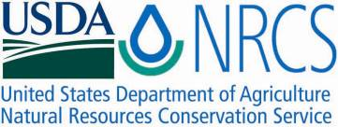

Plant Fact Sheet

# nebraska sedge

## Carex nebrascensis Dewey

Plant Symbol = CANE2

*Contributed by*: USDA NRCS Idaho Plant Materials Program

### nebraska sedge

### Nebraska sedge. Photo by Derek Tilley, USDA-NRCS.

### Uses

*Wildlife and Livestock*: Nebraska sedge is a valuable forage species used by big game and livestock. The annual forage production and nutrient levels are quite high. It has half the protein level of alfalfa. Nebraska sedge provides cover for nesting waterfowl, seeds for small mammals and birds, and muskrats and geese graze the shoots. It can be used as a key species to determine grazing pressure. It has moderate to good palatability early in the season, but becomes tough as the temperatures grow colder during the fall.

*Conservation Uses*: This species has utility for erosion control, constructed wetland system applications, wetland creation and restoration, and for increasing plant diversity in wetland and riparian communities. The dense root mass makes this species resistant to soil compaction and erosion. It also makes it an excellent choice for soil stabilization in wetland and riparian sites. Nebraska sedge is used extensively in bioengineering techniques because of its/the dense root system. The rhizomes also form a matrix for many beneficial bacteria making this plant an excellent choice for wastewater treatment.

### Status

Please consult the PLANTS Web site and your State Department of Natural Resources for this plant’s current status (e.g., threatened or endangered species, state noxious status, and wetland indicator values).

### Description and Adaptation

Nebraska sedge is a native, perennial, heavily rhizomatous wetland plant that is found in low valleys to mid-elevations. It reproduces by rhizomes and seed. However, seedling establishment is rare, probably because it needs freshly deposited, fertile, moist soil. Shoots from rhizomes are produced throughout the growing season and into late fall.

The stems are upright and triangular. The plants growing in saturated soils will grow to about 90 cm (35 in). The leaves are elongated, alternate, longer or shorter than the stem, up to 12 mm (0.5 in) wide, and often with a bluish tinge. The flowers are borne in spikes. Male and female spikes are usually separate and on the same plant (monoecious). One or two male spikes are found above the female spikes. They are narrowly cylindrical and up to 5 cm long. Two to five 1-5 cm (0.39-1.9 in) long female spikes sit below the male spikes with the lowest spike subtended by a leafy bract. Plants flower in June to August.

The fruits are brown lenticular achenes, up to 2 mm (0.08 in) long. Seed ripens in August to September. They are surrounded by a leathery capsule called a perigynium. Perigynia are elliptic to ovate, 3 to 4 mm (0.12 to 0.16 in) long and yellowish brown to light brown in color. The seed (if present) is found in the base of the perigynium. There are approximately 450,000 seeds/lb (with the perigynia still intact), and 800,000 seeds/lb with perigynium removed. The perigynia are not held tightly in the seed heads and high winds and frost will cause the perigynia and seed to drop off.

*Distribution*: Nebraska sedge is common throughout the western Midwest and western United States. For current distribution, consult the Plant Profile page for this species on the PLANTS Web site.

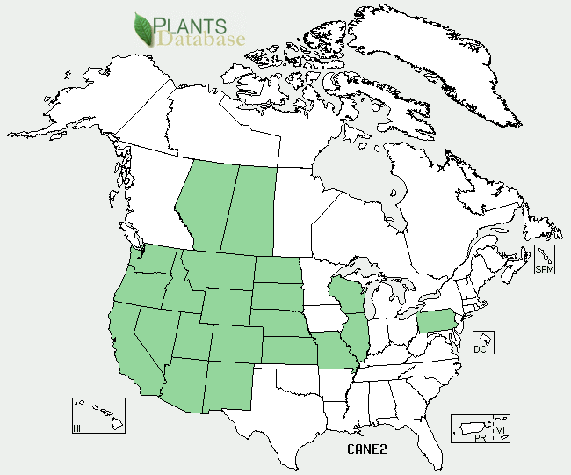

Nebraska sedge distribution from USDA-NRCS PLANTS Database.

*Habitat*: Nebraska sedge is often found in wetland plant communities, in seeps, springs, lakes, canals, and slow moving streams. It will form dense stands, but more often, it is the dominant member of the wetland community. Associated species include water sedge (*C. aquatilis*), common spikerush (*Eleocharis palustris*), cattail (*Typha* spp.), and bulrush (*Schoenoplectus* spp.).

Nebraska sedge tolerates alkaline conditions very well. It is a wetland obligate plant growing in areas that are saturated. It can handle standing water for long periods as long as there are times when the soils are dry. The sites where it is found rarely have the water table drop more than 1 m below the root zone late in the growing season. It can tolerate total inundation for about 3 months.

### Establishment

### Wild plants can be collected and transplanted directly into the desired project site. Care should be taken not to collect plants from weedy areas as these weeds can be relocated to the transplant site and the hole left at the collection site may fill with undesirable species.

For wetland plantings using greenhouse grown transplants or wildings, plant at 15, 30 or 60 cm (0.5, 1.0 or 2.0 ft) spacing for uniform ground cover in 1, 2 and 3 years respectively. Seedlings can be hand-planted or dibbled into moist soil or standing water.

Direct seeding of sedge species in field conditions is largely unsuccessful, because seeding establishment success depends on critical manipulation of water levels. Hydroseeding and broadcasting seed can be marginally successful with proper water control.

**Management**

The soil should be kept saturated with no more than 2.5 to 5.1 cm (1 to 2 in) of standing water until the plants are well established and the aerenchymous material (the above ground biomass) is about 0.3 m (12 in) tall. Fluctuating water levels during the establishment period may improve establishment and spread. Water levels can be managed to enhance rhizome spread and to control weeds.

### Pests and Potential Problems

Few insect or disease problems have been encountered in the greenhouse. Aphids will feed on the stems, but little or no damage has been noted and the vigor of the plant has not been affected.

### Environmental Concerns

Nebraska sedge is native to western North America. It can spread under favorable conditions but does not pose any environmental concern to native plant communities.

### Cultivars, Improved, and Selected Materials (and area of origin)

There are no cultivars, improved, or selected materials of Nebraska sedge. Common wildland collected seed is available from commercial sources.

### Prepared By

### Derek Tilley, USDA NRCS Plant Materials Center, Aberdeen, ID

Loren St. John, USDA NRCS Plant Materials Center, Aberdeen, ID

### Citation

Tilley, D. and L. St. John. 2012. Plant Fact Sheet for Nebraska sedge (*Carex nebrascensis)*. USDA-Natural Resources Conservation Service, Aberdeen Plant Materials Center. Aberdeen, Idaho 83210.

Published January 2013

Edited: 17dec2012djt; 17dec2012ls; 10Jan2013jab

For more information about this and other plants, please contact your local NRCS field office or Conservation District <<http://www.nrcs.usda.gov/>>, and visit the PLANTS Web site <[http://plants.usda.gov](http://plants.usda.gov/)> or the Plant Materials Program Web site <<http://plant-materials.nrcs.usda.gov>>

**USDA IS AN EQUAL OPPORTUNITY PROVIDER AND EMPLOYER**