|  |
| --- |
| halfshrub sundrop |
| *Calylophus serrulatus* (Nutt.) Raven |
| Plant symbol = CASE12 |

Contributed by: USDA NRCS James E. “Bud” Smith Plant Materials Center, Knox City, Texas

Alternate Names

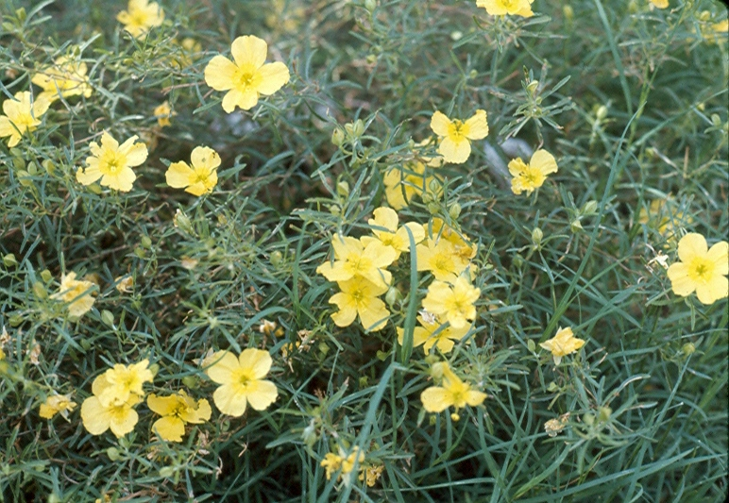

Lynn Pace

Texas Parks and Wildlife

Yellow evening primrose, buttercup, and yellow sundrop

Uses

Halfshrub sundrop is very palatable for livestock and deer in range and pasture land. It is an attractive wildflower in landscape uses in rock gardens and meadows. Halfshrub sundrop can grow in gardens in part shade and full sun.

Status

Please consult the PLANTS Web site and your State Department of Natural Resources for this plant’s current status (e.g. threatened or endangered species, state noxious status, and wetland indicator values).

Description and Adaptation

Evening Primrose family (Onagraceae). Halfshrub sundrop is a native, perennial, warm-season subshrub, shrub forb/herb which is more upright, bushy, and with numerous branches. Halfshrub sundrop grows into a large clump and up to 18 inches in height. The narrow leaves are 3 ½ inches long and alternate from each other with toothed leaf margins. Each small yellow flower has four petals up to 1 ½ inches across which includes the pistils (female organs) and eight prominent stamens (the male organs). The flowers tube is usually no more than 1 inch long. The flowers open in early morning and close in late afternoon and blooms from March to November. The old flowers can turn orange or pink and the plant leaves may stay green in mild winters.

The mature fruit is a cylindrical capsule shape with small seeds enclosed.

Adaptation

Halfshrub sundrop occurs throughout Texas except in East Texas Piney woods and infrequent in open sandy or rocky places in the Panhandle and north-central Texas. Its range extends from Saskatchewan, Montana, Minnesota, Wisconsin, Oklahoma, Colorado, New Mexico, eastern-central Arizona, and south to Mexico. Halfshrub sundrop grows in clay and sandy loams, caliche, limestone, gypsum, and in well drain-soils. Established plants are extremely drought and heat tolerant.

Establishment

Halfshrub sundrop seed should be seeded early in the spring. Seed either by broadcasting or use grass drill equipped with a slick seed box. Mix seed with some type of carrier such as sand, if needed for proper distribution. Seeding at a depth of ¼ inch in a well prepared seedbed is sufficient. Broadcasting the seeds on uneven soil surface in pastures or rangelands can work. The halfshrub sundrop seeds could be included in a grass mix for pastures or rangelands.

Management

Halfshrub sundrop needs to be properly managed, because it can be eliminated by livestock or deer. If the fruit capsule is allowed to mature and seed fall to the ground, it can germinate in ten to fifteen days with proper conditions, such as moisture and warm soils. Harvesting seed with a combine can be difficult due to indeterminate inflorescence.

Pests and Potential Problems

No serious pests or diseases were observed.

Cultivars, Improved, and Selected Materials (and area of origin)

There are currently no cultivars of halfshrub sundrop in commercial production.

Prepared By and Species Coordinator:

*Rudy G. Esquivel*, USDA NRCS Plant Materials Center, Knox City, Texas

Edited: 23mar2006 jsp

For more information about this and other plants, please contact your local NRCS field office or Conservation District, and visit the PLANTS Web site<<http://plants.usda.gov>> or the Plant Materials Program Web site <<http://Plant-Materials.nrcs.usda.gov>>

*The U.S. Department of Agriculture (USDA) prohibits discrimination in all its programs and activities on the basis of race, color, national origin, sex, religion, age, disability, political beliefs, sexual orientation, and marital or family status. (Not all prohibited bases apply to all programs.) Persons with disabilities who require alternative means for communication of program information (Braille, large print, audiotape, etc.) should contact USDA's* [*TARGET Center*](http://www.usda.gov/oo/target.htm) *at 202-720-2600 (voice and TDD).*

*To file a complaint of discrimination write USDA, Director, Office of Civil Rights, Room 326-W, Whitten Building, 14th and Independence Avenue, SW, Washington, DC 20250-9410 or call 202-720-5964 (voice or TDD). USDA is an equal opportunity provider and employer.*

*Read about* [*Civil Rights at the Natural Resources Convervation Service*](http://www.nrcs.usda.gov/about/civilrights/)*.*