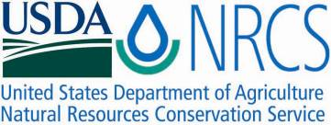

Plant Fact Sheet

# american bittersweet

## Celastrus scandens L.

Plant Symbol = CESC

Contributed by: USDA NRCS Plant Materials Program

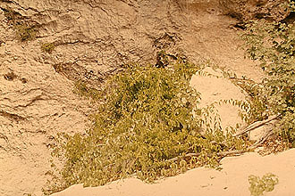

USDA NRCS PLANTS

**Alternate common names**

Climbing bittersweet, false bittersweet, climbing orange-root, fever-twig, fever-twitch, staff-vine, Jacob’s-ladder

Uses

The climbing growth habit of American bittersweet makes it a valuable ornamental plant both outdoors and indoors. It is easily trained to climb walls, trellises, and fences. When added to existing shrub plantings, this twining vine produces excellent wildlife cover and aids in erosion control as well. The berry-like fruit provides winter food for wildlife species such as grouse, pheasant, quail, rabbit, and squirrel.

Status

**Warning: American bittersweet fruit is toxic when taken internally. All parts of the plant may be toxic.**

Please consult the PLANTS Web site and your State Department of Natural Resources for this plant’s current status (e.g. threatened or endangered species, state noxious status, and wetland indicator values).

### Description and Adaptation

Bittersweet is a twining vine that, if permitted to ascend trees or poles, may reach heights of 30 feet, although it generally grows close to the ground. The leaves are alternate, dark green, oval shaped, and turn yellow before dropping in the fall. It is often confused with oriental bittersweet, which is a weedy pest. Oriental bittersweet (Celastrus orbiculata) can reach much greater heights than American bittersweet and produces much more seed. As a result it tends to dominate woody vegetation and should not be used. American bittersweet has been aggressive on some sites, and should be used with caution. Oriental bittersweet is distinguished from American bittersweet by leaves that are rounded at the tip, whereas those of the native species are pointed. Also, fruit of oriental bittersweet are few per stalk and close to the stem. American has several seeds on stalks that extend out beyond the leaves.

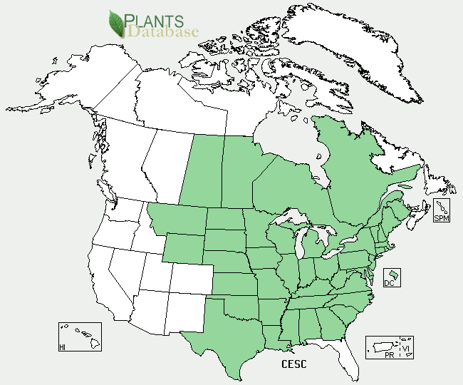

American Bittersweet distribution, from PLANTS database

American bittersweet tolerates diverse climatic conditions, but prefers a neutral soil and a sunny location. It occurs throughout the Northeast and Mid-Atlantic region.

For a current distribution map, please consult the Plant Profile page for this species on the PLANTS Website.

Establishment

Two year old nursery seedlings should be used for planting banks and other large areas. Container-grown plants are ideal for ornamental plantings. Clear at least a one square foot area around the newly established plant to reduce competition.

Management

Because of its aggressive nature, do not plant in areas where it may easily climb favorable trees. Bittersweet can be controlled by allowing deer and rabbits to browse the plants (this only works for young plants) and by herbicides and hand removal.

Prepared By & Species Coordinator:

USDA NRCS Northeast Plant Materials Program

Edited: 01Feb2002 JLK; 01jun06 jsp; 21oct13nm

Published February 2002

### Citation

USDA-NRCS Plant Materials Program. 2002. Plant fact sheet for American bittersweet (*Celastrus scandens* L.*)*. USDA-Natural Resources Conservation Service, Plant Materials Program. Beltsville, MD 20705

For more information about this and other plants, please contact your local NRCS field office or Conservation District <<http://www.nrcs.usda.gov/>>, and visit the PLANTS Web site <[http://plants.usda.gov](http://plants.usda.gov/)> or the Plant Materials Program Web site <<http://plant-materials.nrcs.usda.gov>>

.

**USDA IS AN EQUAL OPPORTUNITY PROVIDER AND EMPLOYER**