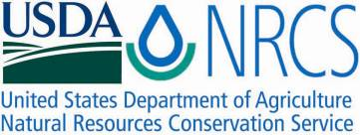

Plant Fact Sheet

# farewell to spring

## Clarkia amoena (Lehm.) A. Nelson & J.F. Macbr.

Plant Symbol = CLAM

*Contributed by: USDA NRCS Corvallis Plant Materials Center, Oregon*

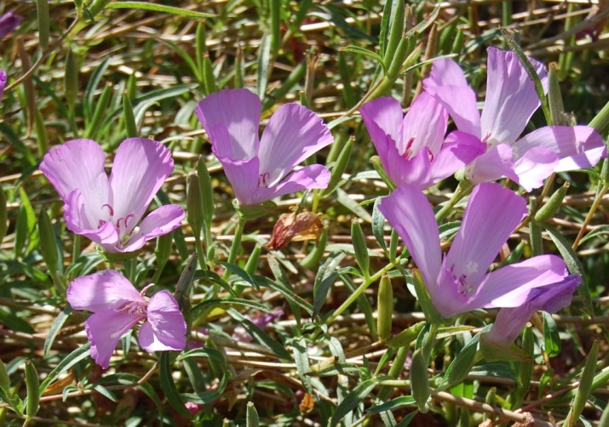

Photo by A. Young-Mathews, Corvallis Plant Materials Center, 2011

### Alternative Names

*Alternate Common Names:* farewell-to-spring, summer’s darling, herald-of-summer, atlas flower, lovely farewell-to-spring, Rocky Mountain garland flower, godetia, satin flower, red ribbons, fairy fans

*Alternate Scientific Names: Godetia amoena* (Lehm.) G. Don, *Oenothera amoena* Lehm., *Oenothera prismatica* var. *amoena* (Lehm.) H. Lév.

### Uses

*Ornamental:* As the Latin name suggests (*amoena* meaning beautiful or pleasing), this plant makes a beautiful addition to many types of gardens including beds, borders, containers, dry banks, cottage gardens, rock gardens and wildflower meadows. The flowers make excellent, long-lasting bouquets.

*Pollinators*: Flowers serve as a nectar source for European honey bees, as well as native bumble bees, mason bees, butterflies and other beneficial insects. Farewell to spring is often included in native wildflower mixes for bee and butterfly meadows or gardens, and should be planted in patches at least 3 to 6 ft in diameter for best attraction.

*Ethnobotanic: Clarkia amoena* seeds were parched and then pounded into a dry seed meal and eaten by the Sierra Miwok in the Sierra Nevada foothills of California.

### Status

Please consult the PLANTS Web site and your State Department of Natural Resources for this plant’s current status (e.g., threatened or endangered species, state noxious status, and wetland indicator values).

### Description and Adaptation

Farewell to spring, a member of the evening primrose family (Onagraceae), is a common, native, annual wildflower that grows ½ to 3 feet tall. Stems are upright to spreading, leafy, covered in fine, short hairs, somewhat grayish-green, often reddish below, and may be branched or simple. The alternate leaves are linear to lance-shaped, usually 1 to 3 inches long, smooth-edged, with lower leaves often falling by flowering time, while the upper leaves are more persistent and often folded. The flowers are single or in open to dense inflorescences with buds held erect. Flowers are cup-shaped, pale pink to deep wine red, and have four petals that are usually less than 1½ inches long, with more or less notched edges, often with a crimson to scarlet or purplish marking in their center. Flowers have eight stamens and a single pistil with a 4-lobed stigma. Flowering period is late spring to mid-summer. Fruits are long, narrow, straight to curved, pod-like dry capsules ¼ to 1½ inches long that ripen in the fall. There are five generally recognized subspecies of C. amoena, although intermediates among subspecies are common: Hunt’s clarkia (C. a. ssp. huntiana), Lindley’s clarkia (C. a. ssp. lindleyi), northwestern farewell to spring (C. a. ssp. caurina), Whitney’s clarkia (C. a. ssp. whitneyi), and farewell to spring (C. a. ssp. amoena).

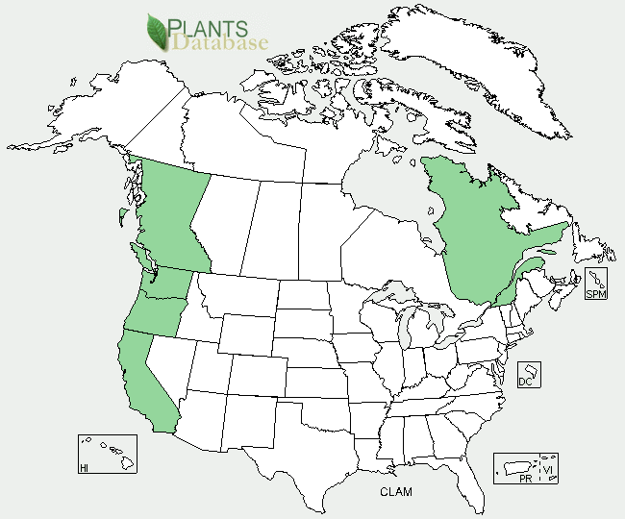

Farewell to spring distribution from USDA-NRCS PLANTS Database.

Farewell to spring prefers relatively dry, open slopes but is also found in meadows, prairies, seaside bluffs, coastal scrub, forest edges, roadsides and spring-wet areas. Plants grow best in full sun to light shade and well-drained to dry soil, but also tolerate seaside conditions, alkaline soil, salt, sand and clay. This species’ native distribution ranges from southern British Columbia west of the Cascades south to the coast of central California and east in the Columbia River Gorge at elevations below 3000 ft, but it also has been introduced in Quebec. For updated distribution, please consult the Plant Profile page for this species on the PLANTS Web site.

### Establishment

Plants are easily established from seed by direct sowing on site in the fall or early spring. They can also be sown in flats of potting soil indoors and planted out at a spacing of 6 to 12 inches after the last frost date in the spring, but plants will generally be sturdier if direct-seeded. Seeds do not require pre-treatment, and should be surface broadcast onto a firm, well-drained, weed-free seedbed at a rate of approximately 2 pounds per acre. Soils should not be over-fertilized or the plants will produce abundant, leggy foliage and few blooms. There are approximately 816,000 to 1,100,000 seeds per pound, so sowing one pound of seed per acre will result in 19 to 25 seeds per square foot.

### Management

This species is drought-tolerant and requires little maintenance once established. In a suitable location the plants will readily self-sow.

### Pests and Potential Problems

There are no serious pest or disease problems, though plants are susceptible to powdery mildew, verticillium wilt, stem rot and leaf spot, as well as aphids, mites and Japanese beetles.

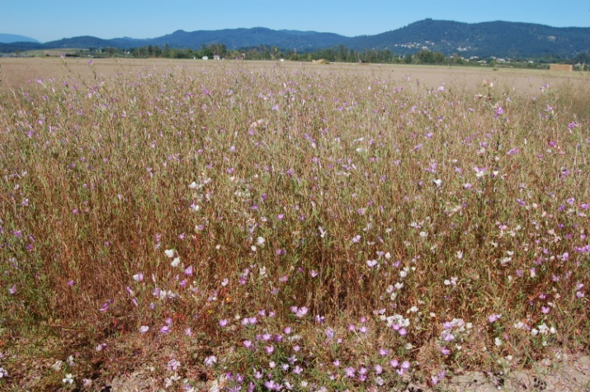

Field of farewell to spring flowering in Corvallis, OR in August, 2011.

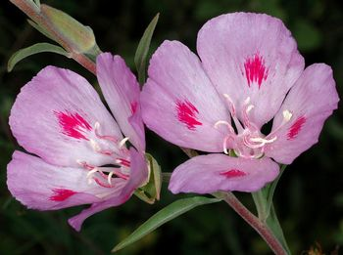

Clarkia amoena ssp. lindleyi, © 2006, G.D. Carr

### Environmental Concerns

Farewell to spring readily self-sows, so blooms should be deadheaded if you do not want volunteer seedlings the next season.

### Cultivars, Improved, and Selected Materials (and area of origin)

Seed of farewell to spring is widely available from commercial sources. There are at least a dozen improved horticultural cultivars on the market that range in color from white to peach to deep magentas, and include dwarfs and some cultivars selected for leafier plants or highly dissected petals giving them a semi-double appearance. Flowers of improved cultivars are often larger and more abundant than those of wild ecotypes.

### Prepared By

*Annie Young-Mathews,* Conservation Agronomist

USDA-NRCS Corvallis Plant Materials Center, Oregon

### Citation

Young-Mathews, A. 2012. Plant fact sheet for farewell to spring (*Clarkia amoena)*. USDA-Natural Resources Conservation Service, Corvallis Plant Materials Center, Corvallis, OR.

Published October 2012

Edited: 25Jan2012 dcd; 17Apr2012 jab; 27Apr2012 dhg

For more information about this and other plants, please contact your local NRCS field office or Conservation District <<http://www.nrcs.usda.gov/>>, and visit the PLANTS Web site <[http://plants.usda.gov](http://plants.usda.gov/)> or the Plant Materials Program Web site <<http://plant-materials.nrcs.usda.gov>>

**USDA IS AN EQUAL OPPORTUNITY PROVIDER AND EMPLOYER**