

Plant Fact Sheet

|  |
| --- |
| ERECT DAYFLOWER |
| ***Commelina erecta* var. angustifolia (Michx.) Fern.** |
| plant symbol = COERA |

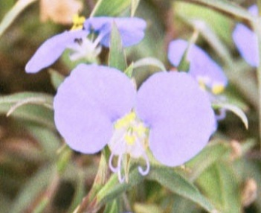Contributed by: USDA NRCS Kika de la Garza Plant Materials Center

##### Alternate Names

whitemouth dayflower, widow’s tears, narrowleaf dayflower, and hierba del pollo

##### Erect dayflower in bloom

##### Uses

*Wildlife:*  Erect dayflower (*Commelina erecta* var. angustifolia) is said to be a preferred food source for white-tailed deer, so it is a good plant to consider when establishing deer food plots. In addition, bobwhite quail, white-winged doves and mourning doves eat its seeds.

*Restoration:* Erect dayflower can also be a good plant for native area restoration projects.

*Forage:* Cattle are known to graze erect dayflower.

##### Status

Please consult the PLANTS Web site and your State Department of Natural Resources for this plant’s current status (e.g. threatened or endangered species, state noxious status, and wetland indicator values).

##### Description

Erect dayflower is a perennial, warm-season, herbaceous forb. A member of the spiderwort (Commelinaceae) family, erect dayflower has also

been known by the common names of widow’s tears, narrowleaf dayflower, and hierba del pollo. According to Ajilvsgi (1991), erect dayflower is said to be named for the three Commelin brothers who were all Dutch botanists, although only two were productive in their field. Erect dayflower’s two larger petals are said to represent the two Commelins who were published, while the third inconspicuous petal represents the unpublished brother.

Erect dayflower has a showy blue flower that is attractive, but ephemeral (lasting only a day) and blooms from March to December in Texas. Erect dayflower starts out erect, becoming decumbent as it matures. There are currently three varieties that are found in Texas: erecta, deamiana, and angustifolia. The variety angustifolia is native to South Texas. Erect dayflower is often considered a weed, especially in rice fields.

##### Adaptation

Erect dayflower can be found from Wisconsin south to Arizona and Florida, west to Wyoming, and throughout most of the eastern United States. It is common in the eastern two-thirds of Texas, but can be found throughout the state. Erect dayflower can grow in both sandy and clayey soils in almost all habitats. It is found along streambanks, in gardens, on prairies, along roadsides, and in waste places.

##### Known Distribution

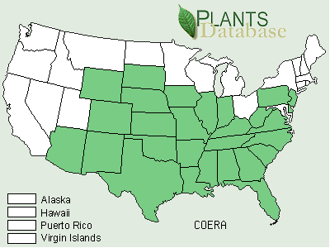

##### Establishment

Erect dayflower can be grown from cuttings or seed. An informal germination test conducted in the greenhouse at the PMC yielded a germination average of 87% with approximately twelve hours of daylight at 75-85ºF and twelve hours of darkness at 50-60ºF. Cuttings of dayflower had about an 80% survival rate with one node and three node stem cuttings. It is recommended that a rooting hormone be used to encourage rapid rooting. Cuttings and seedlings can be transplanted in 6-8 weeks. Irrigation is recommended, although not critical, at drier sites to help the young plants get established. It is recommended that young plants be at least 6 inches in height before transplanting.

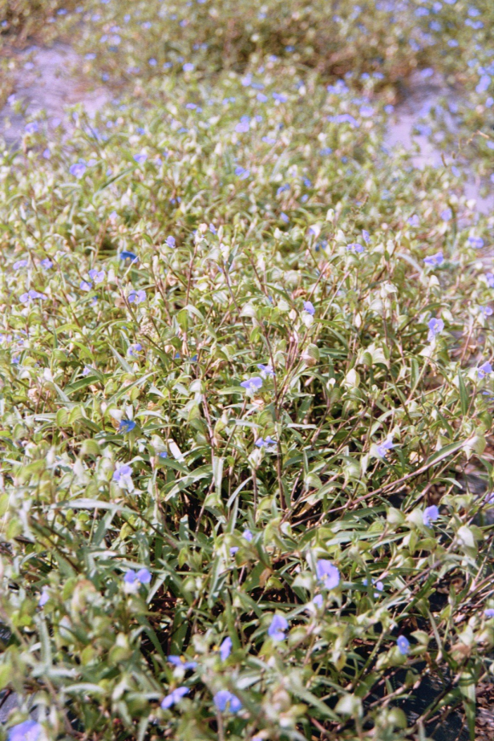

The use of plastic plant shelters is beneficial to protect young plants from heavy grazing, reduce plant competition, and create a more beneficial microclimate until young plants can get established.

##### Management

Weed control is a problem in a dayflower plot as the leggy plants make it difficult to remove the weeds without removing the plants. A weed mat is recommended for situations, such as seed or plant production plantings, where weed control is a necessity. In other situations, such as deer food plots, weed control may not be an issue. Irrigation is recommended during drier periods for seed and plant production plantings.

The seed of erect dayflower is easy to process once harvested. However, the prostrate and indeterminate growth form of erect dayflower results in harvests of very small quantities of seed. This makes commercial production of large quantities of seed uneconomical, and limits its use for large-scale seeding and plantings.

##### Prepared By & Species Coordinator:

*John Lloyd-Reilley*, Manager

*Elizabeth Kadin*, Research Assistant

*Shelly D. Maher*, Research Scientist

Kika de la Garza Plant Materials Center

Kingsville, Texas

Published: October 2002

Edited: 1Oct2002 SDM

For more information about this and other plants, please contact your local NRCS field office or Conservation District <<http://www.nrcs.usda.gov/>>, and visit the PLANTS Web site <[http://plants.usda.gov](http://plants.usda.gov/)> or the Plant Materials Program Web site <<http://plant-materials.nrcs.usda.gov>>

.

**USDA IS AN EQUAL OPPORTUNITY PROVIDER AND EMPLOYER**