|  |
| --- |
| gray dogwood |
| *Cornus racemosa* Lam. |
| Plant Symbol = CORA6 |

Contributed by: USDA NRCS Plant Materials Program

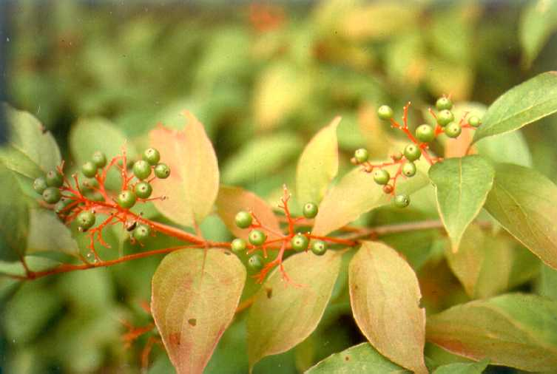

Chris Miller

USDA NRCS Plant Materials Program

Uses

Gray dogwood is useful as a low-growing wild hedge which provides summer food and some cover for small animals and birds.

Status

Please consult the PLANTS Web site and your State Department of Natural Resources for this plant’s current status (e.g. threatened or endangered species, state noxious status, and wetland indicator values).

Description

*Cornus racemosa* Lam, gray dogwood, is a thickly branched, slow growing dogwood seldom more than 6 feet high at maturity. Its flowers, which bloom in June or July, are white and loosely clustered, and its white fruit, which appears in September and October, is set off by bright red fruit-stalks. Its leaves are opposite, taper-pointed and oval.

Adaptation

Gray dogwood has a range of adaptability equaled by few other shrubs, and it tolerates many climatic conditions. Tolerance to shade is considered intermediate. It is not well adapted tocoastalplain conditions.

Gray dogwood is distributed throughout the northeastern United States. For a current distribution map, please consult the Plant Profile page for this species on the PLANTS Website.

Establishment

Only seedlings of gray dogwood are practical. All should be planted as early in the spring as possible. When using dogwood for streambank planting, eroded or steep banks should be graded before planting. Plant in the early spring with dormant planting stock. Planting after May will severely reduce chances for success. One-year rooted cuttings or seedlings can be planted vertically into the bank with one or two inches of cutting wood protruding. They should be stuck in a hole large enough to accommodate the root system when well spread. The soil must be tamped well around the roots. Fresh, unrooted hardwood cuttings, easier to handle but less reliable, should be stuck vertically into the bank, leaving one to two inches above ground. A dibble can be used to make a hole. Tamp adequately to provide complete contact between the cutting and the soil. Cuttings may also be buried horizontally two inches deep in damp soil, if the ground is stony. Fresh hardwood cuttings, 3/8 to 1/2 inch at the thick end, 9 inches long, and made while dormant, are ideal. Without cold storage, planting should be doneas soon as possible after cutting. Plant both rooted cuttings and unrooted hardwood cuttings on 2 feet spacing in a diamond pattern.

When using for wildlife or screening purposes, the planting site should be cultivated to destroy existing vegetation. If not, the sod should be removed from an area two feet across for each plant. The holes should be deep enough to allow for the full extension of the roots. Spacing for hedges and screens should be staggered and 2 x 2 feet, and 4 to 5 feet for windbreaks. A small handful of fertilizer can be placed around each plant.

Management

Dogwoods used on streambanks are subject to mechanical damage. The site should be inspected annually for needed repairs in the spring after heavy runoff or ice floes. Fill in gaps by replanting or by laying down and covering branches of nearby plants. Any mechanical measures used to control the bank, such as riprap, must be kept in repair to maintain effective protection.

Competing vegetation should be controlled around all dogwood plants used for hedges, screens, etc. This is particularly important during the first few years after planting.

Pests and Potential Problems

There are currently no serious pests of gray dogwood.

Cultivars, Improved, and Selected Materials (and area of origin)

No cultivars are available at this time, however common seedlings are available at most commercial hardwood nurseries.

Prepared By & Species Coordinator:

USDA NRCS Plant Materials Program

Edited: 01Feb2002 JLK; 25may06jsp

For more information about this and other plants, please contact your local NRCS field office or Conservation District, and visit the PLANTS Web site<<http://plants.usda.gov>> or the Plant Materials Program Web site <<http://Plant-Materials.nrcs.usda.gov>>

*The U.S. Department of Agriculture (USDA) prohibits discrimination in all its programs and activities on the basis of race, color, national origin, sex, religion, age, disability, political beliefs, sexual orientation, and marital or family status. (Not all prohibited bases apply to all programs.) Persons with disabilities who require alternative means for communication of program information (Braille, large print, audiotape, etc.) should contact USDA's* [*TARGET Center*](http://www.usda.gov/oo/target.htm) *at 202-720-2600 (voice and TDD).*

*To file a complaint of discrimination write USDA, Director, Office of Civil Rights, Room 326-W, Whitten Building, 14th and Independence Avenue, SW, Washington, DC 20250-9410 or call 202-720-5964 (voice or TDD). USDA is an equal opportunity provider and employer.*

*Read about* [*Civil Rights at the Natural Resources Convervation Service*](http://www.nrcs.usda.gov/about/civilrights/)*.*