

Plant Fact Sheet

# May Hawthorn

## Crataegus aestivalis Walt.

Plant Symbol = CRAE

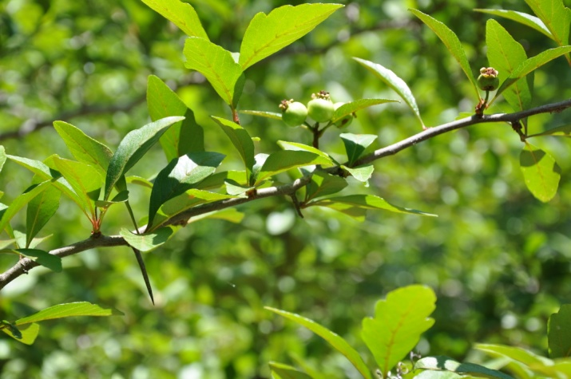

Contributed by: East Texas Plant Materials Center

### Alternative Names

Eastern May Hawthorn, Apple May Hawthorn, Summer Haw and Mayhaw

### Uses

Food:

The fruit is frequently used for preserves and jellies and can also be dried for later use.

Erosion control:

Can be used in shelter belts and stream- bank stabilization.

Wildlife:

Provides nesting sites and cover for small birds. Birds and small mammals eat the fruit. Whitetail deer browse the leaves and young stems.

Timber:

The wood is heavy and strong but is too small for commercial use. Eastern May Hawthorn wood is used locally for tool handles and mallets.

Medicinal:

It has been used as a tea in herbal folk medicine for treatment of high blood pressure.

Landscaping:

In recent years this plant has become popular with home and commercial landscapers due to the plant’s showy white flowers, attractive foliage and ability to adapt to a variety of sites.

### Status

Please consult the PLANTS Web site and your State Department of Natural Resources for this plant’s current status (e.g., threatened or endangered species, state noxious status, and wetland indicator values).

### Description and Adaptation

Description: A member of the Rosaceae family, the May Hawthorn is a deciduous, small, round- topped tree growing to 30 feet in height. Leaves are dark green, simple, and are alternately arranged.. Flowers are white and produced either singly or in clusters of 2 or 3.The fruit is a fleshy, red pome borne in May, contributing to the common name “Mayhaw”. Twigs are brown to gray and spiny.

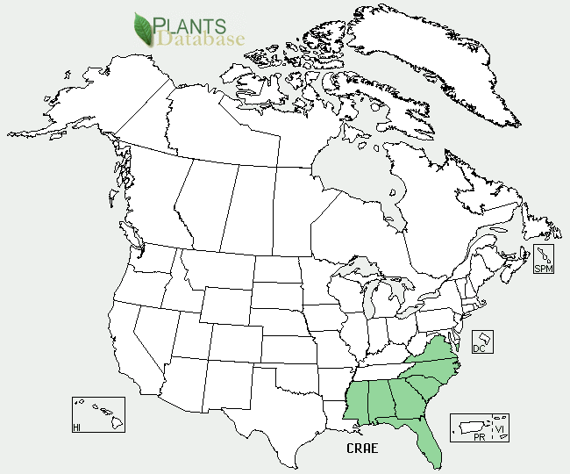

May Hawthorn distribution from USDA-NRCS PLANTS Database.

Adaptation: While preferring full sun, Eastern May Hawthorn will tolerate partial shade. Once established it will also tolerate wet soils and drought conditions. It will grow in a variety of soil types, but preferring well drained, slightly acid soils. Their tolerances to air pollution make it a good choice for urban sites.

For updated distribution, please consult the Plant Profile page for this species on the PLANTS Web site.

### Establishment

Under natural conditions Eastern May Hawthorn seeds do not germinate until overwintered. Successful seed germination requires acid stratification followed by warm stratification and chilling. Propagation can also be done using softwood stem cuttings rooted under an intermittent mist. The use of a rooting hormone will increase rooting success.

Propagation from hardwood and root cuttings is also possible. Grafting to English Hawthorn (*Crataegus oxyacantha* or Single Seeded Hawthorn (*Crataegus monogyna* rootstock is possible but should be done in winter or early spring.

### Management

Annual pruning in the winter to open up the tree canopy will be beneficial in increasing fruit production. In addition weak branches and sucker stems should be removed at this time.

### Pests and Potential Problems

May Hawthorn is susceptible to some of the same insects and diseases that attack other pome fruits. These include insects such as the hawthorn lace bug and roundheaded appletree borer along with leafminers and mealy bugs. Diseases affecting May Hawthorn include fire-blight, cedar-hawthorn blight, cedar quince blight and fruit rot.

### Cultivars, Improved, and Selected Materials (and area of origin)

Commercially available Crataegus aestivalis include:

Lori -80% harvest at one time and Linsey also with concentrated ripening.

### Prepared By

Michael Woody Biological Science Technician, East Texas Plant Materials Center, Nacogodoches Texas

### Citation

Woody, Michael L. 2012. Plant fact sheet for May Hawthorn (*Crataegus aestivalis)*. USDA-Natural Resources Conservation Service, East Texas Plant Material Center. Nacogdoches, Texas, 75964.

Published January 2012

For more information about this and other plants, please contact your local NRCS field office or Conservation District <<http://www.nrcs.usda.gov/>>, and visit the PLANTS Web site <[http://plants.usda.gov](http://plants.usda.gov/)> or the Plant Materials Program Web site <<http://plant-materials.nrcs.usda.gov>>

**USDA IS AN EQUAL OPPORTUNITY PROVIDER AND EMPLOYER**