|  |
| --- |
| California oatgrass |
| *Danthonia californica* Bolander |
| Plant Symbol = DACA3 |

Contributed by: NRCS Plant Materials Center, Corvallis, Oregon

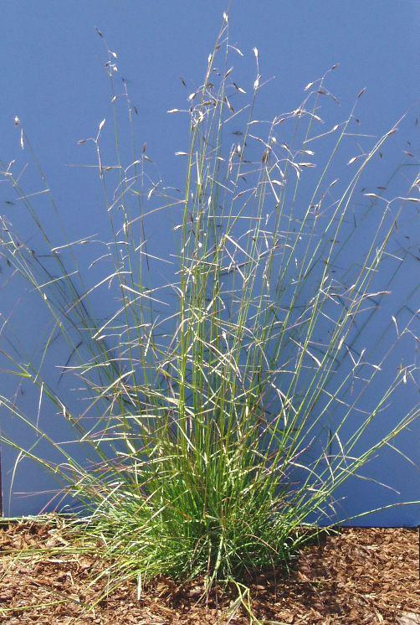

Alternate Names: Another common name is California danthonia. Synonyms include *Danthonia americana* and four botanical varieties: *americana*, *californica*, *palousensis*, and *piperi*.

**Uses:** California oatgrass is recommended for revegetation, wildlife plantings, and restoration of oak savannas, transitional wetlands, and upland prairies, especially in the Pacific Coast states. The species is valuable for enhancing biodiversity by exhibiting a spatial distribution compatible with forbs and improving habitat for feeding, nesting, and hiding by songbirds. It is a definitive component of certain prairies that form critical habitat for other endemic organisms including sensitive butterflies and beetles. The foliage is eaten by certain caterpillars and the grains are consumed by birds and mammals.

As a rangeland plant, California oatgrass is well utilized by livestock. Prior to maturity, it is rated as good to very good forage for cattle and horses in the Pacific Coast states, but less palatable for sheep and goats. Ratings are lower for eastern, drier portions of its natural range. Plants withstand heavy grazing but can be overgrazed leading to their depletion. Protein analysis is high and stands have formed that are dense enough for haying. Other potential uses include cover and erosion control in vineyards, young orchards, and parks, as well as along trails. As a candidate for native lawn, this species can be mowed to maintain a turf-like stand. It takes heavy foot traffic, trampling, and moderate summer moisture stress and can act as a stay-green firebreak.

**Description:** California oatgrass is a long lived perennial bunchgrass with stems (culms) that grow 30-100 cm tall and separate at the lower nodes (joints) upon maturity. The leaf sheaths are smooth to densely hairy. Leaves are both basal and attached to the stem. The upper blades are flat to in-rolled and spreading to abruptly bent with distinct spreading hairs where they meet the stem. The panicle (seed head) flowers between May and early July and is 3-8 cm long, loose, and open with 1-6 broadly spreading spikelets. Awns (linear appendages) on the seed are abruptly bent and 4-12 mm long. Seed is produced both in the terminal panicle and at the lower nodes enclosed (hidden) within the leaf sheaths of the stem. California oatgrass can be confused with timber oatgrass (*Danthonia intermedia*), poverty oatgrass (*D. spicata*), and one-spiked oatgrass (*D. unispicata*) but all three have more erect, compact panicles with the latter having a single spikelet in the seed head.

**Adaptation:** California oatgrass occurs naturally from British Columbia to southern California and eastward through the Rocky Mountain States and Provinces. Broadly adapted, it is a minor to dominant constituent of numerous woodland, shrubland, grassland, and transitional wetland habitats. The species is found on a wide array of soils types from excessively drained sandy loams to less permeable silts and clays and from relatively infertile sites to rich, moist bottomland. While it inhabits summer dry sites such as steep, sunny south and west slopes, shallow rocky outcrops, and serpentine soils (soils high in magnesium, iron, and certain heavy metals and deficient in other nutrients), as well as seasonally flooded wetlands, arid sites do not support it. The species occurs within the following ranges: elevation 0-7200 ft, annual precipitation 17 to 79 inches, and soil pH 5.5 to 8. Ratings are relatively low for fertility requirement, salinity tolerance, deer resistance, and shade tolerance, variable for drought resistance, and high for fire resistance and wildlife value. It has special adaptations for disturbance prone ecosystems.

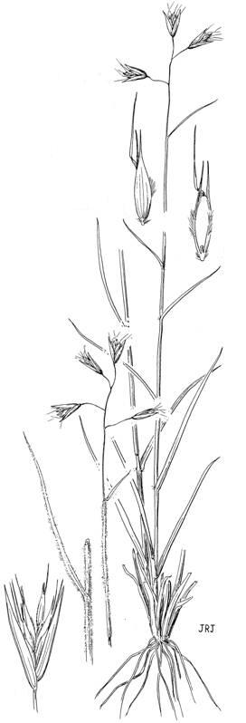

Reprinted with permission,

Univ. of Washington Press

Environmental concerns: California oatgrass is not considered to be weedy within its natural range. However, because of seed dormancy and latent seed in the soil, individuals may continue to sporadically emerge several years after stand removal. No toxic properties for domestic livestock, wildlife, or humans have been reported. The species has few significant pests but is one of many hosts for blind seed disease (*Gloeotinia temulenta*), a potentially serious pest in ryegrass (*Lolium* spp.) fields grown for seed.

**Establishment:** Growing California oatgrass from seed can be problematic as the result of delayed or sporadic germination and moderately slow seedling development combined with early competition from other species. The variable germination rates are the result of either a seed coat imposed dormancy, physiological (embryo) dormancy, no dormancy, or a combination of all three. To determine the amount of dormancy in a seed lot, both a TZ (tetrazolium) test for viability and germination test should be run. The difference between the two indicates the amount of dormancy. To overcome high dormancy, good germination will require fall sowing to cold moist stratify the seed outdoors over winter (alternatively, moist stratify in a cooler for 30-120 days at 1-4°F), scarification of the seed coat to weaken it, or both. Proven methods of scarification (sulfuric acid treatment, abrasion with sandpaper, use of a huller-scarifier or brush machine) each have their limitations. Hull removal (dehulling) and awn removal are coincidental to the process. Mechanical methods must be gentle enough to prevent damage to the seed embryo. An oat huller may be an option.

Keys to establishment for revegetation and other purposes are preplant weed control and proper seedbed preparation such as 1-3 years of fallow. Besides tillage and herbicides, site preparation methods and weed and stand management options include prescribed fire, grazing, mowing, or combinations thereof. The most successful stands are often achieved by sowing the seed alone rather than in a mix, succeeded by the use of a nonselective herbicide such as glyphosate to kill new weeds before the California oatgrass seedlings emerge following delayed germination. Very shallow soil coverage (1/4 inch or less) is critical because of the seed’s light requirement. There are 90,000-165,000 seeds/lb depending on the degree of processing and natural variation. Each 1 lb of pure live seed (PLS) sown per acre results in 2-4 live seeds/ft2. Sown alone, the suggested seeding rate for drilling is 9-15 PLS lbs/ac. The rate is doubled for broadcast seeding. A starter fertilizer is usually not recommended as it encourages excessive weed competition but a thin covering of mulch or jute netting is particularly useful on steeper banks. California oatgrass propagates readily by division. Plugs grown in standard potting media have worked better than direct seeding in many situations.

Prepared By:

Dale C. Darris and Peter Gonzalves, USDA, NRCS, Plant Materials Center, Corvallis, Oregon.

Species Coordinator:

Dale C. Darris, Conservation Agronomist, USDA, NRCS, Plant Materials Center, Corvallis, Oregon

For more information about this and other plants, please contact your local NRCS field office or Conservation District, and visit the PLANTS Web site<<http://plants.usda.gov>> or the Plant Materials Program Web site <<http://Plant-Materials.nrcs.usda.gov>>

*The U.S. Department of Agriculture (USDA) prohibits discrimination in all its programs and activities on the basis of race, color, national origin, sex, religion, age, disability, political beliefs, sexual orientation, and marital or family status. (Not all prohibited bases apply to all programs.) Persons with disabilities who require alternative means for communication of program information (Braille, large print, audiotape, etc.) should contact USDA's* [*TARGET Center*](http://www.usda.gov/oo/target.htm) *at 202-720-2600 (voice and TDD).*

*To file a complaint of discrimination write USDA, Director, Office of Civil Rights, Room 326-W, Whitten Building, 14th and Independence Avenue, SW, Washington, DC 20250-9410 or call 202-720-5964 (voice or TDD). USDA is an equal opportunity provider and employer.*

*Read about* [*Civil Rights at the Natural Resources Conservation Service*](http://www.nrcs.usda.gov/about/civilrights/).