

Plant Fact Sheet

## PURPLE PRAIRIE CLOVER

*Dalea purpurea Vent. var. purpurea*

Plant Symbol = DAPUP

Contributed by: USDA NRCS James E. “Bud” Smith Plant Materials Center, Knox City, Texas

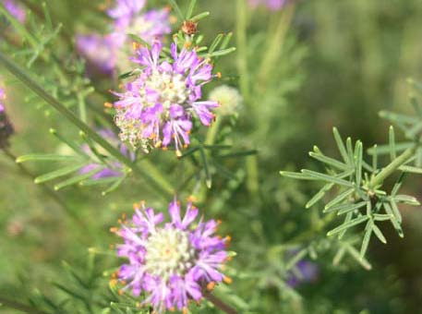USDA NRCS

**Uses**

*Erosion Control:* Purple prairie clover is used in a mixture with grass and forbs to prevent soil erosion on dam structures, roadsides, and other critical erodible areas.

*Wildlife:* Purple prairie clover is readily consumed by many types of wildlife. During early growth stages, its foliage is consumed due to its high nutritional value. Purple prairie clover seed is consumed by birds and small mammals. The purple flowers also attract many different species of pollinators such as bees and butterflies.

*Livestock:* Purple prairie clover can be grazed by livestock, primarily sheep and goats. This plant is highly palatable and nutritious.

*Landscaping/Beautification:* Purple prairie clover is used in wildlife gardens, parks, prairie restorations, and recreation areas.

**Status**

Please consult the PLANTS Web site ([http://plants.usda.gov](http://plants.usda.gov/)) and your State Department of Natural Resources for this plant’s current status (e.g. threatened or endangered species, state noxious status, and wetland indicator values).

**Weediness**

This plant may become weedy or invasive in some regions or habitats and may displace desirable vegetation if not properly managed. Please consult your local NRCS Field Office, Cooperative Extension Service office, state natural resource, or state agriculture department regarding its status and use. Weed information is also available from the PLANTS Web site at http://www.plants.usda.gov. Please consult this and Related Web Sites and view the plant profile for this species for further information.

**Description**

Purple prairie clover is a native, warm-season, perennial legume. The plant has one to many stems that grow up to 2.5 feet long from a woody, stout taproot that branches near the surface. The leaves are about one inch long and very narrow. They alternate and have an average of five leaflets per pinnate compound. The flowers appear on the end of the stems and have cylindrical floral spikes about two inches long. The flowers open beginning at the base of the flower head and progress up to the tip. Seed is produced in a seed pod about ½ inch long. The seed pod will contain between one to two seed each. Purple prairie clover blooms from April to June with the seed maturing from mid July to late August

**Adaptation**

Purple prairie clover is adapted to slopes along hillsides, prairies, and plains. The plant is widely distributed throughout central, south, and west Texas. It occurs mostly on sandy, sandy loam, and other moderately drained soils

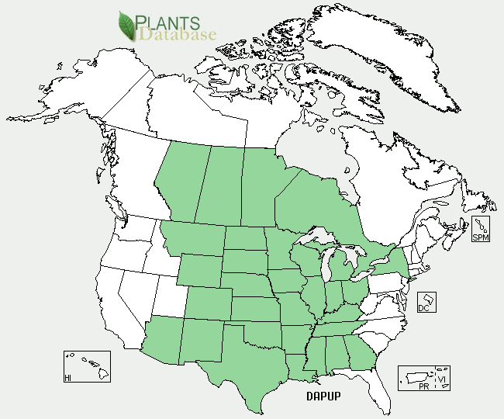

*Purple prairie clover area of distribution from* PLANTS *database.*

*Distribution*: Please consult the Plant Profile page for this species on the PLANTS Web site.

**Establishment**

Purple prairie clover should be planted on a clean, firm seedbed. Planting can be done using either a grass drill or broadcast seeder, but grass drills are the most successful method of planting. Seed should be placed ½ to ¼ inch deep. Purple prairie clover should be planted at a rate of 3 lbs pure live seed (pls) per acre. When planting this as a component of a seed mixture, the seeding rate should be adjusted to the desired percent of the mix.

**Management**

Purple prairie clover is commonly found as a component in seed mixtures for range seeding and conservation cover. Stands should be well established before livestock grazing is permitted. The plant does not tolerate continuous grazing or heavy overuse. Proper management of purple prairie clover is required to ensure the plant is not overgrazed or over utilized by livestock or wildlife. Consult your local NRCS Field Office for assistance with planning and applying prescribed grazing. Soil tests should be conducted regularly to determine the amount of fertilizer needed to maintain a medium level of fertility.

**Pests and Potential Problems**

None known

**Environmental Concerns**

None known

**Control**

Please contact your local agricultural extension specialist or county weed specialist to learn what works best in your area and how to use it safely. Always read label and safety instructions for each control method. Trade names and control measures appear in this document only to provide specific information. USDA NRCS does not guarantee or warranty the products and control methods named, and other products may be equally effective.

**Cultivars, Improved, and Selected Materials (and area of origin)**

Cuero Germplasm was released from the James E. “Bud” Smith Plant Materials Center, Knox City, TX in 2003. It was collected originally in 1970 from native plants in DeWitt County, TX approximately 11 miles from the town of Cuero.

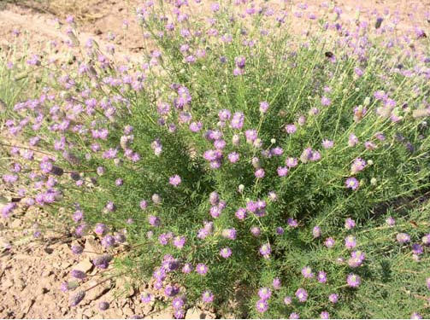

USDA NRCS

**Prepared By:**

Brandon Carr, USDA NRCS James E. “Bud” Smith Plant Materials Center, Knox City, Texas

**Species Coordinator:**

### Citation

Carr, B. 2009 Plant Fact Sheet for purple prairie clover (*Dalea purpurea Vent. var. purpurea*). USDA-Natural Resources Conservation Service, James E. “Bud” Smith Plant Materials Center, Knox City, Texas 79529

Published November, 2009

Edited:

For more information about this and other plants, please contact your local NRCS field office or Conservation District <<http://www.nrcs.usda.gov/>>, and visit the PLANTS Web site <[http://plants.usda.gov](http://plants.usda.gov/)> or the Plant Materials Program Web site <<http://plant-materials.nrcs.usda.gov>>

**USDA IS AN EQUAL OPPORTUNITY PROVIDER AND EMPLOYER**