

Plant Fact Sheet

# TUFTED HAIRGRASS

***Deschampsia cespitosa* (L.) P. Beauv**.

Plant Symbol = DECE

Contributed by: USDA NRCS Plant Materials Center, Corvallis, Oregon

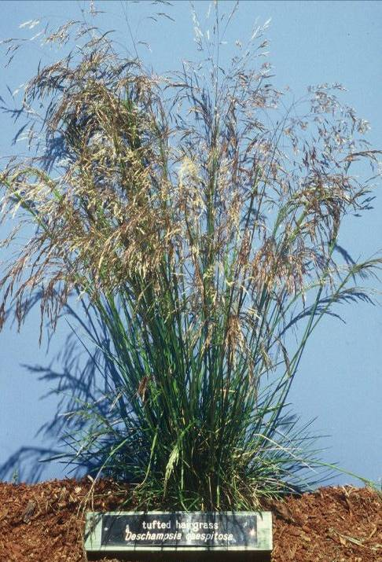

Photo by Dale Darris

**Alternate names**

Other common names include blue-green hair-grass, fescue-leaved hairgrass, salt and pepper grass, tussock grass, and canche cespiteuse.

**Uses**

Tufted hairgrass is useful for restoring moist to seasonally wet prairies and stabilizing disturbed sites, streambanks, canals, shorelines, and upper tidal marshes. Other applications include acid and heavy metal mine spoil reclamation, alpine and boreal revegetation work, and bio-filtration swales. As a range or pasture grass, it is both a desirable, productive forage for cattle and sheep particularly at higher elevations, and a species of lesser or low value in regions where plants are coarse and less palatable. The species is sometimes cut for hay. Utilization by deer, elk, pronghorn, bison, bear, horses, and rabbits is variable. Likewise, cover and food values are rated poor to good for small mammals, upland game birds, songbirds, and waterfowl depending on wildlife species and location. Tufted hairgrass is a larval food plant for several butterflies in North America and is host for at least 40 species of Lepidopteran insects world-wide. Varieties have been bred as wear resistant turf for golf courses, sports fields and other uses.

**Description**

Tufted hairgrass is a highly variable, perennial cool season species that grows 20 to 60 in. tall. Stems are erect and the leaves are .06 to .16 in. wide, flat or rolled, and mostly basal in a dense tuft. The panicle (seed head or inflorescence) is upright to nodding, loosely branched, open, and 4 to 10 in. long. There are two florets (flowers) per spikelet. Flowering occurs from May to September and seeds mature from late June to late September depending on location.

**Status**

Please consult the Plants Web site and your State Department of Natural Resources for this plant’s current status, such as state noxious and wetland indicator values.

**Adaptation**

Populations occupy moderately moist to seasonally flooded, sunny to partially shaded environments with a wide variety of soil types (fine to coarse, mesic to hydric) and pH ranging from 3.5 to 7.5. Some populations have extreme tolerance to heavy metals and high soil acidity. Salinity tolerance is generally considered low, but plants occurring in coastal estuaries may be slightly more salt tolerant. Crowns typically survive all but the most severe or hottest fires.

*Distribution*-As one of the most widely distributed grasses on earth, tufted hairgrass is found in many arctic and temperate regions. It occurs from sea level to 14,000 ft in the mountains. Habitats include coastal terraces, upper tidal marshes, seasonally wet prairies, moist subalpine mountain meadows, open forests, and alpine areas above timberline.

**Limitations or environmental concerns**

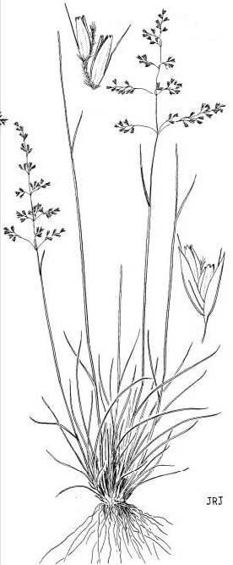Tufted hairgrass is host to a number of diseases including ergot, several rusts, stripe smut, blind seed, several leaf spots, and the turf disease take all patch. Insect pests typical of pasture and turf grasses include aphids, billbugs, leafhoppers, and others. In some parts of the world, this grass spreads readily into newly disturbed areas, is a weed in certain forage crops, and can become a serious competitor with trees.

Reprinted with permission Univ. of WA Press

Specific management practices are applied to wet, low elevation pastures in Europe in order to control it. The plant is considered nontoxic to livestock and humans. Uses such as general cover and turf can be limited by summer moistustress and billbugs.

**Establishment**

While the seed (1.1 to 2.5 million seeds/lb) from alpine environments may have dormancy and does better if fall sown, low elevation sources typically have low dormancy and can be fall or spring planted. Slow to establish the first year, tufted hairgrass originating at low elevations in the Pacific Northwest can become large and dominate a site by the end of the second growing season if sown heavily (2 to 3 lbs of pure live seed/ac). Where species diversity is a goal, space for forbs and other grasses may require that seed mixes contain no more than ¼ to ½ lb of tufted hairgrass seed per acre. Turf varieties are sown at 1 to 2 lbs/1000 sq. ft. Light enhances germination so seeds should be only lightly covered (¼ in.). Choose seed originating from the same region and a similar elevation range (low, mid, or high). Specific populations are often required for extreme soils (acid, metals). Depauperatesties may need mulch and fertilizer.

*Grazing management*- Once established, use a rotational, moderate grazing system since the species often declines with continuous, season long use. Defer grazing each spring until soils are dry enough to prevent damage to soils and plants. Also, postpone livestock utilization for a year or more after fire to allow recovery.

**Improved cultivars and selected materials (and area of origin)**

The NRCS in Oregon released the pre-varieties Tillamook Germplasm for revegetation use in coastal zones of Oregon and Washington, and Willamette Germplasm for use in western interior valleys of the same states. Reclamation cultivars include ‘Peru Creek’ from Colorado for use in certain Rocky Mountain habitats, and ‘Nortran’ for use in parts of Alaska. Given the fine wispy seed heads and natural beauty of the plant, 20 or more ornamental varieties are found in the landscape and nursery trade. Seed companies have developed at least eight proprietary turf varieties from European sources that reportedly tolerate more shade and mowing down to 1/3 to 1/2 in.

**Prepared by**

Dale Darris and Pete Gonzalves, USDA NRCS Plant Materials Center, Corvallis, Oregon.

**Species coordinator**

Dale Darris, USDA NRCS Plant Materials Center, Corvallis, Oregon.

Published: October 2009

Edited:

For more information about this and other plants, please contact your local NRCS field office or Conservation District <<http://www.nrcs.usda.gov/>>, and visit the PLANTS Web site <[http://plants.usda.gov](http://plants.usda.gov/)> or the Plant Materials Program Web site <<http://plant-materials.nrcs.usda.gov>>

**USDA IS AN EQUAL OPPORTUNITY PROVIDER AND EMPLOYER**