

Plant Fact Sheet

# HAIRY SMALL-LEAF TICKTREFOIL

## Desmodium ciliare

## (Muhl. ex Willd.) DC.

Plant Symbol = DECI

#### Contributed by: USDA, NRCS, Norman A. Berg National Plant Materials Center, Beltsville, MD

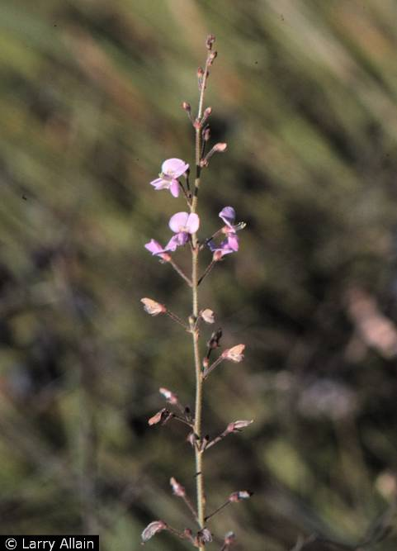

Larry Allain@USDA-NRCS PLANTS Database

Alternate Names

*Hedysarum ciliare (L.)*

*Hedysarum barbatum (L.)*

#### **Uses**

#### Ethnobotanical: The Houma Indians of Louisiana used an infusion of the roots in whiskey to treat weakness and cramps.

#### Landscaping and wildlife: Hairy Small-Leaf Ticktrefoil attracts birds and is a good grazing and browsing plant for livestock. Hairy Small-Leaf Ticktrefoil enriches the soil through nitrogen fixation. Long-tongued bumblebees (Bombus impatiens and Bombus pensylvanicus ) collect pollen from the flowers. Other long-tongued bee pollinators include leaf-cutting bees (Megachile brevis brevis, Megachile mendica, and Megachile petulans), and digger bees (Melissodes bimaculata bimaculata). Short-tongued bee pollinators include: sweat bees (Nomia nortoni nortoni) and Campus bees (Calliopsis andreniformis). The caterpillars of several skippers feed on the leaves: Hoary Edge (Achalarus lyciades), Silver-Spotted Skipper (Epargyreus clarus), Southern Cloudywing (Thorybes bathyllus), and Northern Cloudywing (Thorybes pylades). The caterpillars of the butterfly Eastern Tailed Blue (Everes comyntas) also feed on the foliage, while the caterpillars of the butterfly Gray Hairstreak (Strymon melinus) eat the flowers and developing seedpods. Other insect feeders include many kinds of beetles, and some species of thrips, aphids, moth caterpillars, and stinkbugs. The seeds are eaten by some upland game birds (Bobwhite Quail, Wild Turkey) and small rodents (White-Footed Mouse, Deer Mouse), while the foliage is readily eaten by White-Tailed Deer and other hoofed mammalian herbivores. The Cottontail Rabbit also consumes the foliage.

#### **Status**

Please consult the PLANTS Web site and your State Department of Natural Resources for this plant’s current status (e.g., threatened or endangered species, state noxious status, and wetland indicator values).

#### **Description and Adaptation**

Hairy Small-Leaf Ticktrefoil is a native, perennial, wildflower that grows up to 3 feet tall. The name of the genus *Desmodium* originates from Greek meaning "long branch or chain," probably from the shape of the seedpods and the way they attach to clothing and animals. The central stem is green with trifoliate (clover-like), oblong, compound (made up of multiple green leaflets), green leaves proceeding singly up the stem. The showy purple flowers appear in late summer and grow from panicles (flowers arranged on a stem) that mature from the bottom upwards. In early fall, the flowers produce leguminous seed pods approximately ⅛ inch long. Hairy Small-Leaf Ticktrefoil plants have a single crown. This wildflower is a pioneer species that prefers some disturbance from wildfires, selective logging, and other causes. The sticky seedpods cling to the fur of animals and the clothing of humans; as a result, the seeds are carried to new locations. Hairy Small-Leaf Ticktrefoil grows in upland habitats such as forests and savannahs. It prefers coarse- to medium- textured soils that are well-drained.

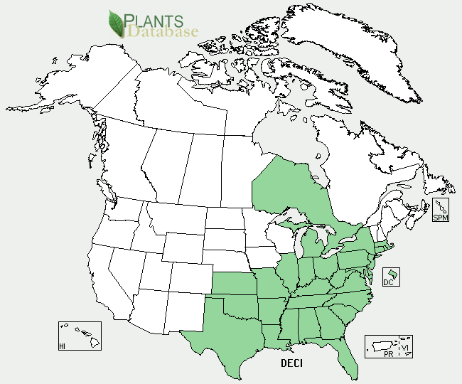

Hairy Small-Leaf Ticktrefoil distribution from USDA-NRCS PLANTS Database.

For updated distribution, please consult the Plant Profile page for this species on the PLANTS Web site.

#### **Establishment**

Gather seeds in the fall and dry them in paper bags for 1 – 2 weeks. Sow seeds directly in fall and plant a cover crop of a cool season annual grass over the seedbed to protect seed over the winter. If seeds are to be propagated in a container, stratify them for approximately 3 months at 34 to 38 degrees Fahrenheit. Scarify the seeds before planting by rubbing them with sandpaper and inoculate them with a *Desmodium*-specific inoculant. Cover seeds lightly with a vermiculite/perlite mixture and keep air temperature at approximately 65 degrees Fahrenheit until seeds have germinated.

#### **Management**

Hairy Small-Leaf Ticktrefoil grows in partial shade and prefers neutral to slightly acidic soil and fine- to medium- textured soil.

#### **Pests and Potential Problems**

No known pests or potential problems at this time.

#### **Environmental Concerns**

No concerns at this time.

#### **Cultivars, Improved, and Selected Materials (and area of origin)**

There are no recommended cultivars or selected materials at this time.

#### **Prepared By**

Samantha Kirk and Shawn Belt, NRCS, Norman A. Berg National Plant Materials Center, Beltsville, MD

#### **Citation**

Kirk, S. and Belt, S. 2010.  Plant fact sheet for Hairy Small-Leaf Ticktrefoil **(***Desmodium ciliare***),** USDA-Natural Resources Conservation Service, Norman A. Bern National Plant Materials Center, Beltsville, 20705**.**

Published October 2010

Edited: (18-Jan-10 SMK, 18-May SVB, 13-Aug-10 JW)

For more information about this and other plants, please contact your local NRCS field office or Conservation District <<http://www.nrcs.usda.gov/>>, and visit the PLANTS Web site <[http://plants.usda.gov](http://plants.usda.gov/)> or the Plant Materials Program Web site <<http://plant-materials.nrcs.usda.gov>>

.

**USDA IS AN EQUAL OPPORTUNITY PROVIDER AND EMPLOYER**