

Plant Fact Sheet

# annual hairgrass

## Deschampsia danthonioides (Trin.) Munro

Plant Symbol = DEDA

*Contributed by*: USDA NRCS Plant Materials Center, Corvallis, Oregon

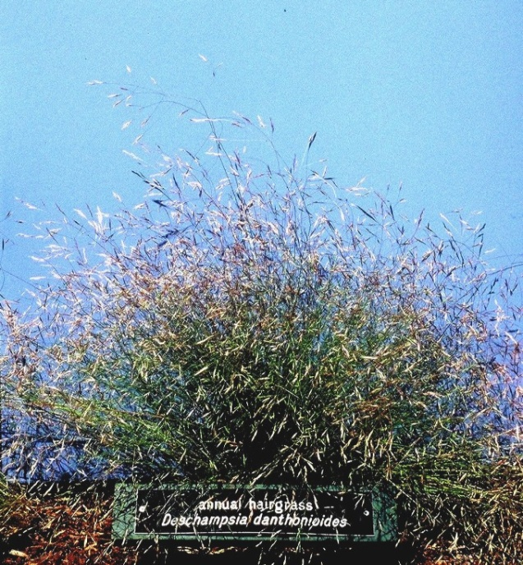

*Photo by Dale Darris, USDA NRCS Corvallis PMC.*

### Alternative Names

*Alternate Common Names:* none known

*Alternate Scientific Names: Aira danthonioides* Trin., *Deschampsia calycina* J. Presl, and *Deschampsia danthonioides* (Trin.) Munro var. *gracilis* (Vasey) Munz

Uses

Annual hairgrass is useful for wetland restoration, erosion control, and revegetation of other moist, disturbed areas where quick, low growing ground cover is desired. Given its apparent lack of competitiveness, this species may prove valuable as a temporary nurse crop for establishing perennial native species in both wetland and upland seed mixes. Waterfowl and birds eat the seeds. However, the foliage may be of less merit for wildlife herbage and cover compared to other grasses because of its short stature, annual lifespan, and limited productivity. The palatability and nutritional value of annual hairgrass for livestock and game is not documented. The vernal pools which it occupies are important reservoirs for aquatic invertebrates and amphibians.

Status

Please consult the PLANTS Web site and your State Department of Natural Resources for this plant’s current status (e.g. threatened or endangered species, state noxious status, and wetland indicator values).

Description and Adaptation

Annual hairgrass is a fine textured, native, cool season grass with smooth, slender stems (culms) that are 10 to 60 cm tall. The form is upright to spreading, short, and somewhat tufted. The narrow leaf blades are hairless, rough on the edges, slightly in-rolled, 0.5 to 1.5 (2) mm wide, and 1 to 10 cm long. Flower heads (panicles) are open, 7 to 25 cm long, with ascending lower branches. Annual hairgrass occurs from near sea level at the coast to 8,000 feet in the Rocky Mountains. It is primarily found from Alaska south to Baja California and east to Montana and New Mexico; also the Northeast US and Chile.

*Key to identification*: Annual hairgrass can be distinguished from slender hairgrass (*Deschampsia elongata*) and tufted hairgrass (*Deschampsia cespitosa*) by its weaker root development, fewer leaves, and smaller stature. Without close inspection it may be confused with other annual grasses, such as annual fescues (*Vulpia* spp.). Both may occur in waste areas. Consult botanical keys for proper identification.

*Relative abundance in wild:* While most common in the Pacific Coast states, the species can still be hard to locate. However, it can occur in large stands, especially in vernal pools dominated by annuals. Seed retention is fair and fill is good. The period for wild collection can extend several weeks as maturation progresses along a soil moisture gradient within depressions.

### *Adaptation:* Annual hairgrass reaches its preeminence in vernal pools, mudflats and other shallow depressions that are ponded in winter and desiccated in summer. In California, habitat also includes alkali and coastal grasslands, the edges of alkali playas, and seasonally or periodically inundated wetlands dominated by annuals. Other habitats can include streambanks, roadsides, drier banks, vernal seepage areas, waste areas, and mountain meadows. Typical substrates appear to be acidic (pH 5) to moderately alkaline, fine-textured clay soils and silt loams above a shallow, impervious layer. However, it also grows on coarse textured substrates that stay moist through seed development. Annual hairgrass apparently tolerates some salinity and prefers full sun. Fall germinants actively grow all winter, tolerating several days to several weeks of continual submergence.

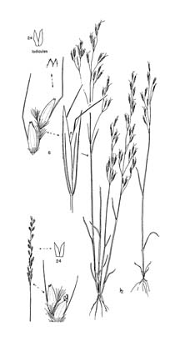

*Line drawing of* Deschampsia danthonioides *reprinted with permission, University of Washington Press.*

Establishment

Annual hairgrass germinates readily and is easy to establish on open, moist ground. There is no seed dormancy and therefore no requirement for physical conditioning or over wintering outdoors. However, as a winter annual in milder growing climes of the West Coast, it is best suited to early fall sowing. The seed should be run through a debearder or brush machine to remove pubescence (hairs). This will facilitate further seed cleaning and improve flow through a drill and other planting device. There are approximately 900,000 seeds per pound (± 30%). A seeding rate of one pound per acre pure live seed (PLS) would result in 20 live seeds per square foot. Seeding rates will vary widely depending on planting purpose, site conditions, and method used.

Management

As an annual, this species requires regular disturbance or moist to wet open ground in fall and winter in order to proliferate. It is not competitive and is easily replaced by other species. Annual hairgrass should be well suited to moist soil management techniques (slow de-watering, disking, etc.) in shallow water impoundments and other controlled wetlands. Such methods are used to improve habitat for waterfowl, shorebirds and other wildlife by maximizing seed production of annuals.

Environmental Concerns

Shallow roots and low herbage production may limit the usefulness of this species for soil stabilization on highly erosive soils or unconsolidated substrates. While annual hairgrass is a weak competitor with weeds, it may be less likely to become a weed itself. Although this species can increase in open waste areas, there are no reports of this species becoming invasive.

Cultivars, Improved, and Selected Materials (and area of origin)

Plants and seeds are sometimes available in California. This species is generally not available elsewhere within its range, requiring wild harvest or contract seed growing to provide material.

Prepared By

*Dale Darris* *and* *Amy Bartow*

USDA NRCS Plant Materials Center, Corvallis, Oregon

Citation

Darris, D., and A. Bartow. 2005. Plant fact sheet for annual hairgrass (*Deschampsia danthonioides*). USDA-Natural Resources Conservation Service, Plant Materials Center, Corvallis, OR.

Edited: 16Mar2006 jsp; 16Sep2008 dcd; 17Sep2008 jsp; 17Feb2012 aym

For more information about this and other plants, please contact your local NRCS field office or Conservation District <<http://www.nrcs.usda.gov/>>, and visit the PLANTS Web site <[http://plants.usda.gov](http://plants.usda.gov/)> or the Plant Materials Program Web site <<http://plant-materials.nrcs.usda.gov>

**USDA IS AN EQUAL OPPORTUNITY PROVIDER AND EMPLOYER**