

Plant Fact Sheet

# slender hairgrass

## Deschampsia elongata (Hook.) Munro

Plant Symbol = DEEL

*Contributed by*: USDA NRCS Plant Materials Center, Corvallis, Oregon

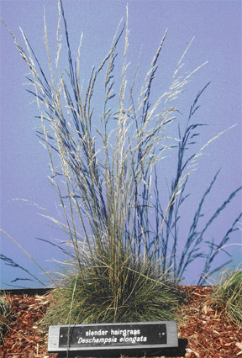

*Photo by Dale Darris, USDA NRCS Corvallis PMC.*

### Alternative Names

*Alternate Common Names:* none known

*Alternate Scientific Names*: *Aira* *elongata*

Uses

Slender hairgrass is a moderate to fast growing native bunchgrass useful for erosion control along waterways, ditches, and streambanks, as well as on other seasonally wet or recently disturbed sites. It can also be sown as cover after logging in ravines and other moist forest areas. This species has potential as a nurse crop for slower establishing, longer lived species like California oatgrass (*Danthonia californica*) or other native prairie and woodland grasses and herbs. Forage value is fair to good prior to maturity. This is a versatile and underutilized native grass. It is also regarded as an attractive ornamental grass because of its fine texture, wispy seed heads, and golden color in summer.

Status

Please consult the PLANTS Web site and your State Department of Natural Resources for this plant’s current status (e.g. threatened or endangered species, state noxious status, and wetland indicator values).

Description and Adaptation

Slender hairgrass is a moderate sized, fine textured, cool season grass. It is generally a biennial or short-lived perennial under most conditions. Stems (culms) are 40 to 80 (100) cm tall. Leaves are hair-like, less than 1.5 mm wide, and form a basal tuft. The open sheaths are smooth and auricles are absent. The panicle (flowerhead) is 5 to 25 (30) cm long, narrow with slender upward-pointing branches, and a pale green to purple color. This species occurs primarily from Alaska to California and east to Montana and New Mexico.

*Key to identification:* The slender, upright to arching seed head and fine leaves are indicative of its common name. It should not be confused with tufted hairgrass (*Deschampsia cespitosa*) which is taller, coarser, and more robust. In addition, the panicles of tufted hairgrass are more open and branching, and the leaves are broader and flatter than slender hairgrass. Annual hairgrass (*Deschampsia danthonioides*) is smaller and the panicle is also much broader and open compared to slender hairgrass. Because of the fine texture and small florets, it may loosely resemble a bentgrass (*Agrostis* spp.) without closer inspection.

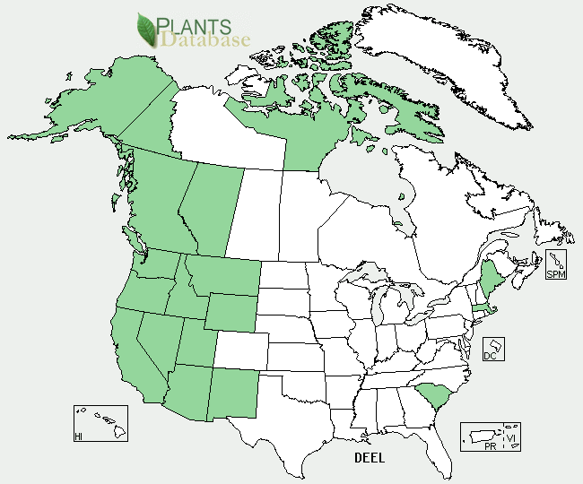

*Slender hairgrass distribution from USDA-NRCS PLANTS Database.*

*Relative abundance in the wild:* Scattered to relatively common, but rarely in large numbers. Slender hairgrass is occasionally found in drainage ways, seep areas, ditches, and damp open woods, as well as adjacent to moist pathways or other disturbed areas.

*Adaptation:* Slender hairgrass can be found in wet meadows and along the margins of streams, ponds, and lakes. Habitat also includes moist slopes and the understory of open forests from lowland to alpine zones. It is also a component of coastal prairies. As a species of secondary plant succession, slender hairgrass establishes after logging in associated forest communities. It is found on fine sandy or gravelly soils as well as heavier soil types. This species tolerates full sun to partial shade.

### Line drawing of slender hairgrass courtesy of University of Washington Press.

*Line drawing of* Deschampsia elongata *reprinted with permission, University of Washington Press.*

Establishment

There is no seed dormancy and slender hairgrass establishes readily by sowing in the fall or early spring. Removal of surface hairs (pubescence) on the seed facilitates further seed cleaning as well as sowing with a drill. There are approximately 2,300,000 seeds per pound (± 20%). Each pound of live seed sown per acre applies about 54 seeds per square foot. Based on seed size and seedling vigor, suggested seeding rates are 2 to 4 lbs/acre when sown alone. Higher rates may be required when broadcasting to achieve full stands under more difficult conditions.

Management

Information on the management of this species is lacking. Given its short-lived nature, grazing must be deferred during flowering and seed set every other year for stand regeneration. Its ability to easily volunteer on moist, disturbed ground and readily produce seed makes it a candidate for moist soil management of wetland habitat for waterfowl, shorebirds, and other wildlife.

Environmental Concerns

This plant is short-lived and may not compete well with weedy herbaceous species. There are no major concerns described for this species.

Cultivars, Improved, and Selected Materials (and area of origin)

Multiple sources of seed are readily available in California. One or more populations originating from western Oregon are on the market as well. Seed sources from other regions may be lacking.

Prepared By

*Dale Darris and Robert Tracey*

USDA NRCS Plant Materials Center, Corvallis, Oregon

### Citation

Darris, D., and R. Tracey. 2004. Plant fact sheet for slender hairgrass (*Deschampsia elongata*). USDA-Natural Resources Conservation Service, Plant Materials Center, Corvallis, OR.

Published November 2004

Edited: 20Mar2006 jsp; 17Feb2012 aym

For more information about this and other plants, please contact your local NRCS field office or Conservation District <<http://www.nrcs.usda.gov/>>, and visit the PLANTS Web site <[http://plants.usda.gov](http://plants.usda.gov/)> or the Plant Materials Program Web site <<http://plant-materials.nrcs.usda.gov>>

**USDA IS AN EQUAL OPPORTUNITY PROVIDER AND EMPLOYER**