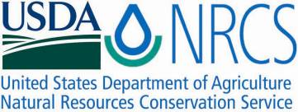

Plant Fact Sheet

# VELVET BUNDLEFLOWER

## Desmanthus velutinus Scheele

Plant Symbol = DEVE2

Contributed by: USDA NRCS James E. “bud” Smith Plant Materials Center, Knox City, Texas

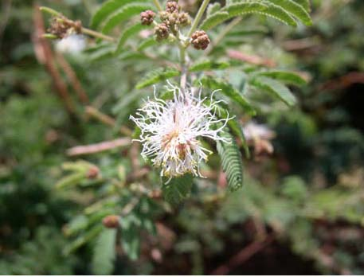

Uses

*Wildlife:* Velvet bundleflower is consumed by large and small wildlife. Deer and other browsing animals can feed on the young, tender foliage. The numerous seed produced by the plant are utilized by many species, especially quail.

*Livestock:* Velvet bundleflower has a good forage value for sheep and goats while the foliage is young and tender. After seed begins to form, the forage value becomes fair for all livestock.

*Erosion Control:* Velvet bundleflower can be planted along field borders, railroads, and other sloping areas to reduce soil erosion from both water and wind.

**Status**

Please consult the PLANTS Web site ([http://plants.usda.gov](http://plants.usda.gov/)) and your State Department of Natural Resources for this plant’s current status (e.g. threatened or endangered species, state noxious status, and wetland indicator values).

**Weediness**

This plant may become weedy or invasive in some regions or habitats and may displace desirable vegetation if not properly managed. Please consult your local NRCS Field Office, Cooperative Extension Service office, state natural resource, or state agriculture department regarding its status and use. Weed information is also available from the PLANTS Web site at http://www.plants.usda.gov. Please consult this and Related Web Sites and view the plant profile for this species for further information.

**Description**

Velvet bundleflower is a native, warm-season, perennial legume. The plant is composed of several widely spreading, smooth stems that grow two feet long. Velvet bundleflower produces a white “powder-puff” cluster shaped flower, one inch in diameter, between the months of April and June. The leaves are three to four inches long with a bluish-green tint. Numerous leaflets positioned twice pinnate make up the leaves of the velvet bundleflower. The seed from the velvet bundleflower grows in straight pods two to three inches long, and fully matures from mid July to late August.

**Adaptation**

Velvet bundleflower is widely adapted throughout central, south, and west Texas, as well as southern Oklahoma. It prefers calcareous and limestone soils. Velvet bundleflower does not adapt well to heavily wooded areas or areas that tend to remain wet for extended periods of time.

*Distribution*: Please consult the Plant Profile page for this species on the PLANTS Web site.

**Establishment**

Velvet bundleflower should be planted on a clean, firm seedbed. Planting can be done using either a grass drill or broadcast seeder, but grass drills are the most successful method of planting velvet bundleflower. Seed should be placed ¼ inch deep. Soil samples should be taken before planting to determine the amount of fertilizer needed to bring the fertility level up to a medium range. Limit nitrogen application to ten pounds per acre or less until the stand is established. Velvet bundleflower should be planted at a rate of 4.5 lbs pure live seed (pls) per acre. When planting this as a component of a seed mixture, the seeding rate should be adjusted to the desired percent of the mix.

**Management**

Velvet bundleflower is commonly found as a component in seed mixtures for range seeding and conservation cover. Stands of velvet bundleflower should be well established before livestock is permitted to graze. Once the stand is established, velvet bundleflower should never be grazed or cut below six inches. Velvet bundleflower does not tolerate continuous grazing or heavy overuse. Soil tests should be conducted regularly to determine the amount of fertilizer needed to maintain a medium level of fertility.

Proper management of velvet bundleflower is required to ensure the plant is not overgrazed or over utilized by livestock or wildlife. Consult your local NRCS Field Office for assistance with planning and applying prescribed grazing.

**Control**

Please contact your local agricultural extension specialist or county weed specialist to learn what works best in your area and how to use it safely. Always read label and safety instructions for each control method. Trade names and control measures appear in this document only to provide specific information. USDA NRCS does not guarantee or warranty the products and control methods named, and other products may be equally effective.

**Pest and Potential Problems**

None known

**Cultivars, Improved, and Selected Materials (and area of origin)**

Hondo Germplasm was released from the James E. “Bud” Smith Plant Materials Center, Knox City, TX in 2003. It was collected originally in 1969 from native plants in the eastern part of Medina County, near Hondo, TX, and released to provide an adapted forb for inclusion in range mixes for wildlife and livestock browse.

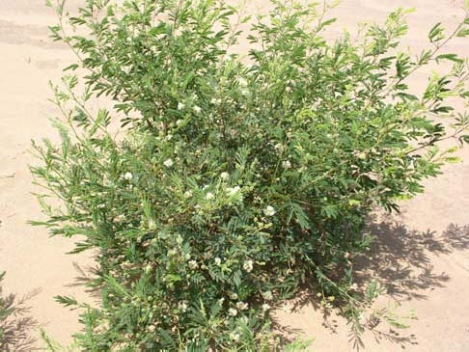

USDA NRCS

**Prepared By:**

Brandon Carr, USDA NRCS James E. “Bud” Smith Plant Materials Center, Knox City, Texas

**Species Coordinator:**

Published November 2009

Edited:

For more information about this and other plants, please contact your local NRCS field office or Conservation District <<http://www.nrcs.usda.gov/>>, and visit the PLANTS Web site <[http://plants.usda.gov](http://plants.usda.gov/)> or the Plant Materials Program Web site <<http://plant-materials.nrcs.usda.gov>>

.

**USDA IS AN EQUAL OPPORTUNITY PROVIDER AND EMPLOYER**