

Plant Fact Sheet

# ENGELMANN’S DAISY

## Engelmannia peristenia (Raf.) Goodman & C.A. Lawson

Plant Symbol = ENPE4

Contributed by: USDA NRCS James E. “Bud” Smith Plant Materials Center, Knox City, Texas

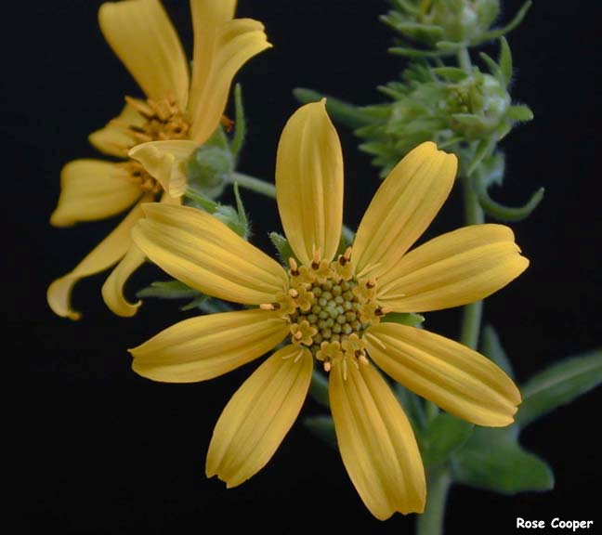Texas AgriLife Research and Extension at Uvalde 2000 Copyright Texas A&M University System

### Alternate Names

Cutleaf daisy

**Uses**

Livestock: Engelmann’s daisy is rarely found on overgrazed pastures due to its palatability by livestock. Cattle, sheep, and goats can all benefit from the high protein and digestibility obtained from this species. Crude protein can reach as high as twenty-five percent in early spring. Livestock, like wildlife, can benefit from grazing on Engelmann’s daisy before warm-season varieties become available.

Wildlife: This species benefits wildlife in several ways. Deer and rabbits enjoy feeding on Engelmann’s daisy. It has high protein content and is available earlier in the year than warm season vegetation. Engelmann’s daisy also provides cover for small mammals and many species of birds.

Erosion Control: Engelmann’s daisy is commonly planted on slopes like roadsides and embankments to help reduce the potential of soil erosion.

**Status**

Please consult the PLANTS Web site ([http://plants.usda.gov](http://plants.usda.gov/)) and your State Department of Natural Resources for this plant’s current status (e.g. threatened or endangered species, state noxious status, and wetland indicator values).

**Weediness**

This plant may become weedy or invasive in some regions or habitats and may displace desirable vegetation if not properly managed. Please consult with your local NRCS Field Office, Cooperative Extension Service office, state natural resource, or state agriculture department regarding its status and use. Weed information is also available from the PLANTS Web site; please consult the related web sites on the Plant Profile for this species for further information.

**Description**

Engelmann’s daisy is a native, cool-season perennial which can grow up to three feet tall. The plant produces a basal rosette of leaves that can grow eight inches long. Leaves are very deeply cleft or almost divided. Coarse hair can been found on both the leaves and stems of the plant. The vegetation remains green throughout the winter, and begins to flower in May. The flower head elongates during the spring months. Engelmann’s daisy flower heads are made up of yellow ray and disk flowers. They measure about one to two inches in diameter. During extreme heat, the petals of the plant fold downward.

**Adaptation**

Engelmann’s daisy is adapted to a wide range of soil types and climate conditions, but is found most frequently throughout central Texas. Ideal soil types range from sandy loams to clay loams. Engelmann’s daisy does not seem to tolerate heavy clay soils, salinity, or deep sands. The plant has a deep tap root which makes it a hardy, drought tolerate species.

**Distribution**

Engelmann’s daisy is most commonly found throughout north central Texas and the Edward’s Plateau. It is also found as far north as South Dakota, as far west as Arizona, and as far east as Louisiana. For a current distribution map, please consult the Plant Profile page for this species on the PLANTS Website.

**Establishment**

Planting should be done in late summer or in the fall. Sow seed ¼ to ¾ inch deep in a well prepared, firm seedbed. The full seeding rate for Engelmann’s daisy is fifteen pounds of pure live seed (pls) per acre. When planting this as a component of a seed mixture, the seeding rate should be adjusted to the desired percent of the mix. Ideal plant spacing would be two to three plants per square yard. Fertilizer applications will vary depending on individual soil samples. Nitrogen, potassium, and phosphorus should be considered to bring the fertility up to a medium level. Twenty pounds of a mixture of these three fertilizers will normally provide this level of fertility; however, a soil sample should always be taken before applying fertilizer.

**Management**

Engelmann’s daisy is rarely planted as a monoculture planting but as a component of a range seeding mixture. Twelve months of grazing deferment should be planned and applied to allow plant establishment. Areas with heavy deer populations should consider the impact and added maintenance associated with attempting to establish this species.

Proper management of Engelmann’s daisy is required to ensure the plant is not overgrazed or over utilized by livestock or wildlife. Consult your local NRCS Field Office for assistance with planning and applying prescribed grazing.

**Control**

Please contact your local agricultural extension specialist or county weed specialist to learn what works best in your area and how to use it safely. Always read label and safety instructions for each control method. Trade names and control measures appear in this document only to provide specific information. USDA NRCS does not guarantee or warranty the products and control methods named, and other products may be equally effective.

**Pests and Potential Problems**

None known

**Cultivars, Improved, and Selected Materials (and area of origin)**

‘Eldorado’ Engelmann’s daisy was released from the James E. “Bud” Smith Plant Materials Center, Knox City, TX in 1985. It originated from a native collection in Schleicher County, TX, and released to provide an adapted forb for inclusion in range mixes for wildlife and livestock browse.

**Prepared By & Species Coordinator:**

Brandon Carr, USDA NRCS James E. “Bud” Smith Plant Materials Center, Knox City, Texas

USDA NRCS Plant Materials Program

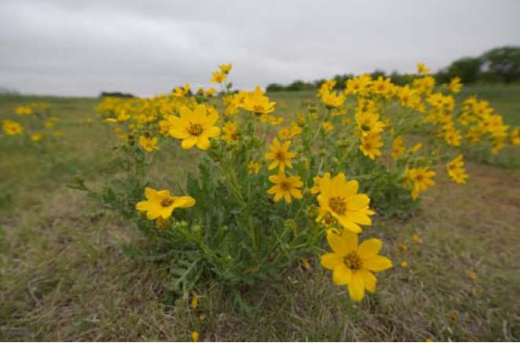 *USDA NRCS 2009*

Published: November, 2009

Edited:

For more information about this and other plants, please contact your local NRCS field office or Conservation District <<http://www.nrcs.usda.gov/>>, and visit the PLANTS Web site <[http://plants.usda.gov](http://plants.usda.gov/)> or the Plant Materials Program Web site <<http://plant-materials.nrcs.usda.gov>>

.

**USDA IS AN EQUAL OPPORTUNITY PROVIDER AND EMPLOYER**