

Plant Fact Sheet

# Plains Lovegrass

## Eragrostis intermedia A.S. Hitchc.

### Plant Symbol = ERIN

Contributed by: USDA NRCS Tucson Plant Materials Center

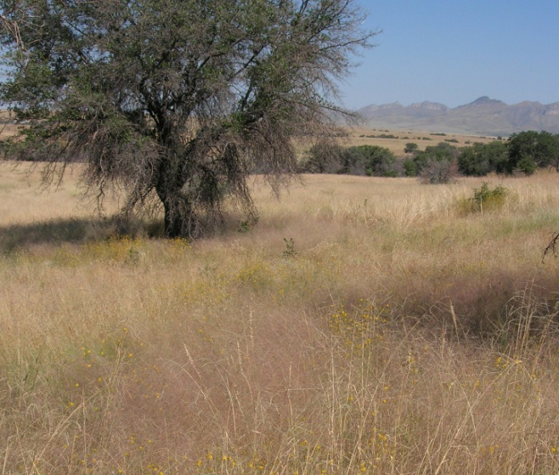

Plains Lovegrass reflects a pink hue in the mixed grasslands of Southeast Arizona.

#### **Alternate Names**

Plains Lovegrass

#### **Uses**

Plains Lovegrass is an important early spring forage grass for livestock and wildlife. Its seeds are also eaten by upland game birds. For restoration purposes, Plains Lovegrass establishes well following fire (Bock et al 2009).

#### **Status**

Please consult the PLANTS Web site and your State Department of Natural Resources for this plant’s current status (e.g., threatened or endangered species, state noxious status, and wetland indicator values).

**Description and Adaptation**

Plains Lovegrass is a native, warm season perennial bunchgrass. Plains Lovegrass typically grows 2 to 3 ½ feet tall. The inflorescence is an erect, open, diffuse, pyramid-shaped panicle 8 to 16 inches long and 6-12 inches wide. The spikelets have 3 to 9 flowers (Hitchcock 1951). The fresh inflorescence is pinkish in color.

Plains Lovegrass occurs from eastern California to Florida, north into Missouri and south into scattered locations of Central America. For updated distribution, please consult the Plant Profile page for this species on the PLANTS Web site.

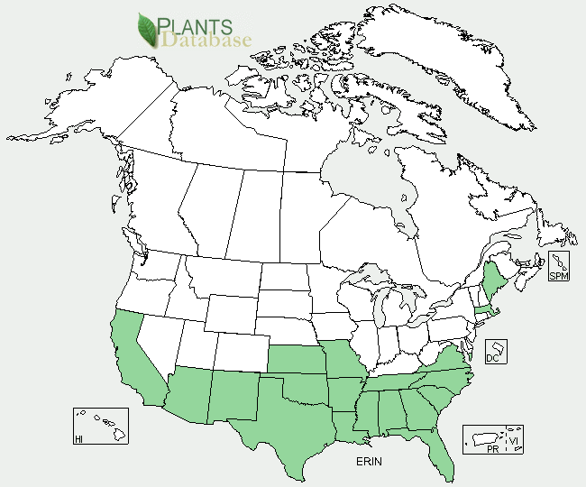

Plains Lovegrass distribution from USDA-NRCS PLANTS Database.

#### **Establishment**

Seed of Plains Lovegrass is reddish-brown, rectangular-prismatic in shape, and very small (3,386,000 per lb). Natural dispersal occurs when the fruiting stalks detach and tumble across the ground, releasing seed.

Recommended seeding rate is 0.3 pure live seed (PLS) lb per acre if planted with a drill, and approximately 0.6 PLS lb per acre if seed is broadcast. When used as part of a mix the seeding rate should be adjusted to the desired percentage of the mixture. Seed should be planted onto a firm, weed-free seedbed. Broadcast seeding should be followed lightly with a cultipacker or harrow to provide seed with a shallow covering of soil.

#### **Management**

Due to its high seed stalk to leaf ratio, this species is intermediate in forage preference to cattle. However, it is often heavily grazed because it is one of the first species to green up in the spring. Where grazing occurs, it often declines.

Because of its importance as an early spring forage plant, ranges where this species is still present should be managed in order to preserve or increase it. These ranges should be deferred from grazing during July and August every third year, if possible (Ruyle and Young 1997).

#### **Pests and Potential Problems**

Plains Lovegrass is at risk of overgrazing, and should be managed where grazing occurs.

#### **Cultivars, Improved, and Selected Materials (and area of origin)**

Bonita Germplasm (*Eragrostis intermedia*) Plains Lovegrass is a selected class release developed by the NRCS USDA Tucson Plant Materials Center for Southeast Arizona Major Land Resource Area (MLRA 41). MLRA 41 corresponds to Level 3 Ecoregion 79. It is a composite of 30 accessions collected from native Plains Lovegrass stands in Southeast Arizona and Southwest New Mexico.

#### **References**

Bock, Carl, J. Bock, M. Grant, T. Seastedt. 2009. Effects of fire on abundance of *Eragrostis intermedia* in a semi-arid grassland in southwestern Arizona. Journal of Vegetation Science, 6(3):325-328.

Ruyle, G. and D. Young, Eds. 1997. Arizona range grasses: their description, forage value and grazing management. University of Arizona Cooperative Extension. College of Agriculture. Tucson, Arizona. 85716.

Gould, F.W. 1977. Grasses of Southwestern United States. University of Arizona Press, Tucson, Arizona. 85716.

Hitchcock, A.S. 1951. Manual of the Grasses of the United States. Misc. Publ. No. 200. Washington, DC; U.S. Department of Agriculture, Agricultural Research Administration.

Kearney, T.H., and R.H. Peebles. 1969. Arizona flora. University of California Press, Berkeley, California.

#### **Prepared By**

#### Mary Hershdorfer, NRCS USDA Tucson Plant Materials Center.

#### **Citation**

## Hershdorfer, M. 2010Plant fact sheet for plains lovegrass (Eragrostis intermedia A.S. Hitchc.). USDA Natural Resources Conservation Service, Tucson Plant Materials Center, Tucson, AZ 85705

Published July, 2010

Edited:17Sep2009 mws; 01Jul2010 mh; 26Jul2010 jab

For more information about this and other plants, please contact your local NRCS field office or Conservation District <<http://www.nrcs.usda.gov/>>, and visit the PLANTS Web site <[http://plants.usda.gov](http://plants.usda.gov/)> or the Plant Materials Program Web site <<http://plant-materials.nrcs.usda.gov>>

**USDA IS AN EQUAL OPPORTUNITY PROVIDER AND EMPLOYER**