

Plant Fact Sheet

# COMMON WOOLLY SUNFLOWER

## Eriophyllum lanatum Forbes

Plant Symbol = ERLA6

Contributed by: NRCS Plant Materials Center, Pullman, WA

### Photo of common wooly sunflower by Ben Legler, University of Washington Burke Herbarium

*Eriophyllum lanatum*. Ben Legler, University of Washington Burke Herbarium

### Alternative Names

*Common Alternate Names:* Oregon sunshine, golden yarrow, yarrow leaved eriophyllum, dwarf woolly sunflower, Pursh’s woolyleaf

*Scientific Alternate Names:* None

### Uses

### *Pollinator habitat:* *Eriophyllum lanatam* attracts beetles, syrphid flies, bees, moths and butterflies. Butterflies that are known to visit this plant include: orange sulfur, red admiral, comma, and skipper. It also serves as a host plant for the painted lady butterfly. An endangered butterfly in Oregon, Fender’s Blue (*Icaricia icarioides fenderi*) relies on *E. lanatum* for a source of nectar. *Ornamental:* This plant is hardy to Zone 3 and can be used in perennial borders, along pathways, and in rock gardens and embankments. The Lady Bird Wildflower Center recommends selecting a local ecotype, planting several plants in a group, and pruning the dead branches. *Rangeland vegetation:* This plant is quick to establish and can be used for revegetation and diversification of rangeland in a variety of habitats.

### *Ethnobotanical:* People of the Miwok tribe made a poultice of the leaves of this plant and bound them to aching parts of the body; the Skagit rubbed the leaves on skin to prevent chapping; and the Chehalis used the dried flowers as a love charm.

### Status

Please consult the PLANTS Web site and your State Department of Natural Resources for this plant’s current status (e.g., threatened or endangered species, state noxious status, and wetland indicator values).

### Description and Adaptation

Sunflower family (Asteraceae). *Eriophyllum lanatum* is a native forb or subshrub, and may be an annual, biennial, or short- or long-lived perennial depending on site conditions. It has a multi-branched, erect to spreading form and grows to 10 to 60 cm (4 to 24 in) tall. Stems and leaves are covered with white hairs. Leaves are 2.5 to 7.5 cm (1 to 3 in) long and irregularly divided into narrow lobes. Flowers are solitary, on long stems and bloom May through July. The flower head is 4 to 6.5 cm (1.5 to 2.5 in) wide with golden yellow disk flowers and 8 to 12 yellow ray flowers, each 1.5 to 2 cm (0.6 to 0.8 in) long. Flower bracts are broad and erect. Seed is narrow, smooth, has four angles and a crown of scales or short pappus.

Common woolly sunflower is adapted to areas with dry, rocky or sandy soil which receive a minimum of 25 cm (10 in) annual precipitation at elevations from sea level to 3,050 m (10,000ft). The plant has a high drought tolerance due to its white hairs that conserve water by reflecting heat and reducing air movement across the leaf surfaces. It often grows in rocky areas along roadsides, on coulees, bluffs, and canyons, and in dry grassland, thickets and forests.

This plantis common on both sides of the Cascade Mountains from British Columbia south to Washington, Oregon and California. Its range extends east to Nevada, Idaho, northwestern Utah, western Wyoming, and western Montana.

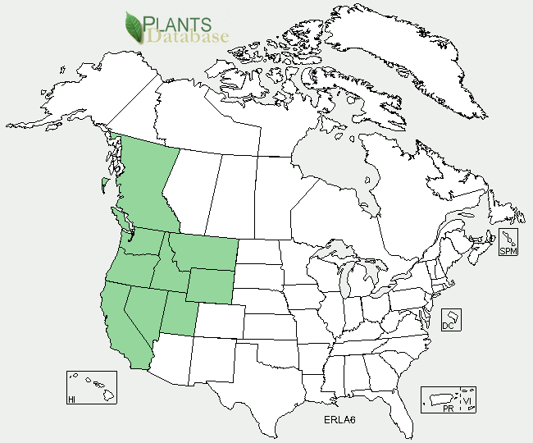

Common woolly sunflower distribution from USDA-NRCS PLANTS Database.

For updated distribution, please consult the Plant Profile page for this species on the PLANTS Web site.

### Establishment

Plants can be established by seed or seedlings. Seeds should be drilled into a weed-free seed bed in the fall at a rate of 3.4 kg PLS per ha (3 lbs PLS per acre) and at a depth of 0.6 cm (0.25 in). When planted in a mix, the seeding rate should be adjusted according to the proportion of the mix. The seed requires a cold and moist period of about 90 days for optimal germination.

To transplant seedlings, the seed should be planted in containers in October or November, stratified in cold and moist conditions for a period of 90 days, and moved inside to a greenhouse. The plants should be hardened off in a cold frame for 2 to 4 weeks prior to transplanting to a prepared field site. Plants should be spaced 15 to 45 cm (6 to 18 in) apart.

### Management

### *Eriophyllum lanatum* is a prolific seed producer and will rapidly spread to any surrounding open ground. If plant spread is not desired, flower heads should be removed prior to seed ripening.

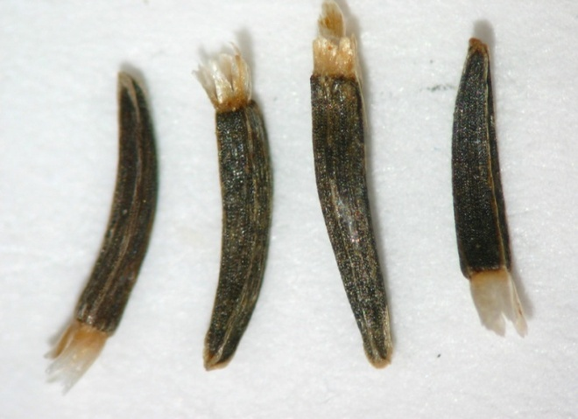

*Eriophyllum lanatum* seeds. Bend Seed Extractory, Seeds of Success

### Pests and Potential Problems

Insects may significantly damage the foliage and seed.

### Environmental Concerns

None.

### Cultivars, Improved, and Selected Materials (and area of origin)

None, although seed and seedlings are available from several vendors.

### Prepared By

*Pamela L.S. Pavek*, USDA NRCS Plant Materials Center, Pullman, Washington

### Citation

Pavek, P.L.S. 2012. Plant fact sheet for common woolly sunflower (*Eriophyllum lanatum*). USDA-Natural Resources Conservation Service, Pullman Plant Materials Center. Pullman, WA.

Published January 2012

Edited: 04Jan2012 plsp; 09Jan2012 aym; 13Jan2012 jab

For more information about this and other plants, please contact your local NRCS field office or Conservation District <<http://www.nrcs.usda.gov/>>, and visit the PLANTS Web site <[http://plants.usda.gov](http://plants.usda.gov/)> or the Plant Materials Program Web site <<http://plant-materials.nrcs.usda.gov>>

**USDA IS AN EQUAL OPPORTUNITY PROVIDER AND EMPLOYER**