

Plant Fact Sheet

# Clay-Loving Wild buckwheat

## Eriogonum pelinophilum Reveal

Plant Symbol = ERPE10

*Contributed by*: USDA NRCS Colorado Plant Materials Program

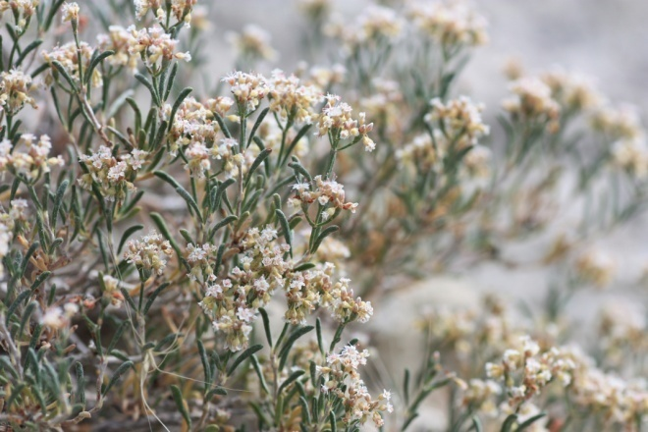

Figure1: Clay-loving wild buckwheat, Eriogonum pelinophilum..

Photo USFWS, Alicia Langton July 2010.

### Alternative Names

*N/A*

### Uses

Pollinators: Clay-loving wild buckwheat flowers are visited by more than 50 species of pollinators in a season. Roughly half of these 50 species are native bees, and 18 species are native ants . The USFWS and others have noted, that of all *Eriogonum* species studied to date, none has as many pollinators as clay-loving wild buckwheat.

### Status

Clay-loving wild buckwheat was designated as endangered, with critical habitat, by the USFWS in 1984.

The NatureServe conservation status rank an international effort which rank species on their “global” status, denotes clay-loving wild buckwheat as G2/S2- globally imperiled and statewide imperiled, with a high risk of extinction due to very restricted range, very few populations (often 20 or fewer), steep declines, or other factors.

Please consult the PLANTS Web site and your State Department of Natural Resources for this plant’s current status (e.g., threatened or endangered species, state noxious status, and wetland indicator values).

### Description and Adaptation

*General*: Buckwheat family (Polygonaceae). Clay-loving wild buckwheat is a long-lived low-growing, spreading sub-shrub, reaching up to 4 inches (10 centimeters) in height and 12 in (30 cm) across. “Stems are spreading without persistent leaf bases up to 1/3the height of the plant; aerial flowering stems spreading to erect, slender, leaves, 1 per node” . Leaves are dark green and appear needle-like with in-rolled margins. Flowers are white to cream with reddish-brown midribs and brownish-red bases, (Figure 2), petals all the same length. Fruits are achenes, light brown, 0.1 in (0.3 to 0.35 cm) and triangular in cross-section. Flowering occurs late May to early September.

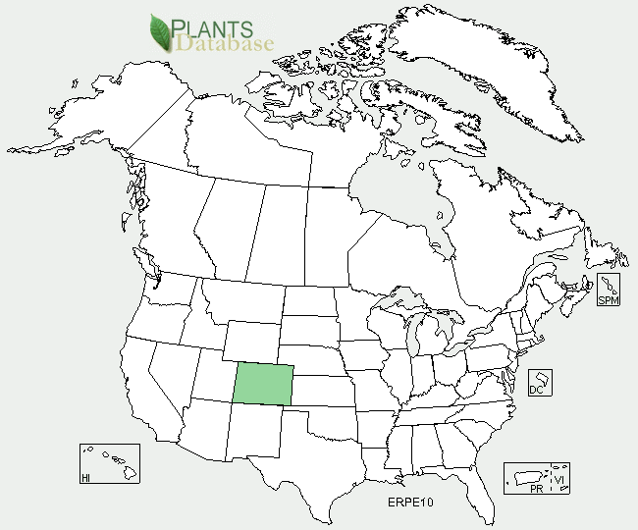

Clay-loving buckwheat distribution from USDA-NRCS PLANTS Database.

*Distribution*: Clay-loving wild buckwheat is endemic to the rolling clay (adobe) hills and flats immediately adjacent to the communities of Delta and Montrose, of west-central Colorado.

*Habitat*: The habitat of clay-loving wild buckwheat consists of adobe clay badland hills and flats within the sparsely vegetated desert shrub community. This plant community includes the following clay-loving buckwheat plant associates: mat saltbush (*Atriplex corrugata*), black sagebrush (*Artemesia nova*), shadscale (*Atriplex confertifolia*), Gardner’s saltbush, (*Atriplex gardneri*), bud sagebrush (*Picrothamnus desertorum*), charming woodyaster, (*Xylorhiza venusta),* and Adobe Hills beardtongue (*Penstemon retrorsus*).

**Adaptation**

Clay-loving wild buckwheat is adapted to the harsh growing conditions that include clay, alkaline, and calcareous soils of the Mancos shale formation, unique to west-central Colorado. The Mancos shale formation has been associated with high salts and selenium, however no selenium accumulation information related to clay-loving wild buckwheat is known at this time. At elevations ranging from 5,180 to 6,350 ft., clay-loving wild buckwheat is generally found growing on the mid to lower slopes of the rolling topography of the adobe Mancos shale hills, also occurring in swales or drainages. With an average annual total precipitation of 7-10 inches, clay-loving wild buckwheat is dependent upon the microclimates created by the small areas where snow lingers longer due to aspect, topography, and landscape position.

For updated distribution, please consult the Plant Profile page for this species on the PLANTS Web site.

### Establishment

Clay-loving wild buckwheat requires an insect pollinator in order to set seed, for both outcrossing and self-pollination (within a plant but not within a flower). O’Kane in 1985 stated that “seed dispersal is usually passive, either being consumed or carried by animals, windblown, or moved by gravity or water.” “All *Eriogonum* species studied thus far have seeds that require a cold period to break dormancy (not necessarily a freeze), and some *Eriogonum* species have seeds with a 5-year shelf life.”

### Management

Clay-loving wild buckwheat occurrences and suitable habitat continue to be threatened by growing development pressure and related expansion activities around the communities where it occurs. Additionally, 75% of the occupied habitat occurs on private lands. In Colorado, endangered plant species are not afforded protection unless a Federal nexus exists, such as canal development projects. Conservation efforts geared toward private lands would greatly benefit this species to prevent further isolation of the small existing populations most at risk from habitat fragmentation, thereby reducing the resiliency of these populations.

According to the Colorado Natural Areas Program life history study of clay-loving wild buckwheat, it appears that this species grows at highest densities away from other shrubs, such as black sagebrush *(Artemisia nova)*. Other research in which individuals of clay-loving wild buckwheat were permanently tagged from 1990 to 2008 supports the conclusion that this species is relatively long-lived (20-30years minimum).

### Pests and Potential Problems

Tent caterpillar impacts have been noted on clay-loving buckwheat.

### Environmental Concerns

The effects of climate change could pose continued uncertainty to the long term survival of clay-loving wild buckwheat populations. Due to the limited range of the Mancos shale formation and the long-lived nature of this species, its ability to migrate with changing climates is uncertain. Decreased or lack of flowering has been noted in association with the 1998 drought in the region, thereby causing concern that a lack of precipitation, during the growing and flowering season, could significantly impact seedling recruitment.

### Cultivars, Improved, and Selected Materials (and area of origin)

N/A

**Prepared By**:

*Christine Taliga*; Plant Materials Specialist, USDA NRCS, Denver, Colorado.

### Citation

Taliga, Christine E. Plant Fact Sheet for clay-loving wild buckwheat (*Eriogonum pelinophilum)*. USDA-Natural Resources Conservation Service, Colorado State Office. Denver, CO 80225-0426.

Published *September 2012*

Edited: 18Sep2012jab

For more information about this and other plants, please contact your local NRCS field office or Conservation District <<http://www.nrcs.usda.gov/>>, and visit the PLANTS Web site <[http://plants.usda.gov](http://plants.usda.gov/)> or the Plant Materials Program Web site <<http://plant-materials.nrcs.usda.gov>>.

**USDA IS AN EQUAL OPPORTUNITY PROVIDER AND EMPLOYER**