|  |
| --- |
| winterberry euonymus |
| *Euonymus bungeanus* Maxim. |
| Plant Symbol = EUBU6 |

Contributed by: USDA NRCS Plant Materials Program

© William S. Justice

Smithsonian Institute

@ USDA NRCS PLANTS

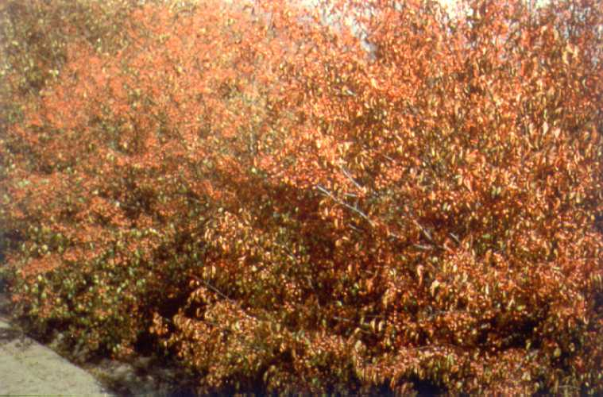

Uses

*Erosion control*: This plant can be used alone, in clumps, in single rows or in multiple rows for windbreaks. It is used on erodible sites for soil stabilization.

*Wildlife*: Winterberry euonymus provides desirable habitat for game and songbirds throughout the year.

*Landscape*: This plant can be used as a living screen, noise barrier, enhancement of transportation corridors, around campgrounds, and in urban and industrial developments.

Status

Please consult the PLANTS Web site and your State Department of Natural Resources for this plant’s current status (e.g. threatened or endangered species, state noxious status, and wetland indicator values).

Weediness

This plant may become weedy or invasive in some regions or habitats and may displace desirable vegetation if not properly managed. Please consult with your local NRCS Field Office, Cooperative Extension Service office, or state natural resource or agriculture department regarding its status and use. Weed information is also available from the PLANTS Web site at plants.usda.gov.

Description

*Euonymus bungeanum* Maxim., winterberry euonymus, is a long-lived, deciduous shrub that grows to a height and spread of 15 to 25 feet. The shrub is usually multiple-stemmed at or near the large base.

The light-green leaves are bright and shiny when they are small. They grow rapidly to a length of 2 to 4 inches. Slender petioles cause the older leaves to droop. The foliage is rather open, so that the light brown bark of the older branches adds contrast to the light-green leaves. Fall leaf color ranges from yellow to reddish or brown.

The flowers are inconspicuous, but the fruits are brilliant red. They are 4-lobed capsules, some of which often remain on the plants after the leaves have fallen. As the capsules open, the brilliant red coats of the seeds are exposed.

Adaptation and Distribution

It is a winter-hardy shrub that is adapted to a wide range of soil and climatic conditions. It is adapted from the low elevation of the mountains to the open plains. It has been widely tested and evaluated in Kansas, Oklahoma, northern Texas, New Mexico, Colorado, and portions of Nebraska.

For a current distribution map, please consult the Plant Profile page for this species on the PLANTS Website.

Establishment

Plants may be grown from recently harvested open-pollinated seed. Seed should be either fall-planted or stratified for spring planting. For field establishment, 2 year old bare root plants can be used under favorable conditions. Potted material has been more successful on difficult sites such as roadsides. All planted area must be weed free to allow for plant establishment and growth.

Management

Care should be taken to control unwanted vegetation in areas planted with winterberry euonymus.

Pests and Potential Problems

This plant has no serious pests.

Cultivars, Improved, and Selected Materials (and area of origin)

‘Pink Lady’ (China). Seed and plants are available from most commercial growers in the western half of the United States.

Prepared By & Species Coordinator:

USDA NRCS Plant Materials Program

Edited: 01Feb2002 JLK; 06jun06 jsp

For more information about this and other plants, please contact your local NRCS field office or Conservation District, and visit the PLANTS Web site<<http://plants.usda.gov>> or the Plant Materials Program Web site <<http://Plant-Materials.nrcs.usda.gov>>

*The U.S. Department of Agriculture (USDA) prohibits discrimination in all its programs and activities on the basis of race, color, national origin, sex, religion, age, disability, political beliefs, sexual orientation, and marital or family status. (Not all prohibited bases apply to all programs.) Persons with disabilities who require alternative means for communication of program information (Braille, large print, audiotape, etc.) should contact USDA's* [*TARGET Center*](http://www.usda.gov/oo/target.htm) *at 202-720-2600 (voice and TDD).*

*To file a complaint of discrimination write USDA, Director, Office of Civil Rights, Room 326-W, Whitten Building, 14th and Independence Avenue, SW, Washington, DC 20250-9410 or call 202-720-5964 (voice or TDD). USDA is an equal opportunity provider and employer.*

*Read about* [*Civil Rights at the Natural Resources Convervation Service*](http://www.nrcs.usda.gov/about/civilrights/)*.*