

Plant Fact Sheet

# COMMON boneset

## Eupatorium perfoliatum L.

Plant Symbol = EUPE3

Contributed by: USDA NRCS National Plant Materials Center, Beltsville, MD

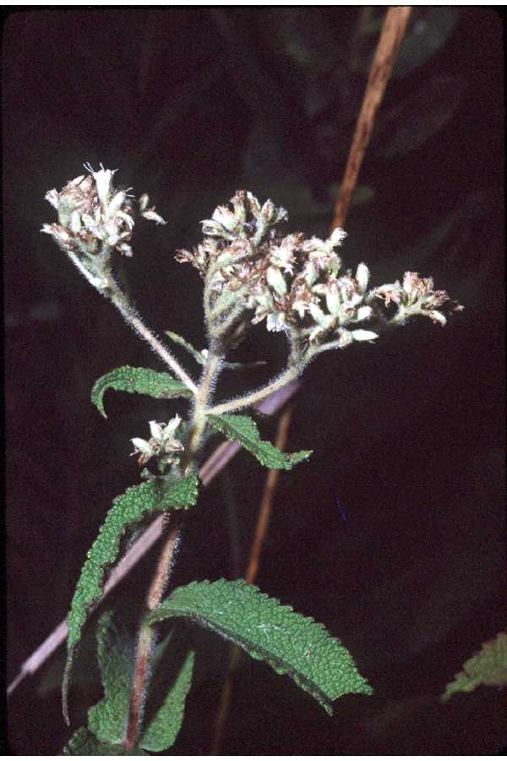

Robert H. Mohlenbrock @ USDA-NRCS PLANTS Database / USDA SCS. 1989. *Midwest wetland flora: Field office illustrated guide to plant species*. Midwest National Technical Center, Lincoln, Nebraska

Alternate Names

Common boneset, Thoroughwort

Uses

*Ethnobotanical:* The leaves have been used to treat dengue fever. Modern German research suggests that Common Boneset may act as a general immune system stimulant. It has also been used as a diaphoretic and weak anti-inflammatory. Caution: Common Boneset is emetic and laxative in large doses, and it may contain pyrrolizidine alkaloids that are potentially harmful to the liver.

### *Landscaping and wildlife:* The nectar from the flowers of Common Boneset is very attractive to a variety of pollinators, including bees, wasps, and butterflies. The Swamp Sparrow supplements its diet with Common Boneset seeds. Various caterpillars, such as *Phragmatobia lineate* (Lined Ruby Tiger Moth), *Papaipema cataphracta* (Burdock Borer Moth), *Schinia trifascia* (Three-lined Flower Moth), *Chlorochlamys chloroleucaria* (blackberry looper), *Semiothisa continuata* (Geometrid Moth sp.)and *Haploa clymene* (Clymene Moth) eat various portions of the plant.

Status

Please consult the PLANTS Web site and your State Department of Natural Resources for this plant’s current status (e.g. threatened or endangered species, state noxious status, and wetland indicator values).

Description and Adaptation

Common Boneset is a native perennial wildflower that grows from 2 - 4 feet tall. The central stem is covered in long white hairs and is unbranched with the exception of a few flowering side stems near the apex of the plant. The narrow, lanceolate (tapering), opposite leaves grow up to 8 inches long and 2 inches across. The bases of the leaves tend to grow together, making it appear as if the central stem perforates the leaves. Two- to eight-inch clusters of fragrant white flowers (with approximately 15 florets per flower head) appear in late summer or early fall. The florets produce wind-dispersed small dry seed with hair-like bristles. The fibrous root system frequently produces rhizomes (subterranean [horizontal](http://www.wordwebonline.com/en/HORIZONTAL) [stems](http://www.wordwebonline.com/en/STEM) with [shoots](http://www.wordwebonline.com/en/SHOOT) [above](http://www.wordwebonline.com/en/ABOVE) and [roots](http://www.wordwebonline.com/en/ROOTS) [below](http://www.wordwebonline.com/en/BELOW)), which create small colonies.

*Distribution:* Common Boneset prefers moist or wet conditions, soil with a significant amount of organic matter, and full to partial sun. It populates a variety of wetland habitats across eastern North America from Quebec south to Florida and west to Texas and Manitoba (USDA cold hardiness zones 2 - 10).

Establishment

*Seed Propagation*

Seeds ripen about a month after flowering and should be collected when the heads dry, split and the fluffy seed begins to float away. If collected earlier, dry the seed heads for 1 - 2 weeks in open paper bags. If seeds are sown directly, sow in the fall and sow thickly as germination rates are typically low. For container production, a cold-moist pretreatment at 40 degrees Fahrenheit for 3 weeks to 3 months will increase germination percentages. After pretreatment, sow seeds in a fine germination mix containing milled sphagnum moss. Transplant to potting mix after seeds have germinated. Seeds germinate at 70 - 85 degrees Fahrenheit and in the presence of light. Use a greenhouse with alternating temperatures (day temperatures 70 - 85 degrees Fahrenheit, night temperatures 65 - 68 degrees Fahrenheit). Seeds will last up to 3 years if stored in a cold (40 degrees Fahrenheit) and dry (30% relative humidity) environment.

*Vegetative Propagation*

Common Boneset can be propagated by division or two-node softwood tip cuttings taken in late spring. Divide the plants in the fall as they go dormant or in the spring just as shoots first appear.

Management

Common Boneset prefers moist to wet soil and full or partial sun. Livestock generally find the foliage of Common Boneset too bitter for grazing.

Pests and Potential Problems

The leaves of Common Boneset are favored by grasshoppers, flea beetles and saw flies, which can leave them looking bedraggled by midsummer. It is not drought-tolerant.

Environmental Concerns

No concerns at this time.

Cultivars, Improved, and Selected Materials (and area of origin)

There are no recommended cultivars or selected materials at this time.

Prepared By:

Samantha Kirk (Horticultural Volunteer) and Shawn Belt (Horticulturist), USDA NRCS National Plant Materials Center, Beltsville, MD.

Species Coordinator:

Shawn Belt, USDA NRCS National Plant Materials Center, Beltsville, MD

### Citation

Belt, S. 2009. Plant fact sheet for common boneset (*Eupatorium perfoliatum* L.). USDA-Natural Resources Conservation Service, Norman A. Berg National Plant Materials Center, Beltsville, MD 20705.

Published September 2009

Edited: 03-Nov-2008 SMK; 090112 jsp

For more information about this and other plants, please contact your local NRCS field office or Conservation District <<http://www.nrcs.usda.gov/>>, and visit the PLANTS Web site <[http://plants.usda.gov](http://plants.usda.gov/)> or the Plant Materials Program Web site <<http://plant-materials.nrcs.usda.gov>>

**USDA IS AN EQUAL OPPORTUNITY PROVIDER AND EMPLOYER**