

Plant Fact Sheet

# Sand fescue

## Festuca ammobia Pavlick

Plant Symbol = FEAM5

Contributed by: USDA NRCS Plant Materials Center, Corvallis, Oregon

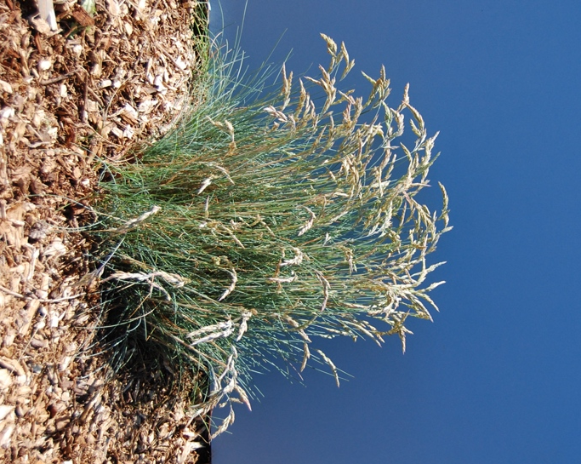

Figure 1. Sand fescue in flower. Photo by Dale Darris.

### Alternate Names

Depending on the taxonomic authority, other names include *Festuca* *rubra* ssp. *arenicola, Festuca rubra* ssp. *densiuscula,* and *Festuca rubra* ssp. *pruinosa* or rock fescue. Classification remains under review.

### Uses

Sand fescue spreads by short rhizomes (underground stems) and develops extensive roots giving it excellent soil and sand binding capability for erosion control along beaches and streambanks, and on other disturbed slopes. Additional uses include forage for cattle and horses, endemic wildlife food and cover, and restoration of coastal meadows and other native plant communities. The species is also planted for low maintenance turf and ornamental landscaping. It has potential as perennial cover in vineyards, young orchards, and no-mow lawns.

**Status**

Sand fescue occurs equally in wetlands and drier uplands. Please consult the PLANTS Web site and your State Department of Natural Resources for this plant’s current status (e.g., threatened or endangered species, state noxious status, and wetland indicator values).

### Description and Adaptation

Sand fescue is a dense, fine textured, medium to long lived, perennial cool season grass. It spreads slowly from rhizomes and seed. Foliage is primarily basal and typically green, with some individuals or populations turning blue-grey in summer. Stems (culms) grow to a height of 8-24 inches (20-60 cm) and the flower head (panicle or inflorescence) is branched but often compressed rather than open. Most populations flower in May or June, maturing seed a month later. Sand fescue is part of a diverse complex of red fescue species that have transitional forms and introduced germplasm. They intergrade from one to another making separation and identification difficult and somewhat disputed.

The prototypical native sand fescue is found on beaches, rock crevices, meadows, gravelly sites, and streambanks in full sun to partial shade primarily along the Pacific Coast. It occurs only at lower elevations on moist to moderately dry soils from California to Washington. The natural range may extend further north into coastal British Columbia but not inland. The species tolerates many soil types besides sands, including silty clay loams with low fertility. Coastal types have presumed tolerance to salt spray and preference for moderately acidic to neutral, well- to moderately well-drained soils. Drought tolerance may exceed that of other closely related red fescues.

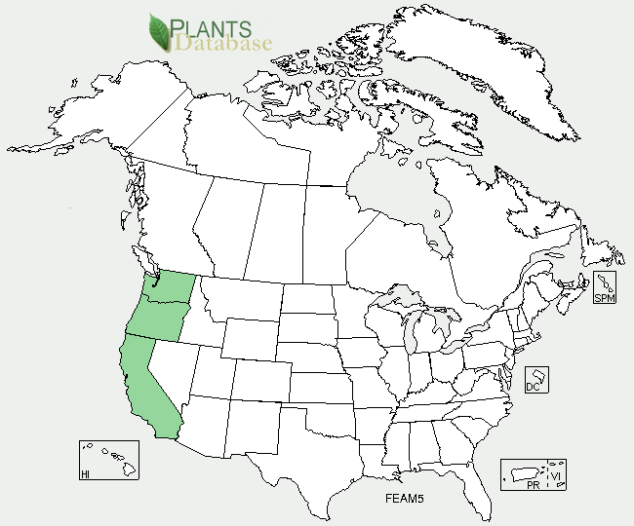

Figure 2.Sand fescue distribution from USDA-NRCS PLANTS Database.

For updated distribution, please consult the Plant Profile page for this species on the PLANTS Web site.

### Establishment

Sand fescue seed germinates readily, indicating dormancy is low or nonexistent in most populations. Fall sowing is preferred to reduce the need for irrigation the following spring and summer. Establishment is slow and plants seldom flower the first full growing season. Where weed competition is expected to be high, fertilization should be postponed for the first six months or more. There are 365,000 to 500,000 seeds/lb. A 1 lb/ac pure live seed (PLS) rate results in 8-12 live seeds/sq. ft. Suggested seeding rates for general revegetation are 4-10 lbs/ac when drilled alone at a depth of ¼ to ½ in. If broadcast sown, rates are often increased 1.5 to 2 times this amount. For turf, a rate of 1 lb/1000 sq. ft. has been recommended. As with many grasses to be planted on initially poor quality soils, an organic mulch or compost amendment can benefit establishment and growth.

### Management

In western Oregon, fall sown plants readily survive the wet winters and warm, dry summers and often remain actively growing throughout the dry season without supplemental water. Under hot, dry conditions of California’s Central Valley, regular, deep spring and summer irrigation is beneficial to keep plants green, and may be required for survival on very droughty soils. Long term tolerance to high heat is yet to be determined.

Until more is known, grazing management practices similar to those suggested for introduced creeping red fescue and related pasture mixtures should be used. In a mowing study at Corvallis, Oregon, plants were injured (partial die off at the base) and the number of seed heads reduced in the spring following a single fall mowing at a height of 1 to 1 ½ in. For turf or ground cover management, plants should not be mowed below a 2 ½ in. height. Fertilization is optional depending on goals and site conditions. Sand fescue appears to perform well under low fertility. Foliage can become grey-blue in summer.

### Pests and Potential Problems

### Sand fescue has few apparent insect problems. Among the most frequently observed foliar diseases are fungal leaf and stem rusts in the genus *Puccinia*. Occurrence of other turf and pasture diseases typical of red fescues is not well documented. Rodents such as voles, field mice, and pocket gophers can damage plants and stands in some years. The species is slow to establish and plants may suffer early on from weed competition.Environmental Concerns

Sand fescue is not considered weedy within its natural range. The potential exists for populations to cross with other native and introduced forms or species of red fescue creating intermediate types or hybrids.

### Cultivars, Improved, and Selected Materials (and area of origin)

Molate red fescue, Point Molate fescue, and Molate fescue are unofficial names that appear in the seed trade and may be derived from native sand fescue growing along the Pacific Coast. A natural blue form of the species is the cultivar ‘Molate Blue’. It was first collected and developed by David Amme from a remnant coastal prairie population at Point Molate near San Francisco, California. ‘Molate Blue’ is under Plant Variety Protection (PVP) and produced commercially in California. The Corvallis Plant Materials Center is increasing seed of material derived from Coastal Oregon and selected for its blue color, shorter seed heads, and fewer visual signs of leaf and stem rusts.

### Prepared By

Dale Darris, USDA NRCS, Corvallis Plant Materials Center

### Citation

Darris, D. 2011. Plant fact sheet for sand fescue (*Festuca ammobia*). USDA Natural Resources Conservation Service, Corvallis, Oregon. 97330.

Published September 2011

Edited: 02nov2011dcd

For more information about this and other plants, please contact your local NRCS field office or Conservation District <<http://www.nrcs.usda.gov/>>, and visit the PLANTS Web site <[http://plants.usda.gov](http://plants.usda.gov/)> or the Plant Materials Program Web site <<http://plant-materials.nrcs.usda.gov>>

**USDA IS AN EQUAL OPPORTUNITY PROVIDER AND EMPLOYER**