

Plant Fact Sheet

# roemer’s fescue

## Festuca roemeri (Pavlick) E.B. Alexeev

Plant Symbol = FERO

Contributed by: USDA NRCS Plant Materials Center, Corvallis, Oregon

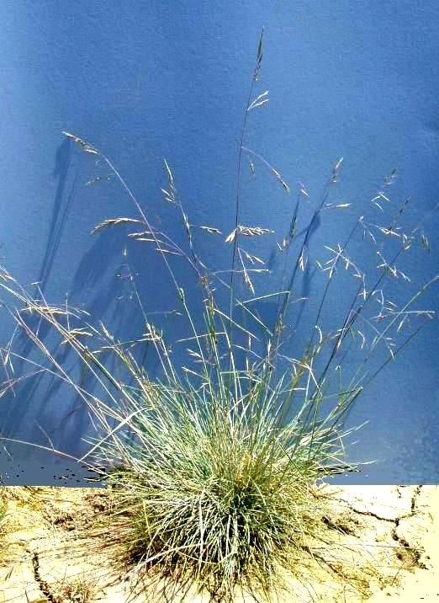

Roemer's fescue. Photo by Dale Darris, NRCS, Corvallis, OR

### Alternative Names

*Alternate Common Names:* northern Roemer’s fescue, southern Roemer’s fescue

*Alternate Scientific Names: Festuca idahoensis* Elmer ssp. *roemeri* (Pavlick) S. Aiken, *Festuca idahoensis* Elmer var*. roemeri* Pavlick*, Festuca roemeri* (Pavlick) E. B. Alexeev *var. roemeri*, *Festuca roemeri* (Pavlick) E. B. Alexeev var. *klamathensis* B.L. Wilson.

### Uses

Roemer’s fescue is an important native grass for restoration of upland prairie, oak savanna, rangeland, and grassy balds, as well as wildlife habitat improvement within its natural range. This includes food or cover for various song and game birds, small mammals, and beneficial insects. Forage value and palatability for wildlife and livestock are not well documented but may be similar to Idaho fescue (*Festuca* *idahoensis*). As a range grass, Idaho fescue is rated as fair to good forage. Roemer’s fescue is drought tolerant and its non-aggressive growth habit is compatible with forbs. After further evaluation, other uses may include general revegetation and erosion control of disturbed sites and roadsides where a fine textured perennial grass is desired, low input turf, and cover crop for vineyards or young orchards. Some specimens have ornamental value, especially those with blue and purple tinged foliage.

### Status

Please consult the PLANTS Web site and your State Department of Natural Resources for this plant’s current status (e.g., threatened or endangered species, state noxious status, and wetland indicator values).

### Description and Adaptation

Roemer’s fescue is a native cool season, perennial bunchgrass with and mostly basal foliage that is fine-textured and dense. Individuals live anywhere from a few years to a couple decades. The basal width of the plant is 3.5 to 7.0 inches. Leaves are often covered with a white waxy coating and their color varies from shades of green to pale blue. The stiff, erect, smooth stems terminate in an open seedhead (panicle) and grow 14 to 45 inches tall. The stems range in color from yellow-green to purple or red, turning mostly straw colored at maturity. Plants rarely flower until May or June of the second full growing season. Seed typically matures from June to July.

Roemer’s fescue naturally occurs from southwest British Columbia to the San Francisco Bay Area of California, remaining entirelywest of the Cascade and northern Sierra Nevada Mountain Ranges. Its elevation range is 40 to 6000 feet above sea level. For updated distribution, please consult the Plant Profile page for this species on the PLANTS Web site.

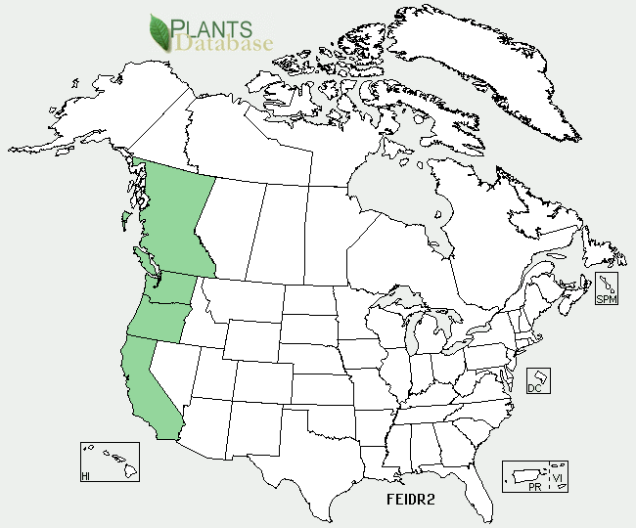

Roemer’s fescue distribution from USDA-NRCS PLANTS Database.

### Roemer’s fescue occurs on moderately dry to moist prairies, savannas, meadows, and grassy openings within woods. It grows best in full sun and part shade near trees on moderately well to well-drained, medium to fine-textured soils that are moderately acidic to slightly basic. While relatively drought tolerant with extensive roots, it favors somewhat more moist rather than drier sites within a habitat. Locally adapted populations can tolerate rocky, shallow, infertile soils, wildfire, and serpentine substrates (soils toxic to many plants due to high levels of magnesium and iron silicates and other minerals), but not salinity or water logged soils.

### Establishment

Seed of Roemer’s fescue typically germinates without treatment indicating dormancy is low. However, germination is quicker and more uniform after 14 days of cold (34-38°F), moist stratification (moist chilling). Fall seeding is generally preferred but not required with untreated seed. Rate of establishment is relatively slow compared to more vigorous grasses. There are approximately 500,000 seeds per pound with hulls intact. A seeding rate of 1 pound per acre results in about 12 seeds per square foot. Sown alone, recommended rates for revegetation vary from 4 to 20 pure live seed (PLS) pounds per acre depending on goals, method of sowing, and site conditions. Fertilization encourages weed competition and should be avoided the first four to six months.

### Management

### If Roemer’s fescue is managed for forage production, a rotational system of moderate grazing similar to that used for Idaho fescue is suggested. Idaho fescue is susceptible to overgrazing. Plants should be allowed to re-seed every three or four years. In settings where utilization is low, prescribed burning or mowing every few years are possible tools to maintain stand vigor and stimulate reproductive capacity. For cover or low input turf, Roemer’s fescue tolerates being mowed two to three times a year at moderate heights (2-3 inches) with or without fertilization.

### Pests and Potential Problems

Roemer’s fescue is a known host of rust diseases (*Puccinea* spp.) which may warrant control in some years when cultivated for seed. Traces to minor amounts of ergot disease (*Claviceps purpurea*) have been observed in some populations of Roemer’s fescue. The same rusts and ergot commonly infect other grasses, so their presence on this species, if detected, is not deemed a special risk. In some states, rust can be treated with approved fungicides. Always read and follow label instructions. In the unlikely event of ergot becoming abundant, special precautions should be considered to avoid toxicity to grazing animals (such as mowing or temporary livestock exclusion).

### Environmental Concerns

Roemer’s fescue is not considered weedy within its natural range and is often planted to enhance or restore native prairie ecosystems. Misidentification between Roemer’s fescue and introduced red fescue (*Festuca rubra*) may lead to contamination of seed fields and restoration sites.

### Cultivars, Improved, and Selected Materials (and area of origin)

The NRCS Corvallis Plant Materials Center in cooperation with the Institute for Applied Ecology, Corvallis, OR, developed five selected class pre-varieties of Roemer’s fescue for upland prairie restoration and other conservation uses in the Pacific Northwest, USA. Each was named to reflect their natural geographic origin and primary intended area of use (ecoregions): Willamette Valley Germplasm for the Willamette Valley (OR), Puget Germplasm for the Puget Trough (WA), San Juan Germplasm for islands of the northern Puget Sound and Olympic rain shadow (WA), Northwest Maritime Germplasm for the Coast Range (OR, WA), and Klamath Mountains Germplasm for the Klamath -Siskiyou Mountains region (OR, CA). Each germplasm is a polycross comprised of two to nine populations to enhance genetic diversity over single wild populations. After further testing, adaptation and use of some germplasms may extend to adjacent ecoregions for select purposes outside of restoration.

Seed and plants of other local, unimproved, and selected or manipulated populations of Roemer’s fescue are commercially available from several seed companies and nurseries, but none are official pre-varieties or cultivars.

### Prepared By

### Dale Darris, Sonja Johnson, and Amy Bartow. USDA NRCS Plant Materials Center, Corvallis, Oregon.

### Citation

Darris, D., S. Johnson, and A. Bartow. 2012 (revised). Plant fact sheet for Roemer’s fescue (*Festuca roemeri*). USDA-Natural Resources Conservation Service, Plant Materials Center. Corvallis, OR.

Published May 2006, revised July 2012.

#### Edited: [31Jul2007dcd; 01Aug 2007 jsp; 17Jul2012dcd; 18Jul2012 aym]

For more information about this and other plants, please contact your local NRCS field office or Conservation District <<http://www.nrcs.usda.gov/>>, and visit the PLANTS Web site <[http://plants.usda.gov](http://plants.usda.gov/)> or the Plant Materials Program Web site <<http://plant-materials.nrcs.usda.gov>>

**USDA IS AN EQUAL OPPORTUNITY PROVIDER AND EMPLOYER**