

Plant Fact Sheet

# blanketflower

## Gaillardia aristata Pursh

Plant Symbol = GAAR

*Contributed by: USDA NRCS Bridger Plant Materials Center, Bridger, Montana*

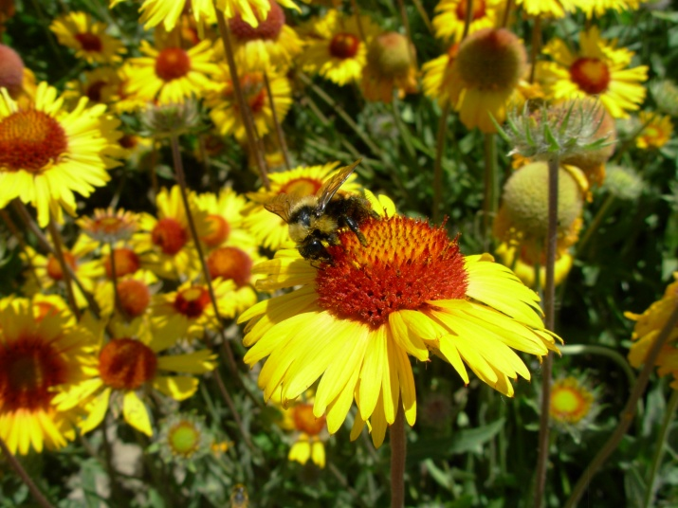

Gaillardia aristata, Susan R. Winslow, Bridger PMC

### Alternate Names

Indian blanketflower, common gaillardia, gaillardia

### Uses

Blanketflower is a native perennial wildflower useful for adding species diversity in native plant seed mixes for rehabilitation of disturbed sites. It can be used in producing native wildflower sod for restoration of native plant colonies. Blanketflower is suitable for use as an ornamental wildflower in low maintenance or naturalistic landscapes. It has utility as a cover and food source for pollinators, wildlife, and livestock.

### Status

Please consult the PLANTS Web site and your State Department of Natural Resources for this plant’s current status (e.g., threatened or endangered species, state noxious status, and wetland indicator values).

### Description and Adaptation

Blanketflower is a native, perennial, tap-rooted wildflower with showy, yellow ray flowers and reddish-brown central disk flowers. The pubescent plants vary from 10 to 24 inches in height. Leaves are arranged alternately along the stem and are 3 to 6 inches long with margins that are coarsely-toothed and deeply divided. Blanketflower grows on sunny, well-drained sites in prairie meadows up to grassy openings in the mountains. It has an extensive bloom period beginning in early summer.

It does well on a variety of soil types, including loams to rocky to gravelly-sandy textures; and tolerates a soil pH range from slightly acidic to mildly alkaline. Blanketflower attains optimum growth in full sun, beginning in early spring until seed set in late summer. It occurs at elevations from 1,300 to 9,000 ft.

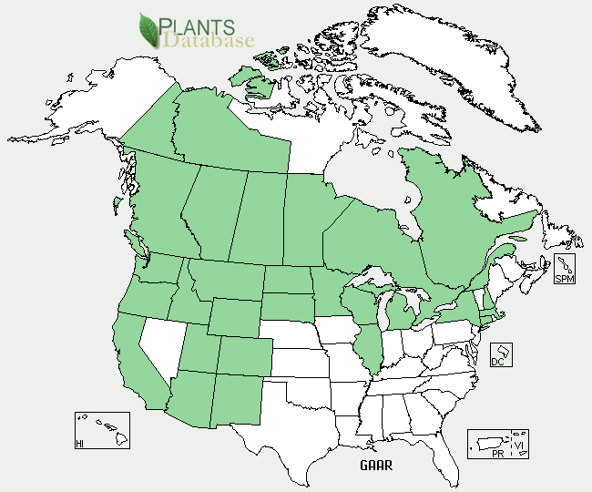

Blanketflower distribution from USDA-NRCS PLANTS Database

For updated distribution, please consult the Plant Profile page for this species on the PLANTS Web site.

### Establishment

Blanketflower may be grown from seed or division of vegetative parts. The seed does not require cold stratification treatment to break dormancy. For range plantings, seed should be planted into a firm, weed-free seedbed, preferably with a mechanical drill that will ensure uniform seed placement depth of ¼- to ½-inch. There are approximately 220,700 seeds in one pound of blanketflower. The full seeding rate is 5 pounds pure live seed/acre, but it would seldom be seeded in a pure stand. It is recommended that blanketflower be included as a component of a native seed mixture at a rate not to exceed ½ to 1 pound pure live seed/acre. When used in a mix, adjust the seeding rate to the desired percentage of mix. Spring seeding is preferred over late summer or dormant, fall planting dates.

Seed production fields should be established in rows at 25 pure live seeds per lineal foot of row. Between-row spacing is dependent on the type of planting and cultivation equipment, and ranges from 24 to 36 inches. Adequate between-row space should be provided to perform mechanical cultivation. At 24-inch row spacing, the recommended seeding rate is 2.5 pounds pure live seed/acre, and at 30- and 36-inch row spacing, the seeding rate is 2.2 and 1.9 pounds pure live seed/acre, respectively. There are presently no herbicides specifically labeled to control weeds in seed production fields of this species. Seed harvest can be accomplished by direct combining when the seeds have just begun to shatter from the radiate flower head. Immediately after combining, spread out harvested material to dry and prevent mold. Due to the persistent hairy pappus, and poor seed flow, this species is fairly difficult to clean. Seeds are moderately viable and longevity can be expected for several years when stored at favorable temperatures and low humidity. Meriwether Germplasm blanketflower yielded approximately 150 bulk pounds of seed per acre in experimental irrigated plots at the Bridger Plant Materials Center (BPMC) on an average harvest date of July 29. Seed production is expected to be much higher when grown under conventional agronomic conditions.

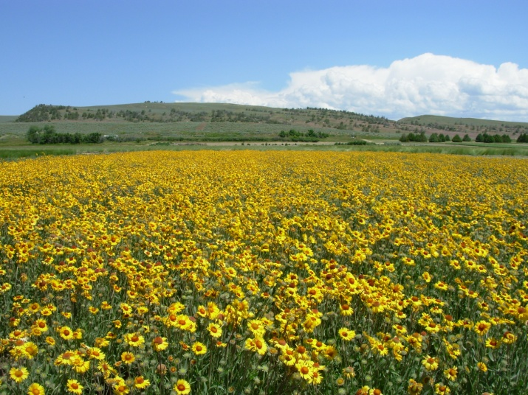

Seed production field in Montana Susan R. Winslow Bridger PMC

Blanketflower seed may be planted directly in containers without pre-treatment for greenhouse production. Seeds dry stored for three months or more do not require a cold stratification to overcome dormancy. However, a brief period of a cold, moist stratification improves germination uniformity. In a 10 in3 cone-tainer, a tight root mass is expected to develop in approximately four months. Containerized material should be transplanted after the last killing frost in the spring in advance of hot, dry weather, and no later than 30 to 45 days before the first killing frost in the fall of the year.

### Management

Blanketflower is tolerant of drought and requires supplemental moisture only during extended hot and dry conditions. Periodic mowing during the establishment year is one option for weed suppression.

### Pests and Potential Problems

Blanketflower has no serious insect or disease problems. Root rot may be a problem in poorly drained soils, especially during extended periods of heavy rain. Powdery mildew may be present at times of elevated humidity, but usually does not have a long-term negative impact on the plants. The species generally is susceptible to aster yellows and fungal leaf spot disease. Gaillardia is slightly susceptible to oat blue dwarf virus.

### Environmental Concerns

Blanketflower plants tend to be moderately long-lived and may re-seed in abundance. A skin rash or irritation may develop following contact with juice or sap from the foliage.

### Cultivars, Improved, and Selected Materials (and area of origin)

Meriwether Germplasm Selected Class blanketflower was released in 2011 by the BPMC in cooperation with the agricultural experiment stations of Montana State University and the University of Wyoming. Meriwether Germplasm is a composite of seed collections from 14 Montana counties and one county in Wyoming.

### Prepared By

*Susan R. Winslow*

USDA-NRCS Plant Materials Center

Bridger, Montana

### Citation

Winslow, S. 2011. Plant fact sheet for blanketflower (*Gaillardia aristata)*. USDA-Natural Resources Conservation Service, Plant Materials Center. Bridger, MT, 59014.

Published August, 2011

Edited: [25July2011 srw; 26July2011 jsj;26July2011 jds; 01August2011 jab; 01September2011 hh; 13September2011 rmg].

For more information about this and other plants, please contact your local NRCS field office or Conservation District <<http://www.nrcs.usda.gov/>>, and visit the PLANTS Web site <[http://plants.usda.gov](http://plants.usda.gov/)> or the Plant Materials Program Web site <<http://plant-materials.nrcs.usda.gov>>.

**USDA IS AN EQUAL OPPORTUNITY PROVIDER AND EMPLOYER**