|  |
| --- |
| American Licorice |
| *Glycyrrhiza lepidota* Pursch. |
| Plant Symbol = GLLE3 |

Contributed by: USDA NRCS Plant Materials Center, Manhattan, Kansas

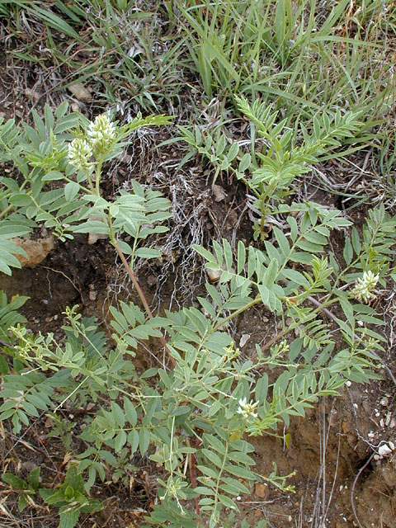

Copyright: Mike Haddock

Kansas Wildflowers and Grasses Website

Alternate Names

Wild licorice, licorice-root, and dessert root

Uses

*Grazing/Rangeland:* Forage analysis indicates that American licorice produces highly digestible and nutritious forage which compares favorably with alfalfa. Forage of juvenile licorice is greedily eaten by cattle. Close grazing will eliminate American licorice from a stand by the time the pasture is considered to be in fair condition. Its bur-like seed pod can become entangled in sheep wool and cause dockage when sold.

*Wildlife value*: Deer and pronghorn antelope consume licorice foliage. Birds and small rodents eat the seed of licorice, while pocket gophers consume their roots.

*Erosion control:* It has a deep root system extending some 12 feet into the prairie soil. It is recognized for its soil binding capabilities and it has wide ecological amplitude. Licorice has extensive rhizome production and it exhibited vigorous growth on mine spoil sites in North Dakota.

*Ethnobotanical:* American licorice was widely used as medicine by the Indians of the Great Plains. The Cheyenne’s drank medicinal tea made from the peeled, dry roots of the plant for diarrhea and upset stomach. The Lakota’s used the root as a medicine for flu. The Dakota’s steeped the licorice leaves in boiling water to make a topical medicine for earache. The roots were also chewed and held in the mouth to relieve toothache. The Blackfeet made a tea from the root to relieve coughs, chest pain, and sore throat.

Status

Please consult the PLANTS Web site and your State Department of Natural Resources for this plant’s current status (e.g. threatened or endangered species, state noxious status, and wetland indicator values).

Description and Adaptation

This plant belongs to the legume family (Fabaceae). *Glycyrrhiza* is a Greek word that means “sweet root”. The species name, *lepidota,* means “scaly” and refers to the minute scales on young leaves. American licorice is a native, perennial legume common to disturbed areas, draws, woods, and depressions over much of temperate North America. The plant reproduces by seed and underground stems called rhizomes. Licorice has an erect growth habit and is 1.5 to 3 feet tall. Its stems are smooth and branched. The leaves are smooth, alternately attached to the stem, and have many (7 to 21) leaflets that are arranged opposite each other along the leaf stem. The flowers are on short stalks and crowded on terminal spikes. Its flowers are yellowish-white and shaped similar to alfalfa flowers. Flowers bloom June to August and seed matures from July to October. The seed pods are brown, leathery and ½ to 1 inch long. The pods are covered with many stout, hooked, brown spines which form a burr. This hooked pod assists the plant in dispersal since they stick to animal fur and are moved to new growing sites. The Dakota name for licorice is “wi-nawizi” (jealous woman), refers to the burrs which “take hold of a man”. Seeds are green to reddish-brown, smooth and bean shaped.

Establishment

Seed scarification of licorice is important for quick and consistent germination of this legume species. Since this is a legume species it should be inoculated with r*hizobium* *Glycyrrhiza* Spec. 1 before planting to allow for nodulation of the plants. This inoculation will allow for the plant to produce nitrogen through the symbiotic relationship with the bacterium.

Management

Manage the plant for the intended use of the species whether that be for forage production, wildlife habitat, or conservation improvement.

Pests and Potential Problems

A bruchid beetle *Acanthosclides aureolus* is a major seed predator of American licorice. A rust fungus *Uromyces glycyrrhizae* has been reported on American licorice in South Dakota. In germination and establishment studies with licorice scientists discovered that some populations of this species exhibited chlorophyll deficient seedlings that were fatal to the individual seedlings. American licorice plants grown in a monoculture situation did not produce very many flowering structures.

Environmental Concerns

The only environmental concern would be the fact that some people consider licorice to be prone to weediness. It does have aggressive vegetative reproduction via rhizomes in a monoculture situation.

The bur-like seed pods can become entangled in domestic livestock or animal fur.

Cultivars, Improved, and Selected Materials (and area of origin)

At the present time there are no cultivar releases or any type of plant materials releases of American licorice.

Prepared By and Species Coordinator:

Richard Wynia, USDA NRCS Manhattan Plant Materials Center, Manhattan, Kansas

Edited: 070817 jsp

For more information about this and other plants, please contact your local NRCS field office or Conservation District, and visit the PLANTS Web site<<http://plants.usda.gov>> or the Plant Materials Program Web site <<http://Plant-Materials.nrcs.usda.gov>>

*The U.S. Department of Agriculture (USDA) prohibits discrimination in all its programs and activities on the basis of race, color, national origin, sex, religion, age, disability, political beliefs, sexual orientation, and marital or family status. (Not all prohibited bases apply to all programs.) Persons with disabilities who require alternative means for communication of program information (Braille, large print, audiotape, etc.) should contact USDA's* [*TARGET Center*](http://www.usda.gov/oo/target.htm) *at 202-720-2600 (voice and TDD).*

*To file a complaint of discrimination write USDA, Director, Office of Civil Rights, Room 326-W, Whitten Building, 14th and Independence Avenue, SW, Washington, DC 20250-9410 or call 202-720-5964 (voice or TDD). USDA is an equal opportunity provider and employer.*

Read about [*Civil Rights at the Natural Resources Conservation Service*](http://www.nrcs.usda.gov/about/civilrights/).