|  |
| --- |
| Honey Locust |
| *Gleditisia triacanthos* L. |
| Plant Symbol = GLTR |

Contributed by: USDA NRCS East Texas Plant Materials Center

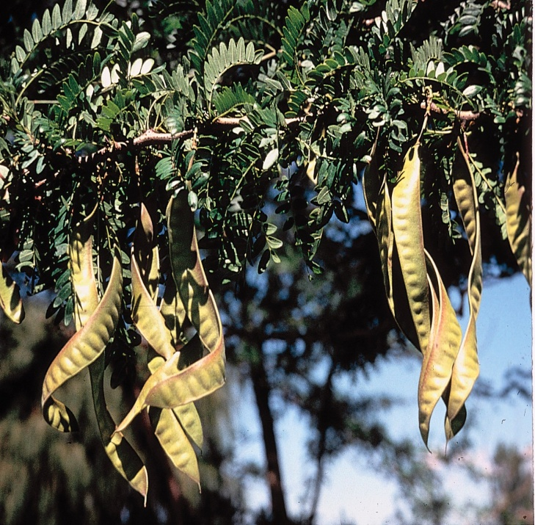Herman, D.E., et al. 1996. North Dakota tree handbook

**Alternate Names**

Honey–shucks, Sweet Locust, Three-thorned-acacia, Thorn tree, Thorny Locust, Sweet-bean

Uses

*Landscaping*

Thornless and fruitless varieties have been developed by the horticultural industry and are used extensively in landscaping. The trees are very hardy and are often used in parking lot islands and along side walks. The open canopy and small leaves will not shade out turf grasses or other landscape plants.

*Wildlife*

Honey locust is used extensively by wildlife. The bean pods are a favorite food of the white-tailed deer, squirrels, rabbits, hogs, opossums, and raccoons. Domestic animals such as sheep, goats, and cattle will also forage on the honey locust bean pods. Browsing and grazing animals, such as deer, cattle, and sheep utilize the tender shoots in spring and the bark of young trees in winter. Honey locust is capable of forming dense thickets of thorny vegetation which provides excellent cover for a wide variety of game animals and birds. Flowers of this species are incredibly attractive to pollinating insects.

*Timber*

Wood from the honey locust is very dense, shock resistant and commonly used in the timber industry. Honey locust wood is easily split, capable of obtaining a high luster finish, and is durable when in contact with soil. For these reasons, timber from honey locust has been used as fence posts, railroad ties, furniture, warehouse or shipping pallets, tool handles and fuel.

*Ethnobotanical*

Native Americans used the dried pulp from the seed pods as a sweetening agent and a minor food source. The wood was used to make bows, and a variety of medicines were made from various parts of the plant.

Status

Please consult the PLANTS Web site and your State Department of Natural Resources for this plant’s current status (e.g. threatened or endangered species, state noxious status, and wetland indicator values).

Weediness

This plant may become weedy or invasive in some regions or habitats and may displace desirable vegetation if not properly managed. Please consult with your local NRCS Field Office, Cooperative Extension Service office, state natural resource, or state agriculture department regarding its status and use. Weed information is also available from the PLANTS Web site at plants.usda.gov. Please consult the Related Web Sites on the Plant Profile for this species for further information.

Description and Adaptation

Honey locust is a woody, long lived, native, deciduous, legume (Fabaceae family), and is capable of obtaining 100 feet in height. The doubly compound leaves are alternate and dark green in color. Large, red thorns are often found on the branches and trunk of wild trees. The thorns typically have 3 points, but may have more, especially those on the trunk. The bark is dark gray and black with deep fissures that form large “plates” of bark on mature trees. Long, twisted seed pods form in late summer, and turn from green to dark reddish brown as they mature. The size of these pods is highly variable, and they give off a very strong, sweet aroma when they ripen and fall to the ground.

Honey locust is a pioneering woody species commonly found in overgrown pastures, fields, fence lines, and wood lot edges. It has a very broad range of adaptation, and is distributed nationwide, excluding Oregon and Washington. The greatest concentration of plants can be found in the central portions of the U.S. It prefers moist, fertile, alluvial soils. It will withstand periods of drought and prolonged wetness, and is commonly found in the upland areas along river drainages.

Establishment

This plant is often distributed by animals which have consumed the seed and passed them through their gut. This can be imitated by scarifying the seed mechanically or by using an acid bath. Seeds soaked in hot water (85 -90oC) and allowed to cool to room temperature have also germinated well. Seed that has been treated with these methods can be planted into a well prepared seed bed or container, approximately ½ inch deep. Seedling should be strong enough for transplanting at one year of age. Root cuttings have also been successfully used for propagation. Honey Locust requires full sun, and will not tolerate shading.

Management

Once established, trees are generally maintenance free. Pruning of lower limbs will encourage tall, upright growth.

Pests and Potential Problems

Honey Locust has few significant pests. Canker can sometimes be a problem, but rarely kills the tree.

This plant can become a nuisance, and will dominate a site if left unchecked or mismanaged. Honey locust can produce numerous thorns that are capable of puncturing implement tires. Though not listed as a toxic plant, contact with thorns often results in sore wounds that are slow to heal.

Environmental Concerns

Due to rapid growth, aggressive re-sprouting, and density of the wood, this plant has excellent potential for use as a biofuel either by direct burning of the wood or cellulosic ethanol production.

Control

Honey locust is intolerant of fire. Timely, periodic burning will eliminate it from open areas. Herbicides may also be used for control and suppression. Cutting young trees results in excessive re-spouting from the stump and roots, compounding the original problem exponentially. Stumps from cut trees must be treated with herbicide to prevent aggressive re-sprouts from forming dense thickets of thorny trees.

Please contact your local agricultural extension specialist or county weed specialist to learn what works best in your area and how to use it safely.

Always read label and safety instructions for each control method. Trade names and control measures appear in this document only to provide specific information. USDA NRCS does not guarantee or warranty the products and control methods named, and other products may be equally effective.

Cultivars, Improved, and Selected Materials (and area of origin)

Thornless and fruitless varieties are readily available through the nursery industry.

Prepared By: *R. Alan Shadow*, Soil Conservationist, USDA/NRCS East Texas Plant Materials Center, Nacogdoches, TX

Species Coordinator: *R. Alan Shadow*, Soil Conservationist, USDA/NRCS East Texas Plant Materials Center, Nacogdoches, TX

Edited: 090108 jsp

For more information about this and other plants, please contact your local NRCS field office or Conservation District, and visit the PLANTS Web site<<http://plants.usda.gov>> or the Plant Materials Program Web site <<http://Plant-Materials.nrcs.usda.gov>>

*The U.S. Department of Agriculture (USDA) prohibits discrimination in all its programs and activities on the basis of race, color, national origin, sex, religion, age, disability, political beliefs, sexual orientation, and marital or family status. (Not all prohibited bases apply to all programs.) Persons with disabilities who require alternative means for communication of program information (Braille, large print, audiotape, etc.) should contact USDA's* [*TARGET Center*](http://www.usda.gov/oo/target.htm) *at 202-720-2600 (voice and TDD).*

*To file a complaint of discrimination write USDA, Director, Office of Civil Rights, Room 326-W, Whitten Building, 14th and Independence Avenue, SW, Washington, DC 20250-9410 or call 202-720-5964 (voice or TDD). USDA is an equal opportunity provider and employer.*

*Read about* [*Civil Rights at the Natural Resources Conservation Service*](http://www.nrcs.usda.gov/about/civilrights/)*.*