|  |
| --- |
| Utah sweetvetch |
| *Hedysarum boreale* Nutt |
| Plant Symbol = HEBO |

Contributed by: Upper Colorado Environmental Plant Center

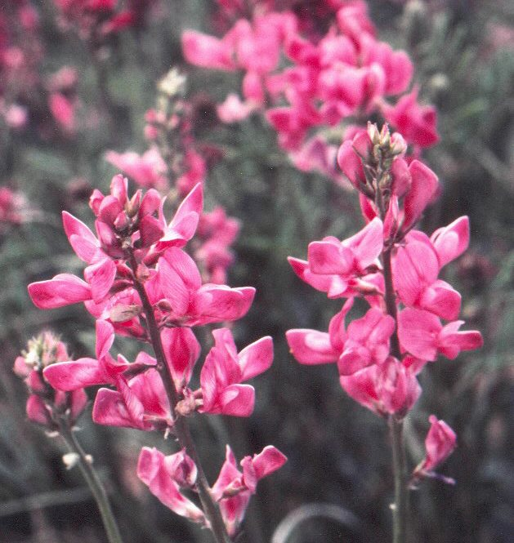

UCEPC, Meeker, Colorado

Alternate Names

Northern sweetvetch, chain-pod, northern sweet broom

Uses

*Grazing/Rangeland/Wildlife:* Utah sweetvetch can beused as a complimentary species in rangeland seedings. It is considered succulent and its foliage is highly palatable to livestock and big game. Utah Sweetvetch also provides important habitat attributes for sage grouse. It has been rated as medium for cover value and excellent for food value.

*Reclamation:* Utah sweetvetch is a legume capable of fixing nitrogen from the atmosphere (Nitrogen fixation is a process whereby inorganic nitrogen-N2 found in the atmosphere is converted into organic compounds usable by the plant with the aid of *Rhizobia* bacteria). Eventually this nitrogen is released into the soil, thereby, improving soil quality.

Status

Please consult the PLANTS Web site and your State Department of Natural Resources for this plant’s current status (e.g. threatened or endangered species, state noxious status, and wetland indicator values).

**Description:** Legume Family (Fabaceae). Utah sweetvetch is a native perennial, cool season, herbaceous legume with deep taproots and several lateral roots. The main stems arise from a woody crown and may grow 1 to 2 feet tall. The leaves are compound (two or more leaflets) and hairless. Flowers can be pink, purple, or white arranged in a loose raceme. Seeds develop in a long constricted pod, with several sections. Each section contains one brown kidney-shaped seed.

**Adaptation:** Utah sweetvetch can grow on clayey or sandy soils, however, is more adaptable to well-drained loamy soils. It is most often found on moderately saline or alkaline soils, but will grow on moderately acidic to neutral soils. Utah sweetvetch is usually found at elevations between 4000 to 8000 feet, in precipitations zones receiving 10 to 18 inches of moisture annually. It grows better with 15 inches or more of precipitation and minimum competition.

Establishment

Planting should be done in early spring or late fall. Drill seed at about ¼ to ½ inch deep. Inoculation with the proper rhizobium will enhance nitrogen fixation. Germination occurs within 6 to 30 days.

Management

Reduce or withhold stocking during establishment and avoid overuse after establishment to maintain a healthy stand. Utah sweetvetch is moderately to fairly tolerant of grazing.

Pests and Potential Problems

Utah sweetvetch is subject to root-rots, seed pod insects and some rust. Rabbits, grasshoppers and crickets can become problems by reducing plant stand.

Environmental Concerns

Some plant sources of Utah sweetvetch have been reported to spread rhizomatously. However, Utah sweetvetch as a native plant has moderate competiveness.

Cultivars, Improved, and Selected Materials (and area of origin)

‘Timp’ Utah Sweetvetch (*Hedysarum boreale* Nutt.) is a seed-propagated cultivar. The genetic material originated from two sources: (1) a site at the base of the Wasatch Mountains and east of Orem County in Utah, and (2) a single-plant selection made by Dr. Robin Cuany. ‘Timp’ was selected based on its seedling vigor, site adaptability, persistence, seed production, dinitrogen fixation, and stability. It was released in 1994 by Upper Colorado Environmental Plant Center, Utah Division of Wildlife Resources, Colorado State University Agricultural Experiment Station, Utah State University Agricultural Experiment Station, and USDA-Soil Conservation Service.

‘Timp’ Utah sweetvetch is adapted to a wide range of soil types, however, performs better in well-drained loamy soils. It has proven acceptable performance where the annual precipitation ranges from 12 to 18 inches.

‘Timp’ certified seed is available commercially and breeder seed is maintained at Upper Colorado Environmental Plant Center.

Prepared By & Species Coordinator:

*Manuel Rosales,* USDA NRCS Upper Colorado Environmental Plant Center, Meeker, Colorado

Edited: 070814 jsp

For more information about this and other plants, please contact your local NRCS field office or Conservation District, and visit the PLANTS Web site<<http://plants.usda.gov>> or the Plant Materials Program Web site <<http://Plant-Materials.nrcs.usda.gov>>

*The U.S. Department of Agriculture (USDA) prohibits discrimination in all its programs and activities on the basis of race, color, national origin, sex, religion, age, disability, political beliefs, sexual orientation, and marital or family status. (Not all prohibited bases apply to all programs.) Persons with disabilities who require alternative means for communication of program information (Braille, large print, audiotape, etc.) should contact USDA's* [*TARGET Center*](http://www.usda.gov/oo/target.htm) *at 202-720-2600 (voice and TDD).*

*To file a complaint of discrimination write USDA, Director, Office of Civil Rights, Room 326-W, Whitten Building, 14th and Independence Avenue, SW, Washington, DC 20250-9410 or call 202-720-5964 (voice or TDD). USDA is an equal opportunity provider and employer.*

*Read about* [*Civil Rights at the Natural Resources Conservation Service*](http://www.nrcs.usda.gov/about/civilrights/)*.*