|  |
| --- |
| TANGLEHEAD |
| *Heteropogon contortus* (L.) P. Beauv. ex Roem. & Schult. |
| Plant symbol = HECO10 |

Contributed by: USDA NRCS Kika de la Garza Plant Materials Center and Hoolehua Plant Materials Center

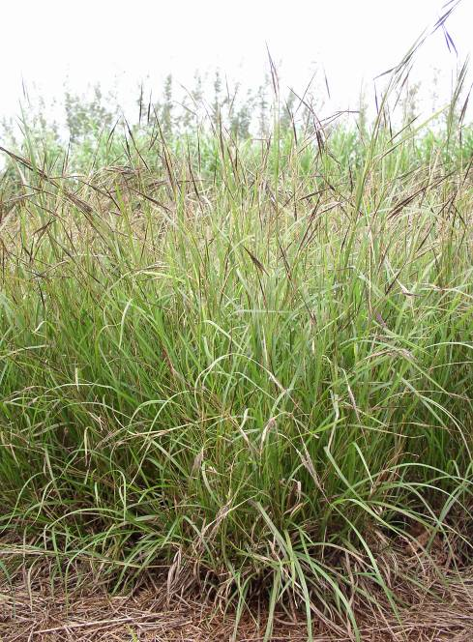

USDA NRCS Hoolehua PMC 2005

Alternate Names

Spear grass, pili, piligrass, twisted beardgrass, lule

Uses

*Forage:* Tanglehead is a good forage grass for the southwestern United States, and does not develop sharp awns if it is consistently grazed. It is palatable to most livestock during the growing season, but as it matures, it becomes coarser, and loses palatability.

*Conservation:* Primary recommendation for this grasswould be vegetation to aid erosion control. Tanglehead also has the potential for ecosystem restoration, re-vegetation of degraded habitats, and to increase diversity in riparian and other communities.

*Wildlife:* Tanglehead can provide good cover for animals and it can also be used as a grass for native habitat restoration projects.

*Cultural*: In ancient Hawaii, tanglehead was used as thatch for houses in drier areas. It was favored because of its pleasant odor and its resistance to weathering.

*Ornamental:* Tanglehead’s interesting looking seedhead makes it a good candidate for ornamental use.

Status

Please consult the PLANTS web site and your State Department of Natural Resources for this plant’s current status (e.g. threatened or endangered species, state noxious status, and wetland indicator values).

Description

Tanglehead is a member of the *Andropogoneae* tribe of grasses.It is an erect, warm season, perennial that may form rather large bunches reaching heights of 1 to 3 feet tall under natural conditions. At the Hoolehua PMC, under optimum conditions, tanglehead has been known to grow to heights of up to 5 feet tall. There is a wide range of morphological and phenological variations within this species because of its wide range of adaptability. The stems are flattened, rather tough, smooth, and a pale bluish-green. Leaves are produced throughout the length of the stem and are flat or folded, 4-12 inches long, about 0.25 inches wide and rough to the touch. The flowering heads have narrow, crowded flower spikes up to 4 inches long. The spikelets overlap and each fertile one bears a conspicuous red-brown awn about 4 inches long, made crooked with two bends. The long-awned seeds are sharp pointed forming tangled masses as they mature. When the seeds come in contact with moisture, the hygroscopic awns and sharp barbed tips arch and twist planting them into the soil. The species is mostly apomictic (producing seed without pollination), but sexual reproduction has also been known to occur.

Adaptation and Distribution

Tanglehead has a high degree of adaptability that has allowed it to survive in locations around the world for many years. It can be found on every major landmass between 35º N latitude and 35º S latitude. In Texas, it is found in sandy prairies, the coastal regions, the Trans-Pecos Mountains, and persists in well-managed pastures, although it was once a common grass in the coastal prairies. In Hawaii, tanglehead occurs naturally on all the major islands at sea level to about 2,000 feet elevation and favors dry habitats and rocky cliffs close to the ocean.

For a current U.S. distribution map, please consult the plant profiles page for this species on the PLANTS web site.

**Establishment**

Tanglehead can be reproduced from seeds or vegetative transplants. A stand of tanglehead was established at the Kika de la Garza Plant Materials Center using vegetative bunches split off of mature plants. The seeds have a dormancy period of about 6 months. Although seeds will germinate before this period, the germ-rate will be very low. Studies indicate that this dormancy can be broken with gibberelic acid. Plant propagules in a sterile, well drained medium. Germination should occur within 5-7 days. One week after germination, it is recommended that time-release fertilizer supplements be added. After 2 months, place propagules in full sunlight to harden off. Propagules should be ready to plant within 3-4 months.

Management

Tanglehead is adapted to low rainfall and low fertility soils, although nutrient amendments according to soil tests would be beneficial for rapid establishment.

Burning is commonly used as a tool to maintain tanglehead pastures for grazing in other parts of the world. Grazing fields can be shredded or burned on an annual basis to reduce dead plant matter and induce new growth, but burning during the dry season may reduce nutrient availability. On the other hand, some of the south Texas accessions were very sensitive to burning, being slow to re-grow. Therefore, ample time should be given between burning and grazing periods. For rotational grazing, forage height should be utilized between four to ten inches. It is recommended that a minimum six-inch stubble height be maintained under continuous grazing. Tanglehead does not develop seeds if it is consistently grazed, but populations will decrease if grazing is too heavy.

Tanglehead can also be harvested as hay-bales containing viable seed, which have been used extensively for the Kahoolawe Island Re-Vegetation Project. Since tanglehead seed-heads have a tendency to bunch-up or tangle when they are mature, harvesting can also be done easily with the ‘PILI COMB’, an implement that was developed at the Hoolehua Plant Materials Center. The use of tanglehead seed bales and seeded hay-bales for re-vegetation of degraded native habitats requires further investigation.

Pests and Potential Problems

There are no known pests that are detrimental to the tanglehead life cycle.

Grazing fields should be managed carefully as not to allow seeds to mature before grazing. Mature seeds are sharp and rigid and can cause injury to grazing animals.

Seed cleaning is difficult because the awn and callus are not easily removed without damaging the seed. However, without the removal of the awn and callus, mechanical planting is impractical since they can clog the planter.

Cultivars, Improved, and Selected Materials (and area of origin)

‘Rocker’ is a NRCS Arizona Source Identified release of a naturally occurring tanglehead germplasm and has been unaltered.

‘Kahoolawe Germplasm Piligrass’ is a NRCS Hawaii Source Identified release of a naturally occurring tanglehead germplasm and has been unaltered.

Prepared By:

*John Reilly* and *Shelly D. Maher*, Kika de la Garza Plant Materials Center, Kingsville, Texas

*David Duvauchelle*, Hawaii Plant Materials Center, Hoolehua, Hawaii

##### Edited: 1Oct2002 SDM; 06dec05 jsp; 060801 jsp; jun08 DD; 080807 jsp

For more information about this and other plants, please contact your local NRCS field office or Conservation District, and visit the PLANTS Web site<<http://plants.usda.gov>> or the Plant Materials Program Web site <<http://Plant-Materials.nrcs.usda.gov>>

*The U.S. Department of Agriculture (USDA) prohibits discrimination in all its programs and activities on the basis of race, color, national origin, sex, religion, age, disability, political beliefs, sexual orientation, and marital or family status. (Not all prohibited bases apply to all programs.) Persons with disabilities who require alternative means for communication of program information (Braille, large print, audiotape, etc.) should contact USDA's* [*TARGET Center*](http://www.usda.gov/oo/target.htm) *at 202-720-2600 (voice and TDD).*

*To file a complaint of discrimination write USDA, Director, Office of Civil Rights, Room 326-W, Whitten Building, 14th and Independence Avenue, SW, Washington, DC 20250-9410 or call 202-720-5964 (voice or TDD). USDA is an equal opportunity provider and employer.*

Read about [*Civil Rights at the Natural Resources Conservation Service*](http://www.nrcs.usda.gov/about/civilrights/).