

Plant Fact Sheet

# Smooth Oxeye

## Heliopsis helianthoides (L.) Sweet

Plant Symbol = HEHE5

Contributed by: Colorado, Kansas and Maryland Plant Materials Programs

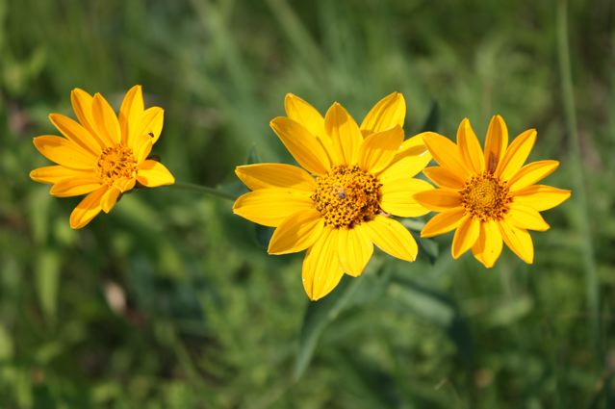Christine Taliga, USDA NRCS Colorado Plant Materials Program

### Alternative Names

Common Alternate Names: Early sunflower, Smooth sunflower, False sunflower, Oxeye daisy, Oxeye, Oxeye sunflower, *Heliopsis* sunflower, Sunflower *Heliopsis.*

### Uses

### *Forage*: Livestock and deer sometimes graze Smooth oxeye.

*Landscape*: Smooth oxeye is considered one of the best hardy plants for a wildflower garden border. It performs well in dry (xeric) locations, in poor to average soils, and in full sun to partial shade. Flowering can be extended by removing spent flowers. Staking may be necessary in shady locations.

*Pollinators*: The ground nesting bee, *Holcopasites heliopis,*  is a specialist pollinator of *Heliopsis helianthoides*. The nectar of Heliopsis attracts butterflies and other pollinators. Birds utilize the seed as a food source, and stems provide winter cover for beneficial insects.

### Status

Please consult the PLANTS Web site and your State Department of Natural Resources for this plant’s current status (e.g., threatened or endangered species, state noxious status, and wetland indicator values).

### Description

Heliopsis from the Greek word helios for "sun" and opsis for "appearance." *Helianthoides* also from the Greek meaning "like *Helianthus,*" the sunflower.

Smooth oxeye is a member of the sunflower family (Asteraceae). It is a vigorous, upright, native, perennial forb growing 3’ to 4’ in height.

The leaves are oppositely attached to the stem consistently to the top of the plant and have coarsely serrated margins. The toothed leaf blades are oval to triangular or lance-shaped.

The stem is rough to the touch and may contain a single flower head or be branched at the apex into multiple stems with several yellow flowers. The flowers of *Heliopsis* have both orange-yellow center disk and yellow ray flowers. Blooming occurs in summer beginning in July to August and extends for up to two months, making it one of the earliest blooming sunflowers. *Heliopsis* forms clumps 2’ to 4’ in diameter.

**Adaptation**

Its native range is widely distributed mainly east of the Rocky Mountains from Ontario to Florida and Mississippi. Smooth oxeye is adapted to full sunlight and dry to moderately moist soil conditions. It can be found growing in prairies, roadsides, and open woods, edge of fields and thickets, and waste areas. This species tolerates some drought and also a wide range of soil types, including nutrient-poor soils. It has proven to perform best in areas receiving >5” of rainfall. Smooth oxeye is not salinity-tolerant.

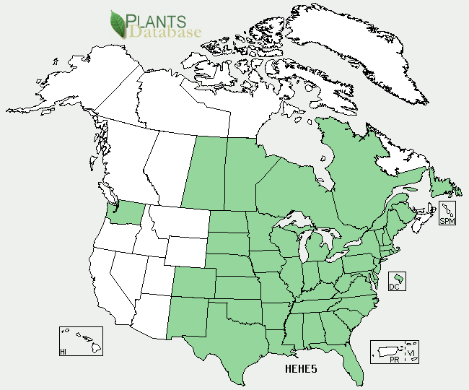

Smooth oxeye distribution from USDA-NRCS PLANTS Database.

For updated distribution, please consult the Plant Profile page for this species on the PLANTS Web site.

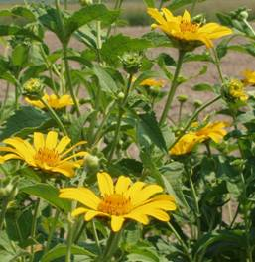

R. Alan Shadow, USDA NRCS Manhattan PMC

### Establishment

*Seed: Heliopsis helianthoides* establishes readily from seed when planted in the winter/fall or early in spring (March to April). Germination generally starts four weeks after sowing if soil temperatures remain in the 60 – 70 degree Fahrenheit range. Seeds ripen approximately one month after flowering, however as with many Asters, plants are self sterile. It may be necessary to crack open a few seeds to make sure they are viable.

*Cuttings and Divisions:* Five to seven node cuttings taken from the top 12 inches of growth in late spring root easily. Cuttings are sometimes reluctant to overwinter. Divide plants in the fall for best results.

### Management

During the establishment period weeds should be mowed or spot treated with a herbicide. Plants will produce viable seed the first year of establishment in mid to late August to September. Seeds readily shatter when mature.

### Pests and Potential Problems

None known at this time.

### Environmental Concerns

### There are no environmental concerns or probability of this plant becoming a weed problem in cultivated agricultural systems or pasture lands. Rock (1981) however, indicates that *Heliopsis* may spread widely and has the tendency to become weedy in landscape settings.

### Cultivars, Improved, and Selected Materials (and area of origin)

‘Midas’was released by the Manhattan, Kansas Plant Materials Center (PMC) in 1984. It is recommended for the more western extent of the native range of this species.

Northern, central and southern Iowa source identified materials were released in the mid and late 1990’s by the Elsberry, Missouri Plant Materials Center.

### Prepared by:

### *Christine Taliga*; Plant Materials Specialist, USDA NRCS, Denver, Colorado.

*Richard L. Wynia*; Plant Center Manager, USDA NRCS Manhattan Plant Materials Center, Manhattan, Kansas.

*Shawn V. Belt*; Horticulturist, USDA NRCS, Norman A. Berg National Plant Materials Center, Beltsville, Maryland.

### Citation

Taliga, C.E., R.L.Wynia, S.V. Belt. 2012. Plant Fact Sheet for false sunflower (*Heliopsis helianthoides* (L.) *Sweet*). USDA-Natural Resources Conservation Service, Denver State Office. Denver CO., 80225-0426.

Published September2012

Edited: 10Sep2012jld, 10Sep2012cga

For more information about this and other plants, please contact your local NRCS field office or Conservation District <<http://www.nrcs.usda.gov/>>, and visit the PLANTS Web site <[http://plants.usda.gov](http://plants.usda.gov/)> or the Plant Materials Program Web site <<http://plant-materials.nrcs.usda.gov>>

**USDA IS AN EQUAL OPPORTUNITY PROVIDER AND EMPLOYER**