

Plant Fact Sheet

# meadow barley

## Hordeum brachyantherum Nevski

Plant Symbol = HOBR2

Contributed by: USDA NRCS Plant Materials Center, Corvallis, Oregon

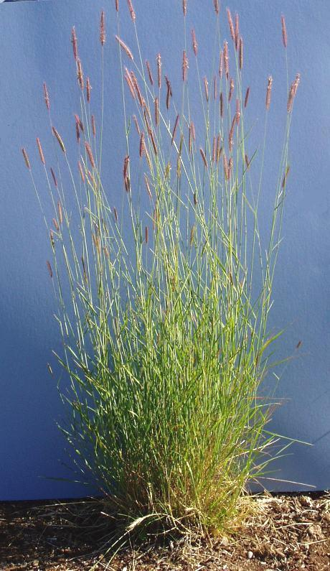

*Photo by Dale Darris, Corvallis Plant Materials Center.*

### Alternative Names

There are two subspecies: *H. brachyantherum* ssp. *brachyantherum* and ssp. *californicum*, the latter referred to as California barley. Another name is little barley. This species can hybridize with certain *Hordeum* and *Elymus* (wildrye) species.

Uses

Because of its high seedling vigor, wide soil tolerances, and rapid development, meadow barley is often used as a quick cover for soil stabilization on wet or dry, saline sites. It is sometimes used for forage where locally abundant, but resource value may be low to moderate for livestock. The value for deer is considered high in spring. Palatability for ungulates is moderately good early on, but poor at maturity. Sown at lower rates to allow other species to establish, meadow barley is an important component of freshwater wetland, tidal marsh, meadow, and riparian seed mixtures for restoration and revegetation. In certain trials, meadow barley has shown higher potential to impede the progress of reed canarygrass (*Phalaris arundinacea*) compared to several other native wetland grasses. It is considered useful as a temporary nurse crop for longer lived species on dry, infertile sites. This species is occasionally used as a vineyard cover crop in California. Plants provide wildlife cover and the leaves and large seed may be of some food value to small mammals and waterfowl.

Status

Please consult the PLANTS Web site and your State Department of Natural Resources for this plant’s current status (e.g. threatened or endangered species, state noxious status, and wetland indicator values).

Description and Adaptation

Meadow barley is a native, short- to medium-lived, cool season, perennial bunchgrass. Growth habit is an open tuft with erect to slightly spreading, smooth stalks (culms) that are 40 to 105 cm tall. The flower head (panicle) is a narrow, flattened spike, 5 to 10 cm long with bristle-like awns and a brittle central axis (rachis) that breaks off in pieces from the top down at maturity. Leaves are green to bluish green, 2 to 9 mm wide. They may be primarily basal or extend up and down the stem. This species occurs primarily from Alaska to California and east to the Rocky Mountains. It can also be found sporadically in other states. For updated distribution, please consult the Plant Profile page for this species on the PLANTS Web site.

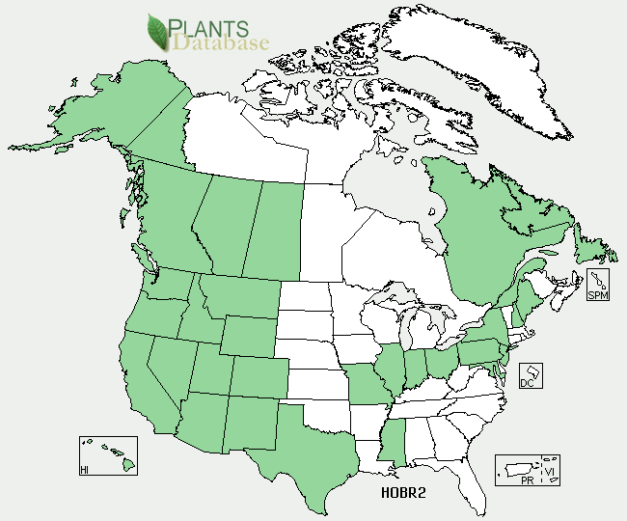

*Meadow barley distribution from USDA-NRCS PLANTS Database.*

*Key to identification:* The flower heads are bristly and often purplish in color, becoming stubby at maturity which distinguishes it from timothy (*Phleum pretense*), meadow foxtail (*Alopecurus pratensis*), or other grasses with narrow spikes. It resembles common barley (*Hordeum vulgare*) which is an annual usually confined to cultivated areas. Meadow barley is upright, while its closest relative, California barley, is shorter and more spreading.

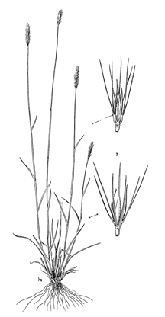

*Line drawing of meadow barley reprinted with permission, University of Washington Press.*

*Relative abundance in the wild:* Meadow barley is common to sporadic in moist meadows and clearings. It is most abundant in maritime environments. Seed shatters (drops) readily requiring careful monitoring of maturity and multiple collections.

*Adaptation:* Meadow barley is moderately drought tolerant, but best adapted to moist soils, including bottom lands, depressions, meadows, the edges of streams and salt marshes, forest clearings, and ocean beaches from sea level to subalpine elevations. It is tolerant to moderately alkaline and saline conditions, as well as low fertility, seasonally saturated soils, and intermittent flooding. Soil texture can vary from coarse sand to clay. This species prefers full sun. This species can produce a seed crop the first year if sown in late fall or early spring. This is among the more broadly adapted and easier to establish of all native grasses in the western US.

Establishment

There is usually no seed dormancy and meadow barley is easy to establish by sowing in the fall or early spring. The awns and nonviable florets (flower structures) attached to each spikelet should be removed to reduce bulk and allow for seed to flow through planting equipment. The number of seeds per pound can vary widely, depending on the degree of seed conditioning. Bulky seed can range from 30,000 to 100,000 seeds per pound, while highly processed seed will have approximately 150,000 seeds/lb (± 30%). The latter will result in 3 to 4 seeds per square foot for each pound applied per acre. Suggested seeding rates vary from 8 to 40 lbs/ac when sown alone, depending on seed size, methods, site conditions, and purpose of planting.

Management

Meadow barley can be an increaser or decreaser under heavy grazing, depending on the palatability of other plants present. Forage value is moderately good early on, but poor at maturity. Livestock are likely to cause soil compaction on moist sites with fine textured soils where this species often thrives. Short-lived especially under drier conditions, regeneration may rely on a period of deferred grazing during flowering and seed set every few years. The species is easily eliminated by close mowing early in the growing season. It stays green all summer if moisture is present and is capable of producing a second flush of seed heads later in summer. Tolerance to prescribed burning is high. Specific management practices apply to cover crop use, particularly in vineyards. Under cultivation for seed, several harvests may be required to capture seed that matures unevenly and shatters easily.

Environmental Concerns

Awns on the spikelets readily attach to hair and skin. Apparently they can harm certain animals by working into the nose, mouth, or intestines. Other sources indicate little injury to livestock or deer that graze the foliage. Certain meadow barley populations are susceptible to fungal diseases, particularly head smut and leaf or stem rust. Fungicides may be needed for control. Consult with your local Extension Service agent, plant disease control handbook, or other experts for advice. The species has potential to be weedy under certain conditions and is listed as a weed in cotton.

Cultivars, Improved, and Selected Materials (and area of origin)

Multiple sources of seed are readily available in California, as are several in Oregon. A limited number of seed sources from other regions are also available for use in certain western states.

Prepared By:

*Dale Darris*, USDA NRCS Plant Materials Center, Corvallis, Oregon

**Citation**

Darris, D. 2004. Plant fact sheet for meadow barley (*Hordeum brachyantherum)*. USDA-Natural Resources Conservation Service, Plant Materials Center, Corvallis, OR.

Published December 2004

Edited: 21Mar2006 jsp; 16Sep2008 dcd; 17Sep2008 jsp; 17Feb2012 aym

### For more information about this and other plants, please contact your local NRCS field office or Conservation District <<http://www.nrcs.usda.gov/>>, and visit the PLANTS Web site <[http://plants.usda.gov](http://plants.usda.gov/)> or the Plant Materials Program Web site <<http://plant-materials.nrcs.usda.gov>>

**USDA IS AN EQUAL OPPORTUNITY PROVIDER AND EMPLOYER**