|  |
| --- |
| OCEANSPRAY |
| *Holodiscus discolor* (Pursh) Maxim. |
| Plant Symbol = HODI |

Contributed by: USDA NRCS Plant Materials Center, Corvallis, Oregon

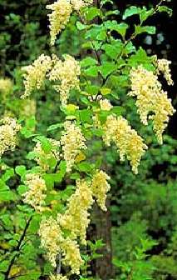

Alternate Names: Also known as Holodiscus boursieri (Carr.) Rehd., Holodiscus microphyllus Rydb., *Spiraea discolor* Pursh, *Sericotheca discolor* Rydb., and *Schizonotus discolor* Raf. Additional common names include creambush, arrowwood, ironwood, hardhack, rock spiraea and mountain spray.

Uses: This hardy species, tolerant of wide moisture regimes, soil types, and both sun and shade, is useful for low maintenance riparian plantings, reclamation of droughty and rocky or disturbed sites, and windbreaks. This broad adaptation and abundant mid-summer flower clusters at the tips of arching branches make oceanspray a popular ornamental for highway and landscape plantings and an important host for beneficial insects. Palatability for livestock and wildlife is generally considered to be low but varies with climate and incidence of fire. It is browsed by cattle, deer, elk, snowshoe hares and dusky-footed wood rats but not moose. As a common understory species, oceanspray provides cover for numerous birds and small mammals and also treefrogs. Seeds were eaten by Native Americans who also used the hard straight stems for arrow, spear and harpoon shafts, halibut hooks, digging sticks and sewing and knitting needles. Pioneers used the wood as pegs in place of nails. Medicinally, an infusion of dried seed was used to treat diarrhea and prevent contagious diseases. A poultice of oceanspray bark and leaves was applied to burns or sores.

Legal Status: Please consult the PLANTS Web site and your State Department of Natural Resources for this plant’s current status (e.g. threatened or endangered species, state noxious status, and wetland indicator values).

**Description:** Oceanspray is a moderately long-lived, moderately fast growing perennial shrub of the Rose family. It is native to western North America from British Columbia to southern California including areas of Montana, Colorado and Arizona. Multiple arching stems achieve 6 to 20 feet with the taller specimens found in shade or nearer the coast. The deciduous, alternate leaves are oval to triangular with deep veins and shallow lobes plus very fine teeth. They are green above and dull green beneath due to fine hairs and turn reddish in fall. Drooping, 4 to 7+ in. clusters of very small creamy white, sometimes pinkish flowers turn to beige then brown and often persist through winter. Fruit develops in mid to late summer and consists of five tiny, hairy, light yellow achenes (dry, one-seeded fruit) per flower. The bark is red-grey and peels from older stems.

**Adaptation and Distribution:** Oceanspray performs well in shade or full sun and is adapted to course, medium and fine textured soils with pH 5.0 to 7.5. Ranging from sea level to 7000 ft., this species has moderate drought tolerance and low fertility requirements. Oceanspray is abundant near the coast and common west of the Cascades where it often dominates the forest shrub layer. Remnant stands occur among higher peaks of Great Basin mountain ranges. Oceanspray habitat varies considerably and includes streambanks, the understory of moist woods, cutover timberland and dry rocky soils and talus slopes. For a current distribution map, please consult the Plant Profile page for this species on the PLANTS Web site.

Pests and Potential Problems: The genus is largely free of insect pests and diseases although susceptibilities to fireblight (*Erwinia amylovora*), a fungal leaf spot (*Septogloeum sp*.) and aphids have been reported. It is also a host of the root parasite, pine broomrape (*Orobanche pinorum*).

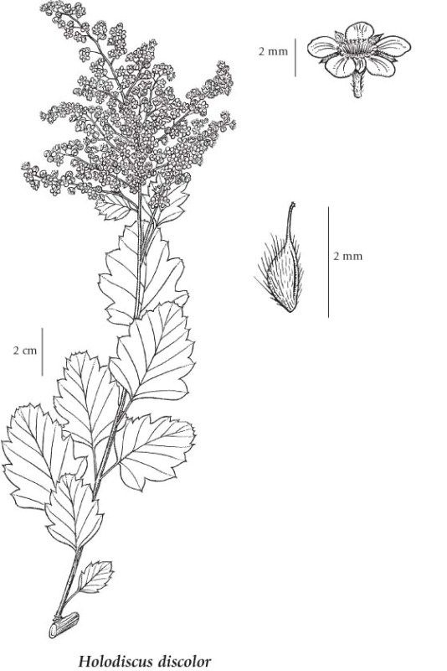

*From the Illustrated Flora of British Columbia, © Province of British Columbia*

**Establishment:** Oceanspray is typically propagated by seed requiring 15 to 18 weeks of cold moist storage (stratification) to overcome dormancy. There are more than 5,000,000 seeds per pound. Seed viability is reported as less than 10%. Seedlings develop slowly. Oceanspray can also be propagated from softwood or hardwood cuttings or by layering. Success in rooting varies widely depending on clone and technique. Softwood cuttings taken in spring may be treated with a rooting hormone and grown under mist with bottom heat. Better results may be expected with fall or winter collected hardwood cuttings, also treated with rooting hormone. Autumn is the best time to transplant container stock.

**Management:** As a poor competitor, oceanspray benefits from weed control when young. The fibrous root system requires well drained soil at least 12 in. deep. Consider supplemental irrigation during establishment year or years with low rainfall. Cutting back mature stems will encourage vigorous growth suitable for cutting wood.

**Environmental Concerns:** Oceanspray spreads slowly either by seed or by root sprouting although it will re-colonize rapidly following fire or other disturbance. It is non-toxic to humans and wildlife.

Cultivars, Improved, and Selected Materials (and area of origin): Oceanspray is available as seed, container stock or bare-root from west coast native plant nurseries. It is a popular ornamental in parts of Europe where the cultivar ‘carneus’ may be available. A more compact growing related species, *Holodiscus dumosus*, native to the east side of the Cascade and Sierra Nevada mountains is sometimes called dwarf oceanspray. The Corvallis Plant Materials Center has two selected class germplasms pending release for western Washington and Oregon.

**Prepared By:** *Pete Gonzalves* and *Dale Darris*. USDA NRCS Plant Materials Center, Corvallis, Oregon. October 2007.

**Species Coordinator:** *Pete Gonzalves*. USDA NRCS Plant Materials Center, Corvallis, Oregon.

**Line Drawing Source Document:** Douglas, G.W., D.V. Meidinger, and J. Pojar (editors). 1999. Illustrated Flora of British Columbia. Volume 4: Dicotyledons (Orobanchaceae Through Rubiaceae). B.C. Ministry of Environment, Lands & Parks and B.C. Ministry of Forests. Victoria, British Columbia.

Edited: 26Oct2007 PG; 080107 jsp

For more information about this and other plants, please contact your local NRCS field office or Conservation District, and visit the PLANTS Web site<<http://plants.usda.gov>> or the Plant Materials Program Web site <<http://Plant-Materials.nrcs.usda.gov>>

*The U.S. Department of Agriculture (USDA) prohibits discrimination in all its programs and activities on the basis of race, color, national origin, sex, religion, age, disability, political beliefs, sexual orientation, and marital or family status. (Not all prohibited bases apply to all programs.) Persons with disabilities who require alternative means for communication of program information (Braille, large print, audiotape, etc.) should contact USDA's* [*TARGET Center*](http://www.usda.gov/oo/target.htm) *at 202-720-2600 (voice and TDD).*

*To file a complaint of discrimination write USDA, Director, Office of Civil Rights, Room 326-W, Whitten Building, 14th and Independence Avenue, SW, Washington, DC 20250-9410 or call 202-720-5964 (voice or TDD). USDA is an equal opportunity provider and employer.*

Read about [*Civil Rights at the Natural Resources Conservation Service*](http://www.nrcs.usda.gov/about/civilrights/).