|  |
| --- |
| Little Walnut |
| *Juglans microcarpa* Berl. |
| Plant symbol = JUMI |

Contributed by: USDA NRCS James E. “Bud” Smith Plant Materials Center, Knox City, Texas

Alternate Names

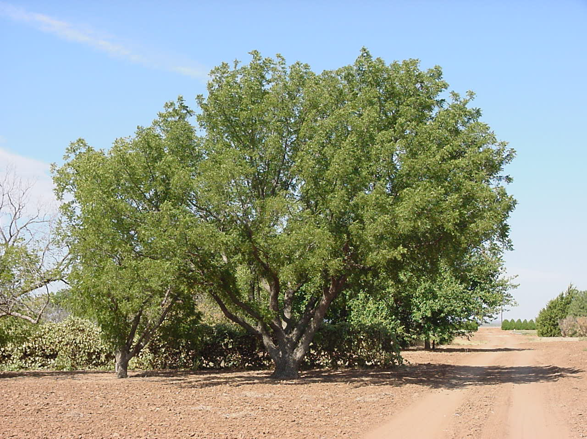

M.J. Houck

USDA NRCS Knox City PMC

Texas walnut, Texas black walnut, dwarf walnut, river walnut, nogal, nogalillo, nogalito

Uses

The wood of little walnut is dark brown, hard and heavy, but not strong. The sapwood of little walnut is a lighter reddish gray to white color. Little walnut wood is sometimes used to make cabinets, furniture, paneling, and veneer, but its lack of abundance limits its use. The nuts produced by this tree are consumed by wildlife and considered a valuable food source for many small mammals. In Texas, little walnut rootstock is used to establish non-native walnut types. Little walnut shows promise as a small tree for use in windbreaks and shelterbelts.

Status

Please consult the PLANTS Web site and your State Department of Natural Resources for this plant’s current status (e.g. threatened or endangered species, state noxious status, and wetland indicator values).

Description and Adaptation

Walnut Family (Juglandaceae). Little walnut is considered a small to medium tree growing to a height of 20 to 30 feet. Plants may have a single or multiple trunk with spreading low branches. The bark is gray to dark brown becoming deeply fissured with age. Little walnut has a long taproot allowing the plant to reach moisture from shallow water tables. Alternate, odd-pinnately compound leaves are 9 to 12 inches long. The 11 to 25 narrow leaflets are serrate with small teeth. The leaves are dark yellow to green with a dull surface and the lower surface is somewhat paler.

Little walnut is monoecious with slender staminate catkins developing on previous year’s wood. Yellow-green pistillate flowers are borne singly or in clusters on the current year's growth. The fruit or nuts are 0.5 to 0.8 inch in diameter, hard, dark brown and covered by a thick fibrous husk. The nut of little walnut is the smallest of all walnuts (*Juglans* spp.).

Little walnut is a native and grows from southwestern Kansas through Oklahoma and Texas, south into northeastern Mexico. Little walnut would commonly be located within the narrow riparian forests adjoining a river or creek bottom.

Establishment

Propagation by seed is the recommended way to produce little walnut seedlings. Like most walnut species, the seeds are characterized by a dormant embryo. Seed dormancy can be broken by artificial stratification at 34 to 41degrees F (1-5 degrees C) for 90 to 120 days. Stratified seeds will normally germinate within 4 to 5 weeks. Seeds may be naturally stratified by planting in the fall in moist, well-drained, deep soil, then allowing at least 90 days with soil temperatures below 41 degrees.

Management

Little walnut trees will first bear seed at approximately 15 years of age with abundant seed crops being produced at irregular intervals. Once seedlings are established, young plants generally grow rapidly. Small seedlings will need to be protected from browsing animals.

Pests and Potential Problems

The walnut husk fly may infest ripening fruit of little walnut in late summer. Damage by this insect varies, but generally tends to be less in exposed windy areas. Little walnut is highly susceptible to root or crown rot when periodically flooded.

Cultivars, Improved, and Selected Materials (and area of origin)

There are no known cultivars of little walnut at this time. The species can be obtained commercially from some state forestry associations and seed companies.

Prepared By and Species Coordinator:

*Morris J Houck*, USDA NRCS Plant Materials Center, Knox City, Texas

Edited: 23mar2006 jsp

For more information about this and other plants, please contact your local NRCS field office or Conservation District, and visit the PLANTS Web site<<http://plants.usda.gov>> or the Plant Materials Program Web site <<http://Plant-Materials.nrcs.usda.gov>>

*The U.S. Department of Agriculture (USDA) prohibits discrimination in all its programs and activities on the basis of race, color, national origin, sex, religion, age, disability, political beliefs, sexual orientation, and marital or family status. (Not all prohibited bases apply to all programs.) Persons with disabilities who require alternative means for communication of program information (Braille, large print, audiotape, etc.) should contact USDA's* [*TARGET Center*](http://www.usda.gov/oo/target.htm) *at 202-720-2600 (voice and TDD).*

*To file a complaint of discrimination write USDA, Director, Office of Civil Rights, Room 326-W, Whitten Building, 14th and Independence Avenue, SW, Washington, DC 20250-9410 or call 202-720-5964 (voice or TDD). USDA is an equal opportunity provider and employer.*

*Read about* [*Civil Rights at the Natural Resources Convervation Service*](http://www.nrcs.usda.gov/about/civilrights/)*.*