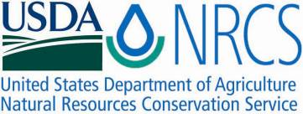

Plant Fact Sheet

manystem wildrye

*Leymus multicaulis* (Kar. & Kir.) Tzvelev

Plant Symbol = LEMU11

Contributed by: USDA NRCS Lockeford Plant Materials Center, California & Bridger Plant Materials Center, Montana

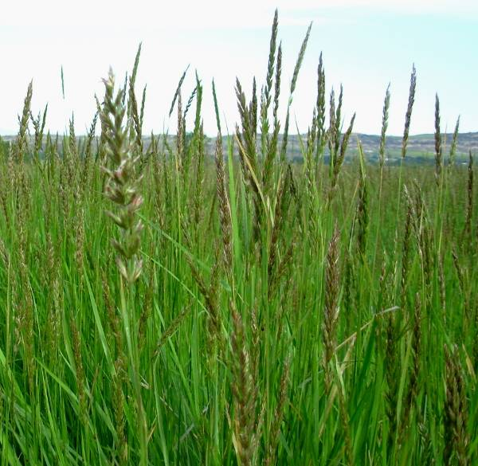 Leymus multicaulis, Susan R. Winslow, Bridger PMC

Alternate Names

Many-stem lyme grass, *Elymus multicaulis*

Uses

Manystem wildrye is primarily used for reclamation of wet, saline soils. It can be used effectively on saline-affected, irrigated cropland and pastureland, and on lands where the water table is within 3 ft of the soil surface. It is also used for reclamation of saline seep discharge areas on dry cropland, where water tables are typically deeper than 3 ft and annual precipitation may range from 12 to 18 inches.

Manystem wildrye is also recommended for use as forage, soil stabilization for prevention of wind and water erosion, and in wildlife cover plantings. It is moderately palatable to all livestock, especially in the early spring before it becomes coarse.

Status

Please consult the PLANTS Web site and your State Department of Natural Resources for this plant’s current status (e.g., threatened or endangered species, state noxious status, and wetland indicator values).

Description and Adaptation

Manystem wildrye is an introduced, perennial, cool-season, sod-forming grass. Plants spread by underground stems and by seed, sometimes forming distinct clumps, and flowering culms reach 19 to 32 inches tall. Leaf blades are grayish green, stiff and flat early in the growth season, becoming rolled later in the year. There are approximately 150,000 to 175,000 seeds/lb.

In its native range in Eurasia, manystem wildrye is found in alkaline meadows and saline soils, and as a weed in fields, roadsides, and around human habitations. In the intermountain West, it is adapted to wet, saline meadows, where rainfall exceeds 9 to 14 inches or where wet, saline-alkaline, sub-irrigated sites exist. Manystem wildrye does well on moderately-coarse/sandy to poorly-drained soils, and ranges from uplands and slopes to bottomlands. It tolerates neutral to strongly alkaline soils (pH 6.6 to 9.0) and soils classified as strongly saline (greater than 16 dS/m). Winter hardiness and frost tolerance are good, though variable among seed lots, and it is moderately shade tolerant.

‘Shoshone’ manystem wildrye has been widely introduced throughout the western US, but its exact distribution is currently unknown. For updated distribution, please consult the Plant Profile page for this species on the PLANTS web site.

Establishment

Fall dormant plantings are recommended for northern regions to overcome seed dormancy. Spring-planted seed must be mechanically scarified to break seed coat imposed dormancy. Seedlings have poor vigor, develop slowly, and compete poorly with weeds and other forage grasses in the first year of establishment. It is thus very important to minimize weed competition with properly prepared seedbeds and weed management prior to seeding. For range and pasture seedings, seeds should be drilled into a well-disked seedbed in late fall just prior to freeze up at a depth of 0 to ¼ inch and a rate of 6 to 9 pure live seed (PLS) lbs/acre (for full-rate, monotypic seedings). Alternately seeds can be broadcast at a rate of 10 to 20 PLS lbs/acre.

Vegetative planting of rhizomes (‘sprigging’) in mid-September to November is recommended for establishment on sites typically saturated or under standing water in the spring or early summer, or where rapid cover is needed. Stand establishment from sprigs is slow during the first year, but once established rhizomes spread rapidly to produce better coverage and more forage than stands originating from seed. In Montana, sprigging at a rate of 40 bu/acre is recommended for streambank protection plantings.

Management

Once established, stands of manystem wildrye survive for many years. Manystem wildrye has been found to be compatible with many other species because it does not form a dense, restrictive sod. It is highly productive for hay when planted at a rate of 6 PLS lbs/acre on irrigated or subirrigated sites. Best yields are attained on fields with adequate levels of fertility, especially available nitrogen. High concentrations of salts and/or low levels of moisture result in poorer stand establishment, lower forage yields and slower growth rates. Forage trials conducted on Shoshone manystem wildrye over a 4-year period, on fields with moderate fertility, yielded an average of 1,750 lbs/acre in Bridger, MT.

Pests and Potential Problems

Manystem wildrye is susceptible to “take-all” disease, caused by the root-inhabiting fungus *Ophiobolus graminis*.A temporary solution to arrest the disease may be achieved with an application of P2O5 at a rate of100 lbs/acre. More drastic follow-up measures to renovate the site include plowing to a 6-inch depth, harrowing, and irrigating to promote rhizome emergence. Manystem wildrye varies in resistance to leaf rust, stripe rust, and ergot. No ill effects are known from livestock consumption of the infected material.

Environmental Concerns

Manystem wildrye is known to produce fertile hybrids with beardless wildrye(*Leymus triticoides*). Seed production in these species is poor so hybrid offspring should not have a competitive advantage in native plant communities.

Cultivars, Improved, and Selected Materials (and area of origin)

‘Shoshone’ was released in 1980 as beardless wildrye (*Leymus triticoides*) through a cooperative agreement between the Bridger PMC and the agricultural experiment stations of Montana and Wyoming. After its release, however, Shoshone was determined to be *Leymus multicaulis*. The original collection was made in 1958 from the Riverton, WY fairgrounds, possibly from a seeded stand established in the 1940s from an unknown source. Shoshone is adapted to a wide range of soil textures on sub-irrigated sites in most areas of Montana and Wyoming, as well as northwestern Colorado and southern Idaho. It is a cool-season, moderately tight sod-forming cultivar selected primarily for forage, stabilization, or cover on wet or moist-saline-alkaline soils.

Prepared By

*Anna Young-Mathews*

USDA-NRCS Plant Materials Center

Lockeford, California

*Susan R. Winslow*

USDA-NRCS Plant Materials Center

Bridger, Montana

Citation

Young-Mathews, A. and S. R. Winslow. 2010. Plant fact sheet for manystem wildrye (*Leymus multicaulis)*. USDA-Natural Resources Conservation Service, Plant Materials Center. Lockeford, CA, 95237.

Published: October 2010

Edited: [17Aug2010 aym, 18Aug2010 kdl, 19Aug2010 cjs, 20Aug2010 msk, 31Aug2010 jds, 1Sep2010 srw]

For more information about this and other plants, please contact your local NRCS field office or Conservation District <<http://www.nrcs.usda.gov/>>, and visit the PLANTS Web site <[http://plants.usda.gov](http://plants.usda.gov/)> or the Plant Materials Program Web site <http://plant-materials.nrcs.usda.gov

**USDA IS AN EQUAL OPPORTUNITY PROVIDER AND EMPLOYER**