|  |
| --- |
| DottEd  Gayfeather |
| *Liatris punctata* Hook. |
| Plant Symbol = LIPU |

Contributed by: USDA NRCS Plant Materials Center Manhattan, Kansas

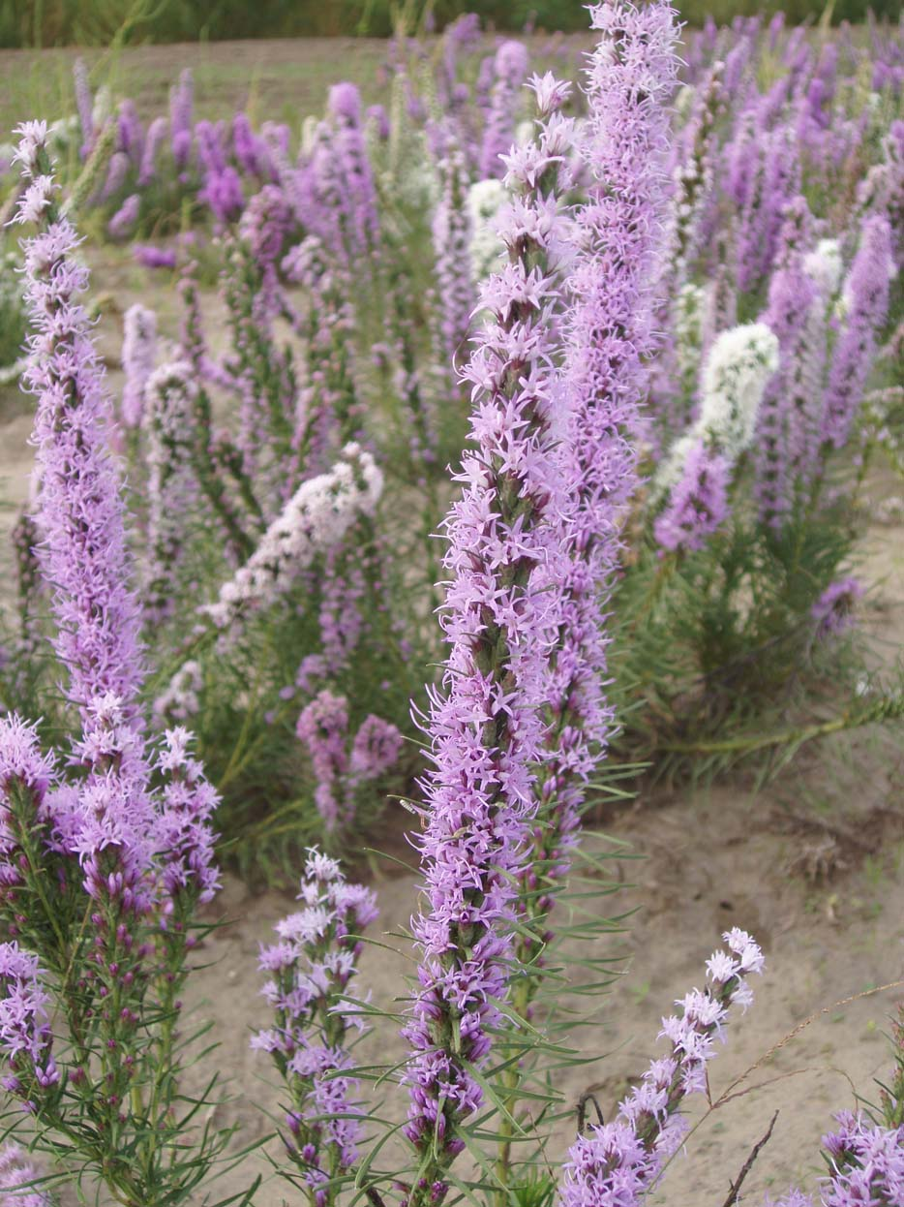

Alan Shadow, East Texas PMC, Nacogdoches, Texas.

Alternate Names

Dotted blazing star, blazing star, Nebraska blazing star, Kansas blazing star, button snakeroot, starwort

Uses

*Forage:* Dotted gayfeather is a forage or a browse species that is consumed by sheep and also wildlife species such as deer and antelope. Its forage quality is rated as fair to good and it will decrease under continuous heavy grazing.

*Ethnobotanical:* American Indian tribes used dotted gayfeather for both food and medicinal purposes. The Kiowa gathered the roots in the spring when they were sweet and baked them over a fire. Gayfeather roots were said to vary greatly in palatability depending on the time of year collected. Although widely distributed over the prairies, gayfeather is not mentioned widely as a food source of native people. The Lakota pulverized the roots of gayfeather and ate them to improve appetite. For heart pains they powdered the entire plant and made a tea. The Blackfeet boiled the gayfeather root and applied it to swellings. They made a tea for stomach aches, but sometimes just ate the root raw instead. The Pawnee boiled the root and leaves together and fed the tea to children with diarrhea. The Omaha powdered the root and applied it as a poultice for external inflammation. They also made a tea from the plant to treat abdominal troubles. The roots were also used as a folk medicine for sore throats and as a treatment for rattle snake bite.

*Horticultural:* Gayfeather plants are becoming more popular for ornamental uses, especially fresh floral arrangements and winter bouquets. The inflorescences make good long lasting cut flowers. If spikes are picked at their prime and allowed to dry out of the sun, they will retain their color and can be used in dried plant arrangements. Dotted gayfeather is a good addition to a sunny flower garden or a prairie planting for its long lasting purple color in late summer and early fall. This species also offers promise for roadside and rest stop beautification projects in the Great Plains region.

Status

Please consult the PLANTS Web site and your State Department of Natural Resources for this plant’s current status (e.g. threatened or endangered species, state noxious status, and wetland indicator values).

Description and Adaptation

*General:* Dotted gayfeather belongs to the composite or sunflower family (Asteraceae). Dotted gayfeather is a native, perennial species that is 1 to 2.5 feet tall with one to many stems arising from a woody crown. It has a deep tap root which extends up to 7 feet in heavy clay soils and to 16 feet in lighter soils. Strong lateral roots branch in the first three feet, but they all penetrate deeply and most absorptive rootlets are at the deeper levels. Its leaves are alternately arranged on the stem, are closely spaced and linear, being up to six inches long and ¼ inch wide. The leaves are dark green with a light colored midrib and covered with translucent glandular dots. Dotted gayfeather leaves arch upward, have ciliate or hairy margins and get progressively shorter the closer they get to the stem apex. A dense spike up to a foot long at the end of the stems has many small rose-purple flower heads of four to eight disc flowers each. Flowering occurs from August to October in Kansas. Spikes bloom for a long time as flower heads bloom successively from the top down. The fruits are black ribbed achenes that are approximately ¼ of an inch long and have numerous feathery bristles at the tips. The achenes are easy to collect from the spikes when they are dry in October into November.

*Adaptation:* This species is ideally suited to grow in dry, coarse soils with its extensive root system and limited foliage of linear, narrow leaves.

*Distribution*: Please consult the Plant Profile page for this species on the PLANTS Web site. Dotted gayfeather is found through much of the plains region from southern Manitoba and Alberta and from western Missouri to New Mexico and into northern Mexico.

Establishment

Dotted gayfeather can most easily be established using seed. Cold, moist stratified seed can be planted in the field in spring or non-stratified seed can be planted in the fall. Typical seedbed preparation should be followed to improve the chances of success. Prepare a firm, weed free seedbed by disking, harrowing and cultipacking the planting site. Chemical weed control can be used prior to planting to minimize weed competition. Plant the seed units of dotted gayfeather utilizing a drill with a legume box and depth bands to ensure that correct depth of planting (1/4 inch) and good seed to soil contact. If establishing this species for seed production purposes, planting in rows is desirable with a rate of 30 Pure Live Seed (PLS) per foot of row. For prairie restoration or diverse plantings intended for wildlife use, 4 ounces of seed per acre can be incorporated into the seeding mixture. Apply no fertilizer the establishment year unless the soil test indicates severely limited potassium or phosphorus levels at the planting site. No nitrogen should be used the establishment year to reduce the level of weed competition. Seedling vigor of this species is good, but first year growth is prioritized to the root system. Establishment is comparatively easy when weed competition can be successfully controlled.

Management

*Liatris punctata* often needs lime or potash to strengthen its stems in moist environments. Observations indicate that its leaves are erect in a natural, drier climate zones.

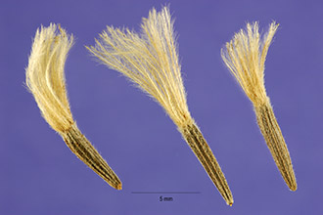

*Photo byline: Steve Hurst@PLANTS Database*

Dotted gayfeather achenes with tufts of feathery bristles.

Pests and Potential Problems

Rodents will eat the flower buds, seedlings, new leaves and roots of *Liatris punctata*. A medium amount of lodging can be a problem during seed maturity in a field monoculture situation.

Environmental Concerns

There are no environmental concerns with dotted gayfeather. This species will reproduce from seed and produce volunteer seedlings, but will not do so aggressively.

Cultivars, Improved, and Selected Materials (and area of origin)

There are currently no released varieties or germplasm lines of *Liatris punctata* from the NRCS Plant Materials Program.

Prepared By and Species Coordinator:

Richard Wynia, USDA NRCS Manhattan Plant Materials Center

Edited: 080303 jsp

For more information about this and other plants, please contact your local NRCS field office or Conservation District, and visit the PLANTS Web site<<http://plants.usda.gov>> or the Plant Materials Program Web site <<http://Plant-Materials.nrcs.usda.gov>>

*The U.S. Department of Agriculture (USDA) prohibits discrimination in all its programs and activities on the basis of race, color, national origin, sex, religion, age, disability, political beliefs, sexual orientation, and marital or family status. (Not all prohibited bases apply to all programs.) Persons with disabilities who require alternative means for communication of program information (Braille, large print, audiotape, etc.) should contact USDA's* [*TARGET Center*](http://www.usda.gov/oo/target.htm) *at 202-720-2600 (voice and TDD).*

*To file a complaint of discrimination write USDA, Director, Office of Civil Rights, Room 326-W, Whitten Building, 14th and Independence Avenue, SW, Washington, DC 20250-9410 or call 202-720-5964 (voice or TDD). USDA is an equal opportunity provider and employer.*