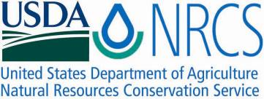

Plant Fact Sheet

# AMERICAN FLY HONEYSUCKLE

*Lonicera canadensis*

## Bartram ex Marsh

Plant Symbol = LOCA7

Contributed by: USDA NRCS Cape May Plant Materials Center and Columbus Service Center, New Jersey

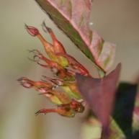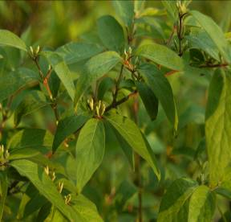

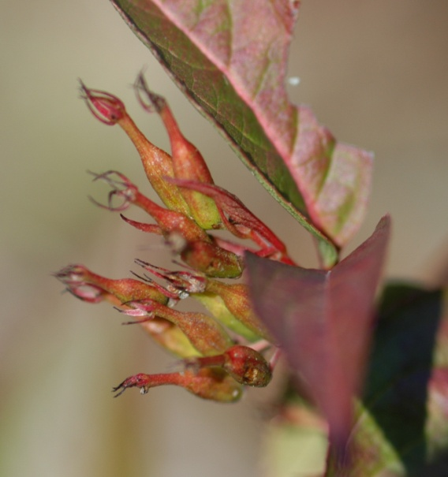William B. Skaradek, USDA NRCS

Alternate Names

Canadian fly honeysuckle, Fly honeysuckle, Xylosteon ciliatum

Uses

Current uses are primarily for the restoration of natural areas on National Park Service lands. American fly honeysuckle is a valuable pollinator support species, and should be incorporated in seeding mixtures for wildlife habitat and plant community diversification.

Status

Please consult the PLANTS Web site and your State Department of Natural Resources for this plant’s current status (e.g. threatened or endangered species, state noxious status, and wetland indicator values).

Description and Adaptation

American fly honeysuckle is a native perennial shrub that grows to about 2 meters (7.5 ft.) in height. It is loosely branched with slender twigs and spreads slowly. From April-July it flowers with yellow and whitish blooms; fruiting in July-Aug. It occurs in native woodlands and is readily located in many diverse eco-tones which include; rock outcrops, droughty gravels/rocky soils as well as marginal lowlands where soil is more moist and fertile. Fly honeysuckle seems to tolerate full sun to partially shaded sites.

Establishment

American fly honeysuckle roots readily from cuttings and is successfully propagated from seed. Plant materials were out-planted from nursery 1-quart and 1-gallon pots for plant community restoration. Plants from both sizes exhibited a high level of survival when out-planted in the spring and late spring months, and when standard guidelines for shrub plantings were followed.

Management

During the year of establishment, as with most shrubs, ensure adequate water is made available to the planting site. Also protect from mowers and traffic during the first year.

Pests and Potential Problems

This native shrub does not seem to exhibit any major damage from pests, disease or browse.

Environmental Concerns

Not known to be invasive. Consult PLANTS database since this shrub has been listed as extirpated and endangered in several states.

Cultivars, Improved, and Selected Materials (and area of origin):

Currently commercial availability of American fly honeysuckle is very limited and commercial cultivars are not known.

Prepared By:

*William B. Skaradek*

USDA NRCS Columbus Service Center, Columbus, NJ

*Christopher Miller*

USDA NRCS Cape May Plant Materials Center, Cape May, NJ

Species Coordinator:

*William B. Skaradek*

USDA NRCS Columbus Service Center, Columbus, NJ

Published: November 2009

Edited: 09Sep07jfh

For more information about this and other plants, please contact your local NRCS field office or Conservation District <<http://www.nrcs.usda.gov/>>, and visit the PLANTS Web site <[http://plants.usda.gov](http://plants.usda.gov/)> or the Plant Materials Program Web site <<http://plant-materials.nrcs.usda.gov>>

**USDA IS AN EQUAL OPPORTUNITY PROVIDER AND EMPLOYER**