

Plant Fact Sheet

# big deervetch

## Lotus crassifolius (Benth.) Greene

Plant Symbol = LOCR

Contributed by: USDA NRCS Corvallis Plant Materials Center

### Photo of Lotus crassifolius, copyright G. D. Carr, 2006.

Big deervetch in flower, © G. D. Carr, 2006.

### Alternate Names

*Alternative common names:* buck lotus, broad leaved lotus, thick-leaved lotus, thickleaf trefoil, thickleaf bird's-foot trefoil, Otay Mountain lotus (=*L. crassifolius* var*. otayensis)*

*Alternative scientific names:* *Hosackia crassifolia*; *Lotus aboriginus* (=*Lotus crassifolius* var*. subglaber*)

### Uses

*Wildlife/livestock forage:* The seed and foliage of big deervetch are eaten by elk, black-tailed deer, quail and other game birds, nongame birds and small mammals. Plants are palatable to livestock and withstand grazing with the help of their perennial roots and rhizomes. Crude protein content is generally high (8–18%), especially on grazed clear-cut test plots.

*Pollinators*: The flowers attract hummingbirds, butterflies, honeybees and native bees, and can be incorporated into hedgerow or pollinator plantings. The plant also serves as a larval food source for butterflies such as the silver spotted skipper.

*Restoration/erosion control*: Big deervetch is an early colonizer of disturbed areas, and because it is a rhizomatous legume it stabilizes soil while adding essential nitrogen and organic carbon to depleted soils. Plants often volunteer on bare road cuts, and can be direct-seeded or established from root cuttings onto disturbed sites such as old roadbeds, road cuts, clear-cuts, fire-damaged land, stream banks and pastures for erosion control cover and critical area plantings.

### Status

The Otay Mountain variety of big deervetch is ranked 1B by the California Native Plant Society (Plants Rare, Threatened, or Endangered in California and Elsewhere) because its occurrence is limited to a few highly restricted populations in California. Variety *crassifolius* is common and widespread. Please consult the PLANTS Web site and your State Department of Natural Resources for this plant’s current status (e.g., threatened or endangered species, state noxious status, and wetland indicator values).

### Description and Adaptation

Fabaceae (Pea family): Big deervetch is a robust, native, herbaceous, perennial legume. Plants are winter dormant, even in mild growing climes. They can easily regenerate from lateral roots and rhizomes, as well as deep taproots that may later become exposed near the soil surface following disturbance. Plants are sprawling to erect, 1–5 feet tall, and stems have a hollow base. Compound leaves have 7–23 leaflets that are about 1 inch long, elliptic to egg-shaped, generally 1–2.5 times longer than wide, bright green on the upper surface and paler below. Flowers are arranged in umbels of 7–20 small (about ½ inch), yellow-green, pea-like flowers that become dark red or purple-blotched with age. A tubular, lobed calyx half encloses the petals and gives the inflorescences a pink to deep red color. Fruits are oblong (1.4–2.8 inches long by 0.1–0.2 inch wide) and hairless, with several dark brown seeds per pod. Bloom period extends from May to August depending on latitude and elevation, with seeds generally ripening late June to September. There are two varieties of big deervetch: var. *otayensis* is covered in long, soft, wavy hairs, while var. *crassifolius* ishairless or has straight, stiff, sharp hairs that lay flat against the stem. There was formerly another recognized variety of big deervetch, var. *subglaber*, but this is now generally considered a separate species, *L. aboriginus* (=*Hosackia rosea*), rosy bird’s-foot trefoil. *Lotus aboriginus* can be distinguished from *L. crassifolius* by its lower elevation coast range distribution (below 2600 ft), smaller stature (0.3–2.3 ft), leaflet length 2–3 times width, fewer flowers per inflorescence (6–10), and white flowers tinged with red or purple.

Big deervetch is common in openings in chaparral, pine or mixed woodlands, as well as on stream banks, disturbed areas and roadsides. It is a fast grower that does best in full sun on fine- to medium-textured, well-drained soils. It grows in areas with 14–80 inches mean annual precipitation, but is drought-tolerant and tolerates temperatures down to -3°F. Plants are fire-stimulated, germinating readily from the seed bank, even after intense fires. Its native range includes southwestern Washington, western Oregon, California and Baja California, Mexico at elevations up to 8000 feet. Variety *otayensis* is found only on Otay Mountain, San Diego County, CA and into Baja California. For updated distribution, please consult the Plant Profile page for this species on the PLANTS Web site.

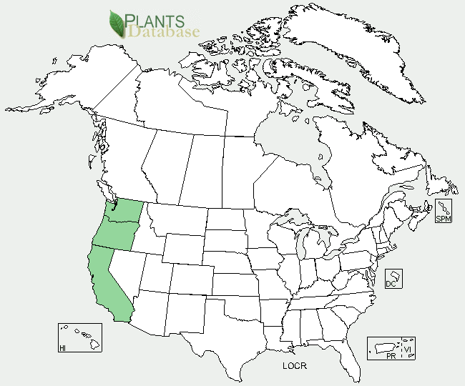

Big deervetch distribution from USDA-NRCS PLANTS Database.

### Establishment

Big deervetch seed has combined dormancy, meaning it has both physical and physiological inhibitions to germination, so seed should be scarified by mechanical abrasion of the seed coat, and stratified by moist chilling prior to sowing. Seed can be scarified in a Forsberg seed scarifier with 220 grit sandpaper for 10 to 15 seconds in order to overcome physical seed coat dormancy, followed by cold-moist stratification for at least 60–90 days to overcome the physiological dormancy. With these treatments, germination rates can reach 80-85% for good seed lots. Treatment with boiling water has been proposed as an alternative to mechanical scarification in some *Lotus* species, but further testing is required to evaluate the success of these treatments on big deervetch germination. Scarified seed can be direct-seeded in the fall to stratify *in situ*, germinating in the spring when the soil begins to warm. Like most legumes, establishment success, plant vigor and nodulation will be improved by inoculating seed prior to sowing. This can be accomplished by making a slurry from soil and/or root nodules of existing big deervetch (or similar) plants, or purchasing rhizobia (nitrogen-fixing soil bacteria) inoculants from a commercial source. Seedlings are often slow to establish initially, so a good weed management plan should be in effect prior to planting in order to minimize competition. There are about 48,600 seeds per pound. Sown alone, the suggested seeding rate is 4–8 pure live seed (PLS) pounds per acre, or 4–8 seeds per square foot.

### Management

Plants require little management once established; they are long-lived, drought-tolerant, and re-sprout or germinate readily after fire and other major disturbances.

### Pests and Potential Problems

Pocket gophers can do significant damage to plantings of big deervetch. There are no other records of specific pest or disease problems, but plants may be expected to be susceptible to insect pests and diseases similar to those found on other native *Lotus* species.

### Environmental Concerns

There are no known environmental concerns associated with big deervetch.

### Cultivars, Improved, and Selected Materials (and area of origin)

There are no improved or selected materials of big deervetch, but container plants and/or seed are sometimes available from commercial sources on the West coast.

### Prepared By

*Anna Young-Mathews and Dale Darris*

USDA-NRCS Plant Materials Center, Corvallis, Oregon

### Citation

Young-Mathews, A., and D. Darris. 2011. Plant fact sheet for big deervetch (*Lotus crassifolius)*. USDA-Natural Resources Conservation Service, Plant Materials Center, Corvallis, OR.

Published September 2011

Edited: [30Aug2011 klp; 06Sep2011 jab]

For more information about this and other plants, please contact your local NRCS field office or Conservation District <<http://www.nrcs.usda.gov/>>, and visit the PLANTS Web site <[http://plants.usda.gov](http://plants.usda.gov/)> or the Plant Materials Program Web site <<http://plant-materials.nrcs.usda.gov>>

**USDA IS AN EQUAL OPPORTUNITY PROVIDER AND EMPLOYER**