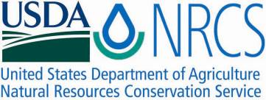

Plant Fact Sheet

# twinberry honeysuckle

## [Lonicera involucrata (Richardson) Banks ex Spreng.](http://plants.usda.gov/java/profile?symbol=LOIN5)

Plant Symbol = LOIN5

Contributed by: USDA NRCS Plant Materials Center, Corvallis, Oregon

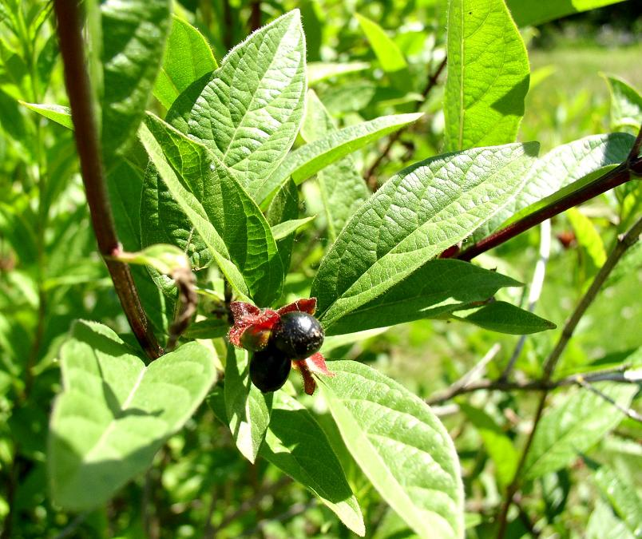

Figure 1. Leaves and black berries of twinberry honeysuckle. Photo by Sonja Johnson.

### Alternate Names

*Common alternative names:* Black twinberry, twinberry, bearberry honeysuckle, bush honeysuckle, bracted honeysuckle

*Scientific alternative names: Lonicera involucrata* var*. involucrata, Distegia involucrata,* and *Xylosteum involucratum.*

### Line drawing of the stem, leaves, fruit, and flowers of twinberry honeysuckle. Reprinted with permission from the University of Washington Press.Uses

*Conservation-* Twinberry honeysuckle is a valuable shrub for streambank erosion control and restoration of riparian areas, swamps, bogs, moist woodlands, scrub-shrub wetlands, and sandy coastal areas within its native range. Winter dormant branches are useful as live stakes, fascines, and other soil bioengineering practices for stabilizing streambanks, moist slopes, and the immediate shoreline of lakes or ponds. The species is also used in hedgerows and pollution resistant wind shelters.

*Wildlife* - The berries are eaten by bears, small mammals, game birds including quail and grouse, and songbirds such as thrushes. The flower is a source of nectar for hummingbirds and butterflies. The plant is host for the larva of certain butterflies including Gillett’s checkermallow. Value as general wildlife cover is high, but as browse its desirability is rated low for most large game animals. However, elk, moose, mountain goats, and deer are reported to utilize the leaves or twigs in some areas. The species is rated as poor forage for domestic cattle and fair for sheep.

*Ethnobotanic –* Reports on the fruit vary from poisonous, to mildly toxic, to bitter and unpalatable, to edible and useful as food, depending on tribe, region or publication. The berry was used as a source of dye. Medicinal uses were many and varied among tribes. These included the leaves, berries or bark as a decoction, infusion, or poultice for sores, body cleansing, swellings, dandruff, wounds, infections, sore throats, paralysis, coughs, burns, itches, venereal diseases, boils, stomach troubles, pains of the legs or feet, arthritis, and sore eyes. Sometimes the leaves or bark were simply chewed for treating ailments or used as a ceremonial emetic (i.e. to induce vomiting).

**Status**

Please consult the PLANTS Web site and your State Department of Natural Resources for this plant’s current status (e.g., threatened or endangered species, state noxious status, and wetland indicator values).

### Description and Adaptation

Twinberry honeysuckle (family: Caprifoliaceae) is an upright deciduous shrub that grows up to 12 (16) ft tall. The leaves are in opposite pairs, egg or broadly lance shaped, pointed, and often hairy beneath. The flowers are tubular, in pairs, and yellow (except for the orange-red tinted flowers for the coastal variety *ledebourii).* The double or “twin” shiny black berries that ripen in July or later are cupped by prominent purple-red colored bracts.

*Figure 2. Stem, leaves, fruit, and flower of twinberry honeysuckle. Reprinted with permission, University of Washington Press.*

Twinberry honeysuckle occurs from the sea coast to high elevations in alpine regions. It ranges from Alaska south to Mexico and west through the Rocky Mountain states, as well as most of Canada. The species is adapted to soils that vary from course sand to fine textured silt and clay with a pH of 5 to 8 (moderately high acidity to slightly basic). Found on moist, seasonally wet, and flooded sites, habitats include moist woods, thickets, riparian zones and bogs. It also occurs in brackish tidal swamps and sandy areas along the coast. While tolerant of full sun, twinberry honeysuckle is most commonly found under shady conditions. It will grow on upland soils with moderate fertility but drought tolerance is lacking.

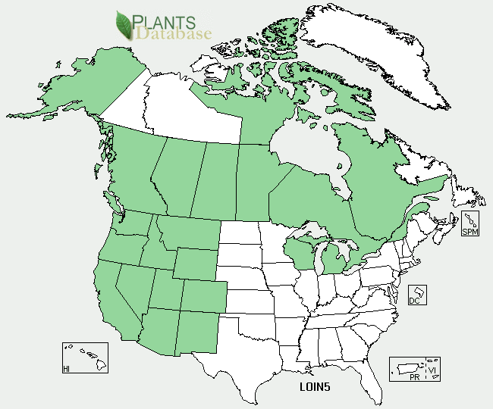

Figure 3. Twinberry honeysuckle distribution from USDA-NRCS PLANTS Database.

Please consult the Plant Profile page for this species on the PLANTS Web site.

### Establishment

Seed is obtained by collecting the ripe berries from July through September then macerating the fruit to separate the seed from the pulp. The seed should be cold moist stratified (moist chilled at 33-36°F) for 30 to 90 days in order to overcome embryo dormancy and improve germination. Air dried seed can be stored in sealed containers under cool temperatures for up to 15 years. There is an average of 327,000 seeds per pound. Unstratified seed should be fall sown and covered with a thin layer of soil and 1-2 in. of organic mulch.

Vegetative propagation in containers or beds is easy from hardwood (winter dormant), softwood (spring) and semi-hardwood (summer) cuttings, or layering of stems if the soil or growth media is kept moist. Rooting hormones are generally not required, but may be helpful for some clones or populations. In western Oregon and western Washington, establishment from direct installation of live stakes on streambanks and other moist revegetation sites in fall or winter has been moderately successful. Live stakes are unrooted, dormant 18 to 36 in. cuttings made from older branches and planted with at least 70 percent of the length in the soil. As with container or bareroot nursery stock, survival and growth are improved if stakes are mulched or irrigated the first full growing season, weeds are suppressed, and animal browse curtailed.

### Management

Plants should be monitored for survival and pest problems the first few growing seasons and remedial action taken as needed. Brush cutting can be used as a management tool to increase or decrease the attractiveness of twinberry honeysuckle to browsing by ungulates in transportation corridors. In British Columbia, cutting the shrubs in July results in less attractive fall and winter browse.

### Pests and Potential Problems

Among the insect pests are aphids, serpentine leaf miners, and scales. Disease problems have not been widely reported but may include those of other honeysuckles.

### Environmental Concerns

The bitter ripe berries may be mildly toxic or poisonous to humans. There is some suggestion the foliage or other plant parts may have a mildly toxic effect on cattle.

### Cultivars, Improved, and Selected Materials (and area of origin)

There are no known cultivars or named selections. However, provenance testing and anecdotal observations show clear distinctions in bud break and growth patterns in northern versus southern and continental versus coastal sources of this species. Such differences are probably adaptive and reflect geographic origin. Thus, source of stock should be carefully considered for plantings.

### Prepared By

Dale Darris, USDA NRCS, Corvallis Plant Materials Center

### Citation

Darris, D. 2011. Plant fact sheet for twinberry honeysuckle (*Lonicera involucrata*). USDA Natural Resources Conservation Service, Corvallis, OR. 97330.

Published September 2011

Edited:

For more information about this and other plants, please contact your local NRCS field office or Conservation District <<http://www.nrcs.usda.gov/>>, and visit the PLANTS Web site <[http://plants.usda.gov](http://plants.usda.gov/)> or the Plant Materials Program Web site <<http://plant-materials.nrcs.usda.gov>>

**USDA IS AN EQUAL OPPORTUNITY PROVIDER AND EMPLOYER**