

Plant Fact Sheet

# Osage orange

## Maclura pomifera (Rafin.) C.K. Schneider

Plant Symbol = MAPO

Contributed by: USDA NRCS Plant Materials Center Manhattan, Kansas

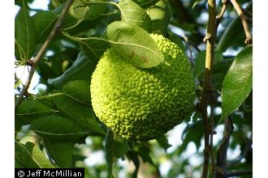*.*

*Figure 1. Fruit and leaf of Osage orange plant from the PLANTS Database website. Photo by Jeff McMillian*

### Alternate Names

Hedge apple, horse-apple, hedge, bodark, Bois d’Arc yellow wood, mock-orange, and bow-wood.

### Uses

Osage orange has a long and interesting history of use by both Native Americans and early pioneers. Its wood was once in demand for making hubs and wheel rims for horse drawn wagons, mine support timbers, posts and many other uses where decay resistance was important. Osage orange was first cultivated in the south in the early 1800’s. It was brought north by Professor Jonathan Turner, a biology teacher at Illinois College, and promoted as a living fence by John Wright, editor of *The Prairie Farmer.* By 1847 Turner was convinced that Osage orange was the best fencing material available. He described it as “horse high, bull strong and pig tight” and it functioned as a “hedge” fence long before the invention of barbed wire. By the 1850’s Osage orange hedges made the fencing of entire farms possible. The French found the Osage Indians making bows from the wood and called it *Bois d’Arc* (meaning wood of the bow). Recently, Osage orange has been studied for the chemical properties it contains that may be of economic importance. Oil extracted from the seeds has been tested for its potential as biodiesel. The isoflavone pomiferin has been studied for its antioxidant activity. Osage orange has also had proteolytic enzymes recently discovered in its fruit.

### Status

Osage orange is a pioneering species forever invading exposed mineral soils, particularly over grazed pastures and abandoned crop fields. It can be a locally dominant tree species in those situations. Please consult the PLANTS Web site and your State Department of Natural Resources for this plant’s current status (e.g., threatened or endangered species, state noxious status, and wetland indicator values).

### Weediness

Osage orange has the potential to invade areas abused by poor management and the over grazing of pasture and range land. This plant may become weedy or invasive

in some regions or habitats and may displace desirable vegetation if not properly managed. Please consult with your local NRCS Field Office, Cooperative Extension Service office, state natural resource, or state agriculture department regarding its status and use. Weed information is also available from the PLANTS Web site at [http://plants.usda.gov](http://plants.usda.gov/). Please consult the Related Web Sites on the Plant Profile for this species for further information.

### Description and Adaptation

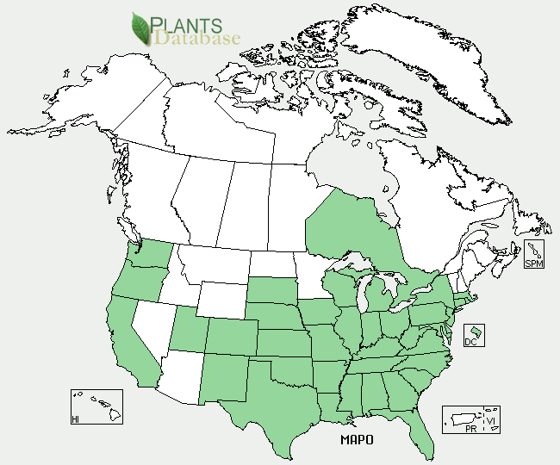

Figure 2.Osage orange distribution from USDA-NRCS PLANTS Database.

General: Osage orange belongs to the Moraceae, or mulberry family. The name Maclura pomifera comes from William Maclure (1763 – 1840) an early American geologist; and pomifera which means “fruit-bearing” for the large fruits that it produces on the female trees. It is a small to medium size tree 36 to 65 feet tall, with deeply furrowed bark and thorny branches. The trunk is usually short and divides into several prominent limbs with upward arching branches. The root system is diffuse and covers large areas with its lateral spread. Leaves are deciduous, simple, and alternate or are in clusters at the end of short spurs. Their shape ranges from broad-ovate to ovate-lanceolate, rounded to subcordate at the base broadly cuneate or acuminate at the apex. Leaves are 2 to 5 inches (in.) long and 0.75 to 2.5 in. wide and have entire margins. Leaf blades are dark green, smooth and waxy above; paler green with a few hairs beneath. The color turns translucent yellow in the fall. Osage orange trees are dioecious and wind pollinated with flowers appearing in mid-May to June, after leaves. Staminate (male) flowers are globular or in short cylindrical clusters, green, hairy, with 4 stamens and large yellow anthers, but no petals. Pistillate (female) flowers are in dense, globular clusters, 0.75 to 1.0 in. diameter at the base of a leaf. The fruit or “Hedge ball” is produced in September and is a multiple fruit consisting of many 1-seeded druplets fused into a globose, yellow-green structure approximately 3 to 5 in. in diameter. Female trees may start to bear fruit at about 10 years old. The individual oval shaped seeds are imbedded in the fleshy calyx and are 0.3 to 0.5 in. long. Seeds are initially cream colored, but will turn brown with age and exposure to air.

For updated distribution, please consult the Plant Profile page for this species on the PLANTS Web site.

### Establishment and Management

Osage orange is easy to plant and establish from seed. Fruit should be collected in the fall and allowed to naturally decay for several months. Seeds can be extracted from the fruit by maceration in water and floating or screening off the pulp. Osage orange averages about 200 to 300 seeds per fruit. Cleaned seed per pound averages about 14,000. Since Osage orange has a slight dormancy problem it may require a short pre-chill to initiate germination. A 30 to 45 day stratification at 40 degrees Fahrenheit (°F) is usually sufficient to break dormancy and allow seed germination.

Seeds extracted from fruit that has fermented over winter in a cold state do not need stratification in the spring. Seeds may be drilled in rows 8 to 12 in. apart, or in bands 3 to 4 in. wide. They should be covered with ¼ to ½ in. of soil. Fall seeded beds should be mulched while spring seeded beds do not need to be mulched.

### Pests and Potential Problems

In a Nebraska nursery, seedlings have been killed by damping off and root rot caused by *Pythium ultimum* and *Rhizoctonia solani* . The most important disease of Osage orange is Texas root rot caused by *Phymatotrichum* *omnivorum.* A six year study of shelterbelt plantings in Texas and Oklahoma revealed a 6.8 percent loss of seedlings of Osage orange to Texas root rot. A result of this study was that Osage orange was not recommended for use on any soil type in the root rot belt.

### Environmental Concerns

Like many woody species Osage orange tends to have an invasive nature when exposed to poorly managed range and pasture land. It can be found on idle acres and on abandoned farm land near hedge row plantings.

### Control

Please contact your local agricultural extension specialist or county weed specialist to learn what works best in your area and how to use it safely. Always read label and safety instructions for each control method. Trade names and control measures appear in this document only to provide specific information. USDA NRCS does not guarantee or warranty the products and control methods named, and other products may be equally effective.

### Cultivars, Improved, and Selected Materials (and area of origin)

Horticulturally desirable varieties of Osage orange are thornless and fruitless. Several male trees have been selected and propagated for these specific traits. ‘Wichita’ was a selection by John Pair, horticulturist for Kansas State University. ‘White Shield’ was an Oklahoma source of a fruitless, thornless male clone whose origin was along White Shield Creek in western Oklahoma.

### Prepared By: Richard L. Wynia, USDA-NRCS Manhattan Plant Materials Center

### Citation

Wynia, R. 2011. Plant fact sheet for Osage orange (*Maclura pomifera)*. USDA-Natural Resources Conservation Service, Manhattan Plant Materials Center. Manhattan, KS 66502

Published March, 2011

Edited:

For more information about this and other plants, please contact your local NRCS field office or Conservation District <<http://www.nrcs.usda.gov/>>, and visit the PLANTS Web site <[http://plants.usda.gov](http://plants.usda.gov/)> or the Plant Materials Program Web site <<http://plant-materials.nrcs.usda.gov>>

**USDA IS AN EQUAL OPPORTUNITY PROVIDER AND EMPLOYER**