

Plant Fact Sheet

# Powderpuff

## Mimosa strigillosa

## Torr. and A. Gray

Plant Symbol = MIST2

Contributed by: USDA NRCS East Texas Plant Materials Center

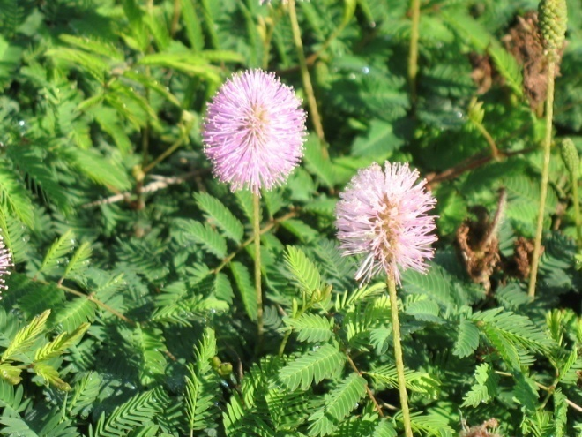

Photo courtesy:USDA/NRCS East Texas Plant Materials Center

### Alternate Names

Some alternate names include powderpuff, herbaceous mimosa and sunshine mimosa.

### Uses

Powderpuff is utilized by both domestic livestock and wildlife. It serves as a food source for cattle, goats sheep and deer. Powderpuff is also an important plant for pollinator habitat. Bees utilize powderpuff as a pollen source while little sulphur butterfly caterpillars (*Pyristia lisa*) feed on the foliage.

### Status

Please consult the PLANTS Web site and your State Department of Natural Resources for this plant’s current status (e.g., threatened or endangered species, state noxious status, and wetland indicator values).

### Description and Adaptation

Powderpuff is a native, warm season, perennial legume which may reach up to eight inches in height. Unlike other *Mimosa* species, powderpuff does not have small prickles along its stems. The plant produces seed and spreads by stems which root to the ground along their length. The leaves are alternately arranged along the stem and are bipinnate. The leaflets are sensitive to contact, folding up quickly after being disturbed. The plant produces a showy pink bloom about one inch long during the spring and summer. The flowers develop into small, flattened, oblong seed pods which turn brown when mature.

The plant can be found on various soils, especially sandy loam. Preferred areas are prairies, grasslands, meadows, forest openings, and roadsides. Powderpuff is found throughout the southeastern United States. For updated distribution, please consult the Plant Profile page for this species on the PLANTS Web site.

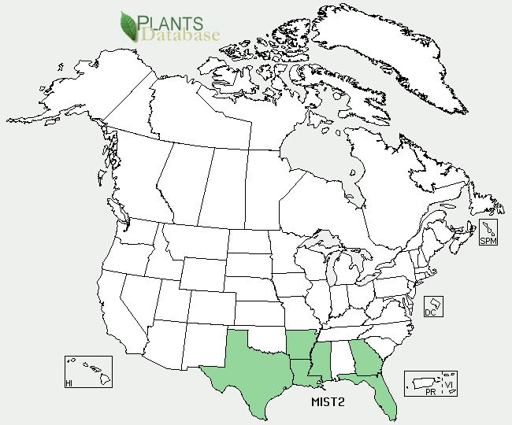Powderpuff distribution from USDA-NRCS PLANTS Database.

### Establishment

A soil analysis should be conducted prior to planting to determine if soil amendments of phosphorus and potassium are needed. The optimum pH range is 6.2 to 7.1. Soils with a pH less than 4.1 are unsuitable and must be amended to increase pH.

Seedbed preparation should begin in advance of planting. Planting can be completed in spring or early fall. Prepare a clean, weed free seedbed using tillage or herbicide application. Soil amendments maybe added while preparing the seed bed to help incorporate them in the soil. Prior to planting, the soil should be firm, not fluffy or powdery. Scarify and inoculate seed with strophostyles spec 1 inoculant before planting. Mechanically scarifying, nicking or roughing the seed coat, results in better germination than chemical scarification or heat treatments. Powderpuff, if inoculated, will fix its own nitrogen. Avoid fertilization with nitrogen as it will promote weedy pests, and make them more competitive.

If available use a drill type planter to ensure good seed to soil contact. Broadcast seeding may be used, however additional cultipacking or light dragging should be done to cover the seed. Seed should be planted about ¼” deep. Crockett germplasm herbaceous mimosa contains approximately 30,000 seeds per bulk pound. A seeding rate of seven pounds of pure live seed (PLS) per acre is recommended. For seed mixes,reduce the seeding rate according to the percent desired in the mixture.

### Management

Powderpuff is not an overly aggressive plant and other plants will eventually come into the stand. Unwanted plants can be controlled by mowing. Glyphosate can be applied to treat cool season weeds in the winter and early spring when the herbaceous mimosa is dormant.. However, powderpuff may not become dormant in the most southern portion of its range.

### Pests and Potential Problems

The caterpillar of the little sulphur butterfly (*Pyristia lisa*) feeds on powderpuff foliage.

### Environmental Concerns

None.

### Cultivars, Improved, and Selected Materials (and area of origin)

Crockett germplasm herbaceous mimosa was released in 2006 by the USDA/NRCS East Texas Plant Materials Center, Nacogdoches, Texas. Crockett germplasm herbaceous mimosa was collected from Houston County, Texas.

### Prepared By: *Melinda Brakie*, USDA NRCS East Texas Plant Materials Center, Nacogdoches, Texas. May 2011

### Citation

Brakie, M. 2011. Plant fact sheet for powderpuff (*Mimosa strigillosa)*. USDA-Natural Resources Conservation Service, East Texas Plant Materials Center. Nacogdoches, Texas 75964.

Published *May, 2011*

Edited:

For more information about this and other plants, please contact your local NRCS field office or Conservation District <<http://www.nrcs.usda.gov/>>, and visit the PLANTS Web site <[http://plants.usda.gov](http://plants.usda.gov/)> or the Plant Materials Program Web site <<http://plant-materials.nrcs.usda.gov>>

**USDA IS AN EQUAL OPPORTUNITY PROVIDER AND EMPLOYER**