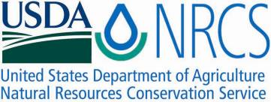

Plant Fact Sheet

# hairawn muhly

## Muhlenbergia capillaris (Lam.) Trin.

### Plant Symbol = MUCA2

#### Contributed by: USDA, NRCS, Norman A. Berg National Plant Materials Center, Beltsville, MD

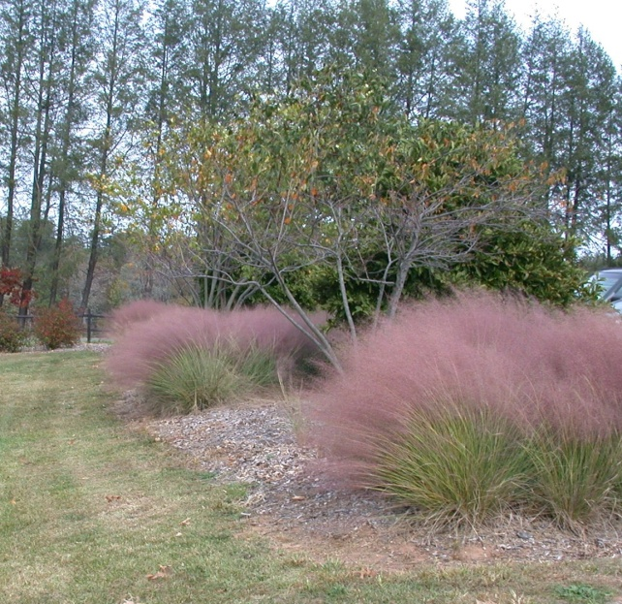

Photo by Shawn Belt USDA, NRCS, Norman A. Berg National Plant Materials Center

#### **Alternate Names**

|  |  |
| --- | --- |
| Purple muhly grass | Pink muhly |
| Hair grass | Gulf muhly |
| Long-awn hairgrass | Muhly grass |
| Hairy-awn muhly |  |

#### **Uses**

*Conservation:* Hairawn muhly is a hardy and drought-tolerant native ornamental grass that can be used for land reclamation. It is also useful as a fine fuel for understory burn management programs.

*Landscaping and wildlife:* Hairawn muhly produces striking pink and purple blooms in the fall. It requires little maintenance and is excellent for meadow gardens and as a general garden plant. Hairawn muhly is known to attract beneficial insects such as ladybug beetles (*Coccinella spp*.). The clumping habit of hairawn muhly makes it excellent for use as wildlife cover.

#### **Status**

Hairawn muhly is listed as an endangered species in Connecticut, Indiana, Maryland, and New Jersey; as extirpated in Pennsylvania; and as presumed extirpated in Ohio. Please consult the PLANTS Web site and your State Department of Natural Resources for this plant’s current status (e.g., threatened or endangered species, state noxious status, and wetland indicator values).

#### **Description and Adaptation**

Hairawn muhly is a native, perennial, warm-season grass that grows from 1–3 feet tall with a 2–3 foot spread. The stems are un-branched and have an upright habit. The wiry, thin leaves are 18–36 inches long, simple (not made up of multiple leaflets), and alternate (progressing singly up the stem). The leaves are green throughout the summer and turn copper in the fall. The purplish-red or pink flowers are grouped together in a long, diffuse, airy, grouping of flowers which mature from the bottom up. The cluster of flowers is arranged on a stem that is about 18 inches long and 10 inches wide and rises above the leaves. The seed stalks are 2–5 feet tall. Flowers give way to oblong tan or brown seed less than half an inch long. Hairawn muhly clumps but does not spread through above or underground stems (stolons or rhizomes).

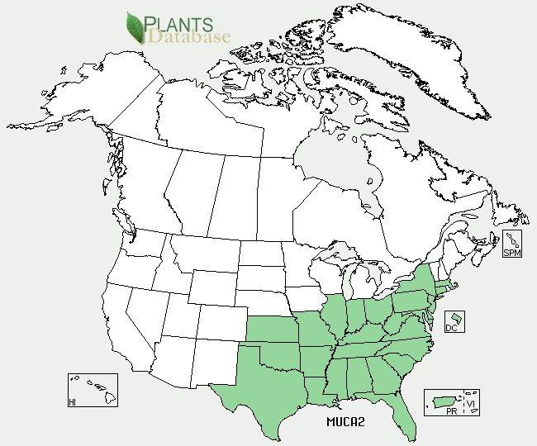

Hairawn Muhly distribution from USDA, NRCS PLANTS database

For updated distribution, please consult the Plant Profile page for this species on the PLANTS Web site.

#### **Establishment**

Seeds should be collected from plants in late fall and air-dried for five to ten days. Collect seeds during the warmest and driest time of day using a comb to avoid disturbing the appearance of the plant. For greenhouse propagation, plant seeds in the winter in order to have full plants which are ready for spring planting. Seeds do not need a cold treatment for germination. If direct-seeded outdoors, plant seeds one-eighth of an inch deep in rows spaced 24–48 inches apart. Keep soil moist at all times during establishment. Fertilization is not recommended for stands that have been sown directly.

Propagate by dividing existing clumps in early spring and summer. Do not divide clumps during the flowering stage.

#### **Management**

Burn or mow hairawn muhly stands in late winter to remove old residue. Hairawn muhly prefers neutral to slightly acidic soils but can tolerate many soil types. It has a low tolerance for high pH soils and a high tolerance for salinity. Hand-weed established stands and fertilize according to soil test recommendations.

#### **Pests and Potential Problems**

Aphids are known to infest hairawn muhly blooms during the early stages of seed development. Increasing the numbers of beneficial insects such as ladybug beetles may be a natural means of biological control.

Environmental Concerns

No concerns at this time.

Cultivars, Improved, and Selected Materials (and area of origin)

There are no recommended cultivars or selected materials at this time. Hairawn muhly is available from commercial nurseries specializing in native plants.

Prepared By: Samantha Kirk and Shawn Belt, NRCS, Norman A. Berg National Plant Materials Center, Beltsville, MD

**Citation**

Kirk, S. and Belt, S. 2010. Plant Fact Sheet for Hairawn Muhly (*Muhlenbergia capillaries*) USDA-Natural Resources Conservation Service, Norman A. Berg National Plant Materials Center, Beltstville, MD 20705

Published November, 2010

Edited: 25-Mar-2009 SMK, 4-Apr 2009 RG, 25-Jan-2010 SVB

For more information about this and other plants, please contact your local NRCS field office or Conservation District <<http://www.nrcs.usda.gov/>>, and visit the PLANTS Web site <[http://plants.usda.gov](http://plants.usda.gov/)> or the Plant Materials Program Web site <<http://plant-materials.nrcs.usda.gov>>

**USDA IS AN EQUAL OPPORTUNITY PROVIDER AND EMPLOYER**